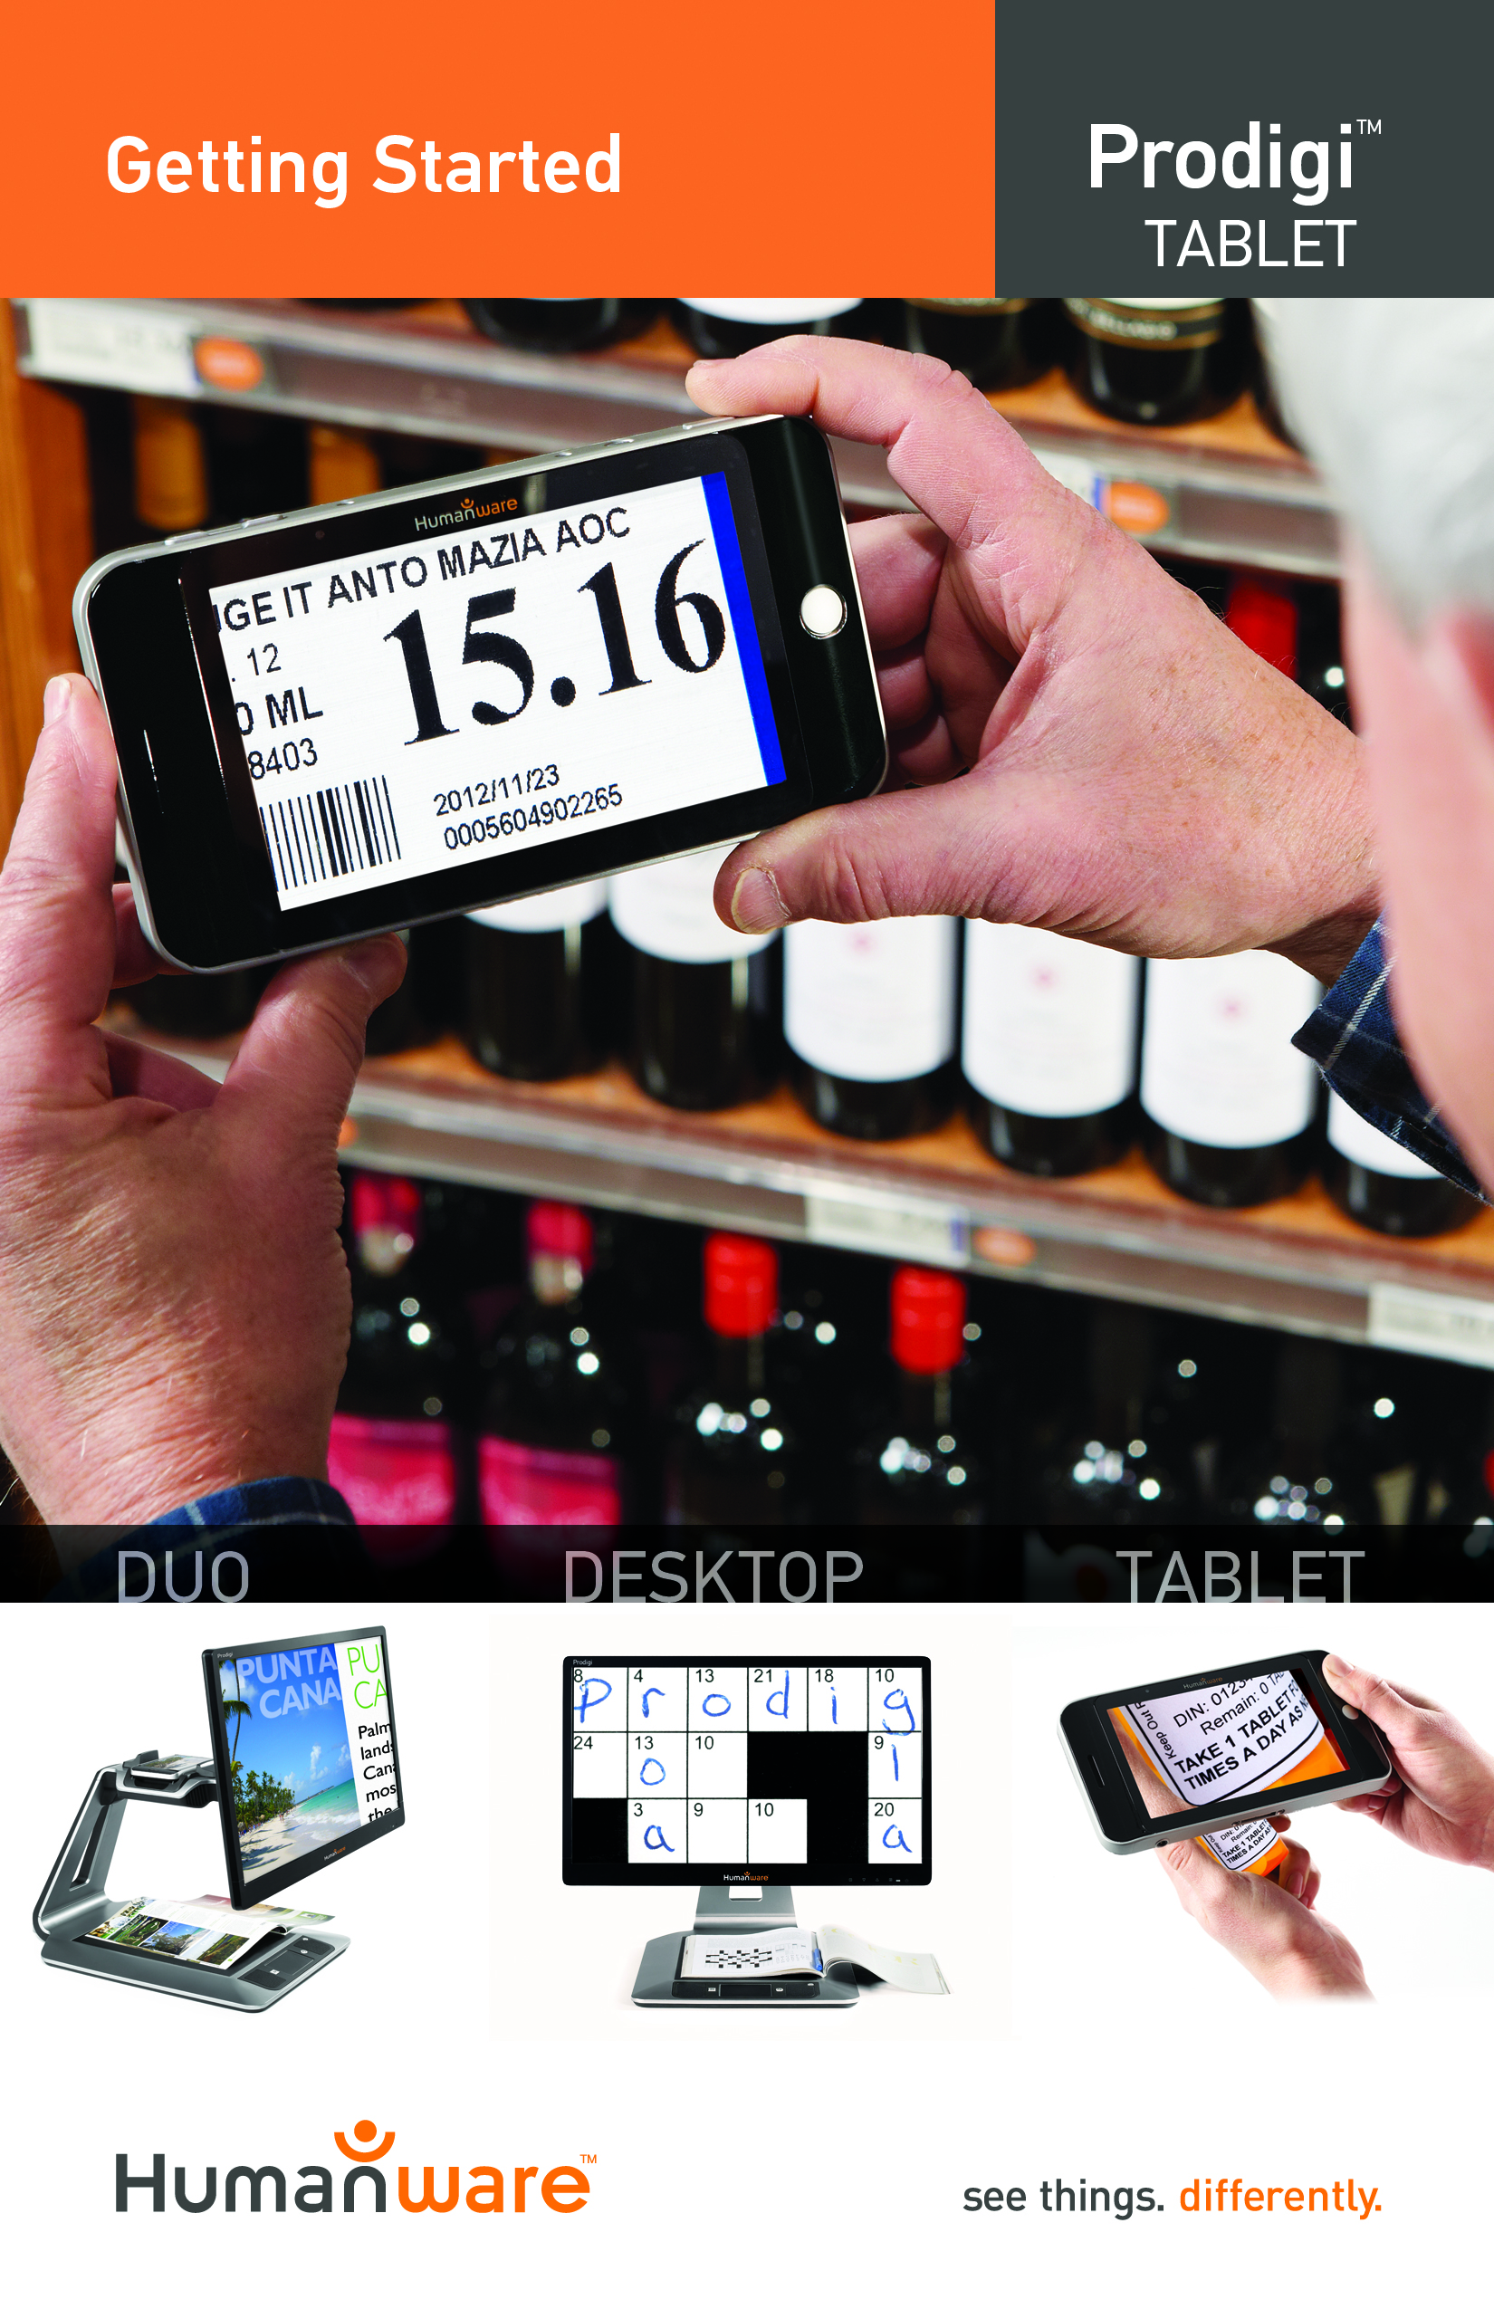

Getting Started

- Connect the USB Recharge Cable to the Power Supply.

- Hold the Tablet so that the screen side is facing you and the recharge port is aiming downwards. Make sure the tactile HumanWare logo on the recharge cable is facing you (1). Carefully connect the cable to the recharge port and plug it to an outlet.
1

IMPORTANT: Use caution while inserting the cable into the Recharge Port.
- Let the Tablet recharge for 8 consecutive hours (initial charge).

- Press Power to power on the Tablet. Prodigi will take about 1 minute to initialize. HumanWare’s logo will appear on the screen, followed by Prodigi’s startup screen.

- Use the Reading Stand (in the box under the plastic blister) to stabilize the Tablet above the document you wish to view. Make sure the tactile HumanWare logo on the Reading Stand is facing up (1) and that you place the Tablet front face up on the Reading Stand:
1

- Use the Plus-Minus keys to adjust the zoom level. To decrease character size, press the Minus key (the left one). To increase character size, press the Plus key (the right one).

For more information on how to use Prodigi, please consult the user guide.

[End of document: VER 04-2014-05-26]

REV 04

REV01

