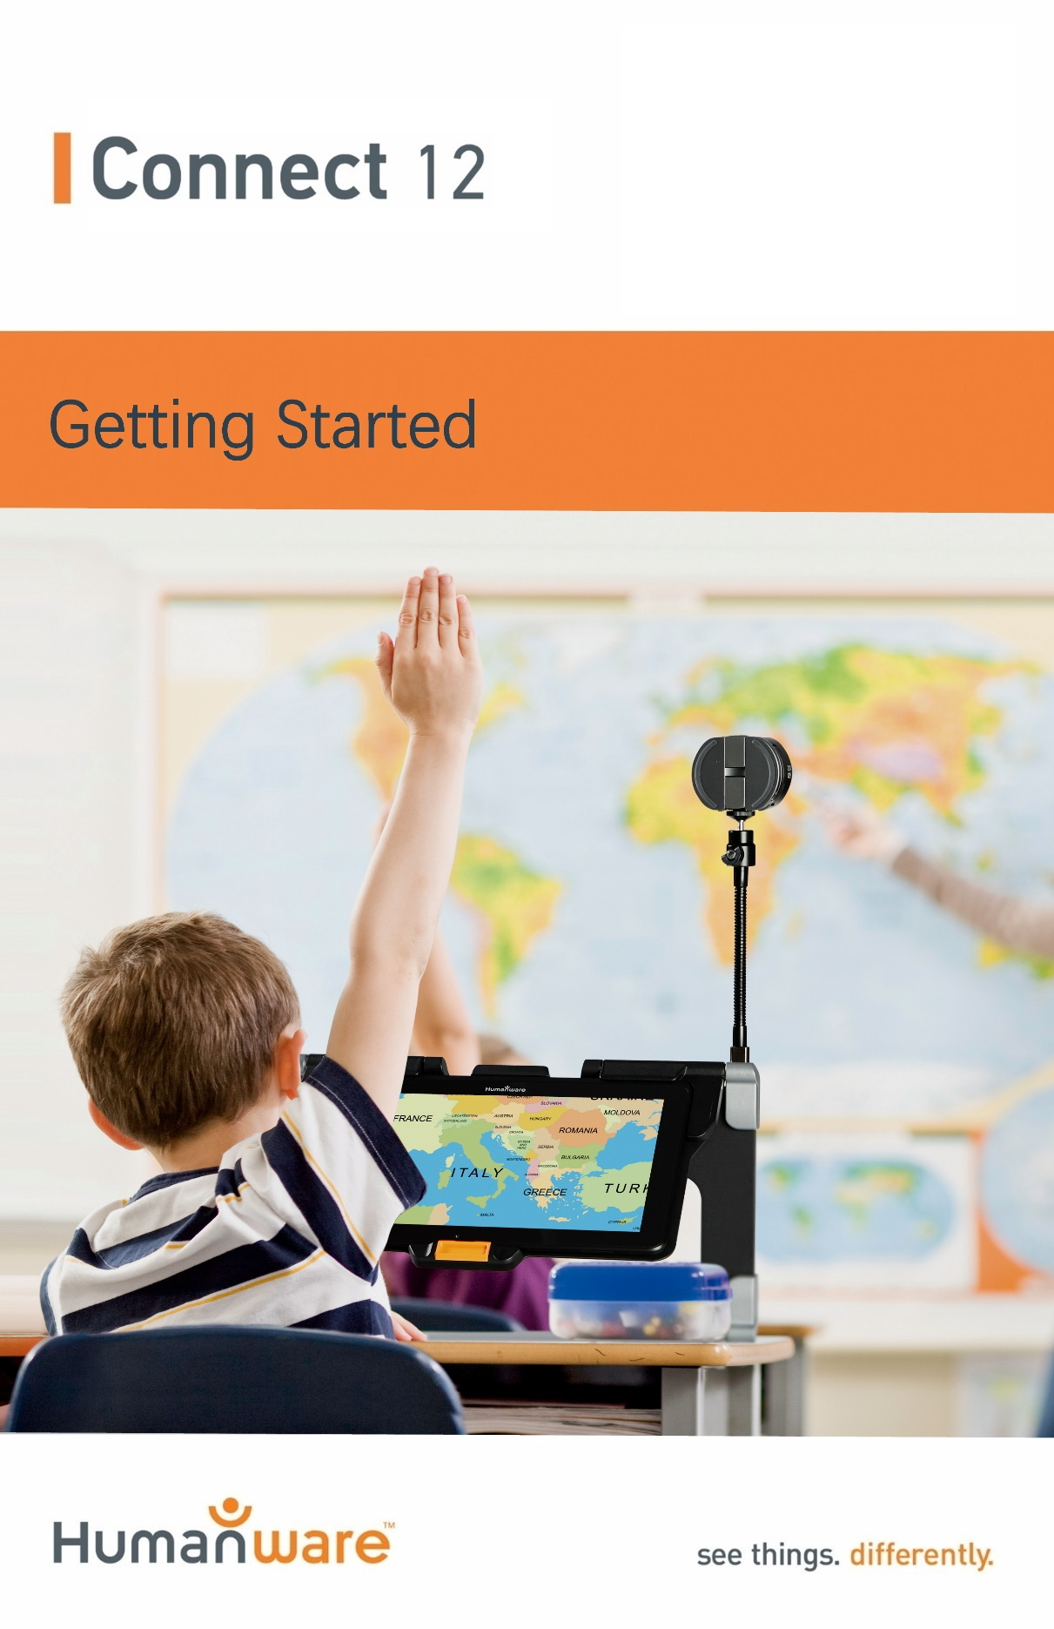

Getting Started
- On a flat, stable surface, hold your Connect 12 stand upright, making sure that the panel marked “Connect” faces towards the back. Hold the handle with one hand, and unfold the lower panel with your other hand until it is lying flat.
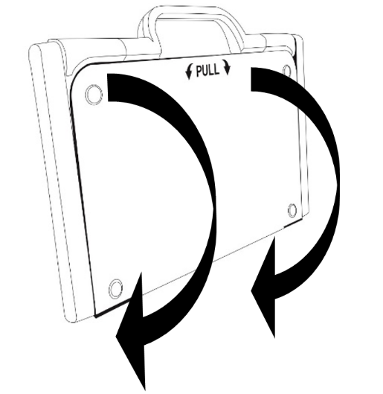

- Unfold the top panel until it is roughly parallel to the lower panel.
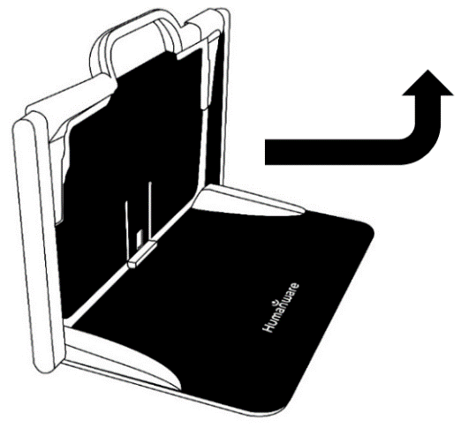
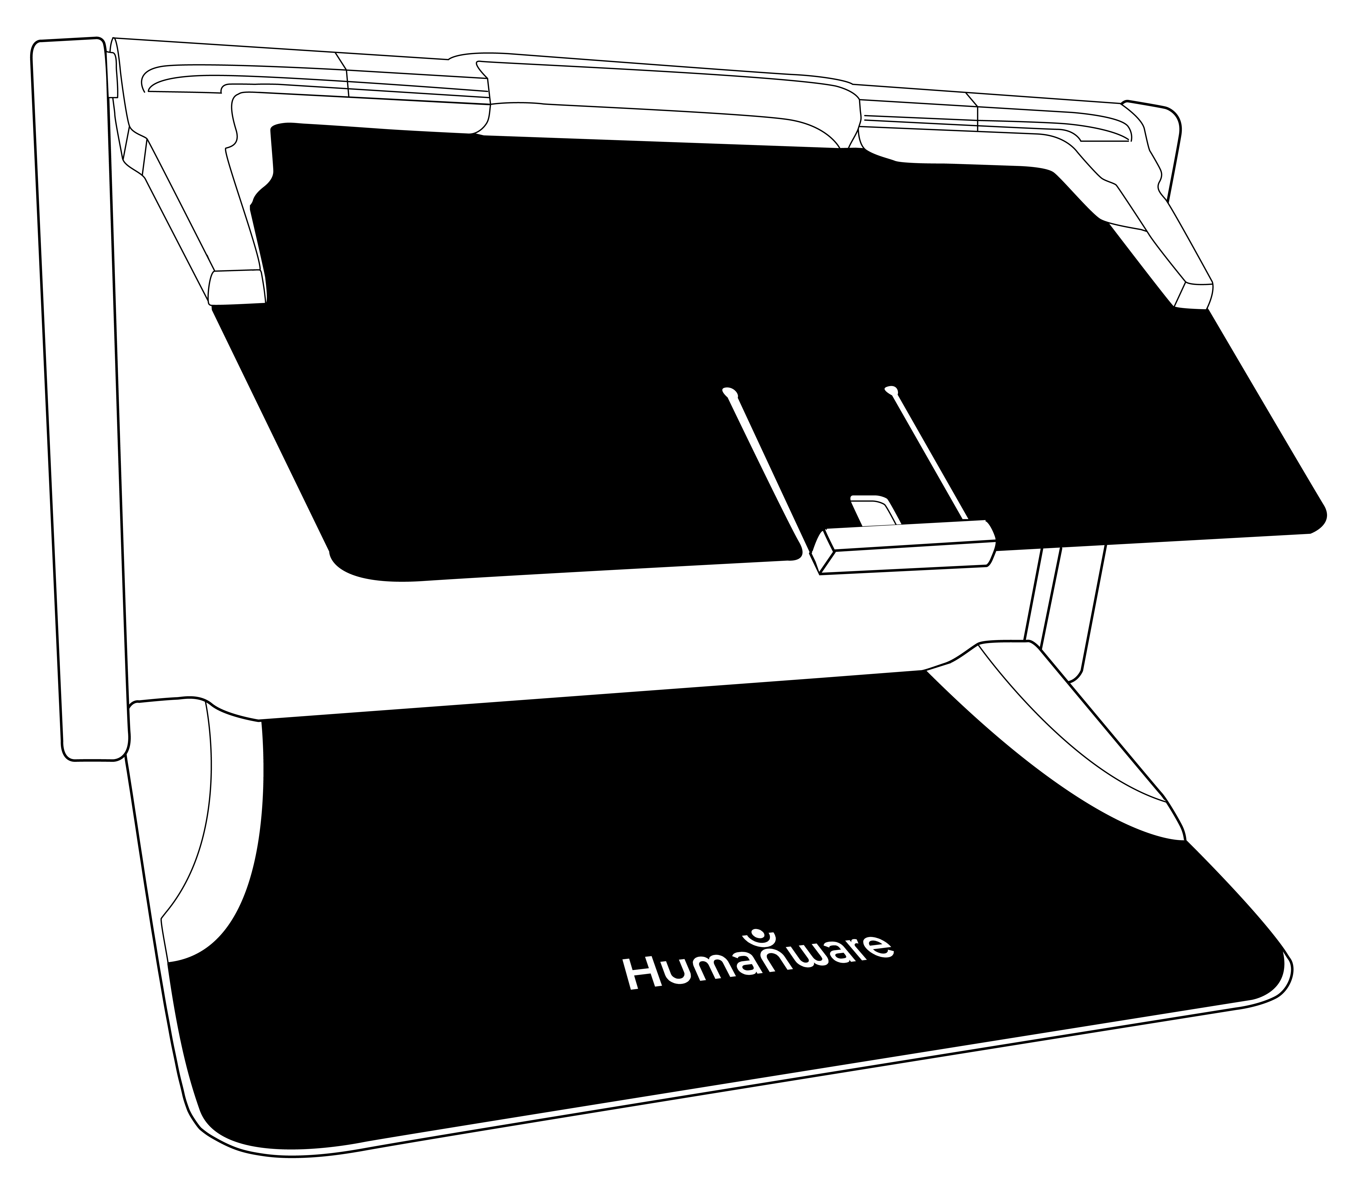
- Hold your tablet with the screen facing you, ensuring the HumanWare logo is at the top. Carefully insert the tablet into the slot and slide it forward until you reach the back end of the slot. Push the bottom part of the tablet down; you will hear a click indicating that your tablet is locked into place.
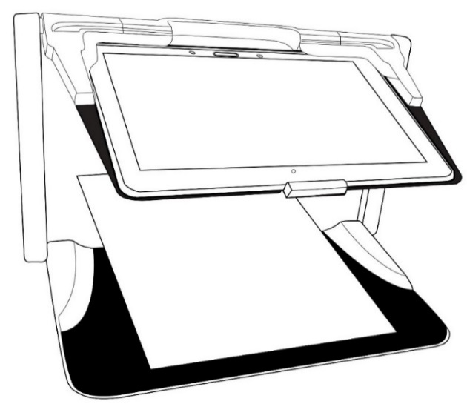

- Connect the USB Cable to the Power Adapter.

- Carefully connect the cable to the USB-C port and plug it into an outlet. The USB-C port is located on the left side of the tablet.
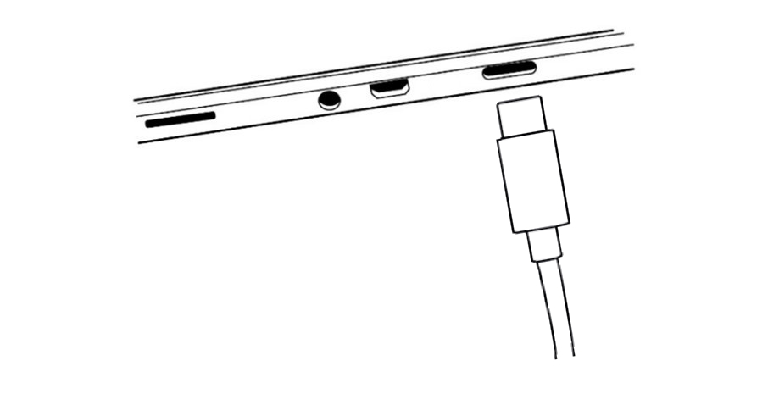
IMPORTANT:
- Only use power adapter and cable supplied with Connect 12.
- Use caution while inserting the cable into the USB-C Port.
- Do not close your folding stand with your tablet in it when the USB cable is plugged in; this will damage the USB cable and/or tablet.

- Charge the battery to full capacity (initial charge is 8 hours).

- Press and hold the Power button to power On your tablet. The tablet will take approximately 45 seconds to initialize. The HumanWare and Android logos will appear on the screen.

- You will now be prompted through several setup wizards.

IMPORTANT: Visual accessibility settings are available before completing the wizards. Be sure to tap “Vision Settings” at the bottom of the screen and make any required adjustments prior to entering the wizard.

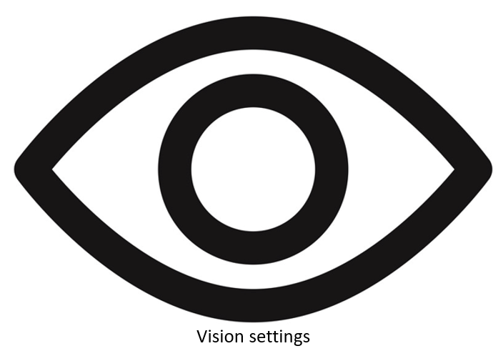

For more information on using your Connect 12, Android, and Prodigi software, refer to the User Guide.

Customer support

For customer support, please contact the HumanWare office nearest you or visit our website at:
www.humanware.com/connectsupport

Global: support@humanware.com

North America: 1 (800) 722-3393
us.support@humanware.com

Europe: (0044) 1933 415 800
eu.sales@humanware.com
Australia / Asia: (02) 9686 2600
au.sales@humanware.com
ACCD-0314
REV 03

