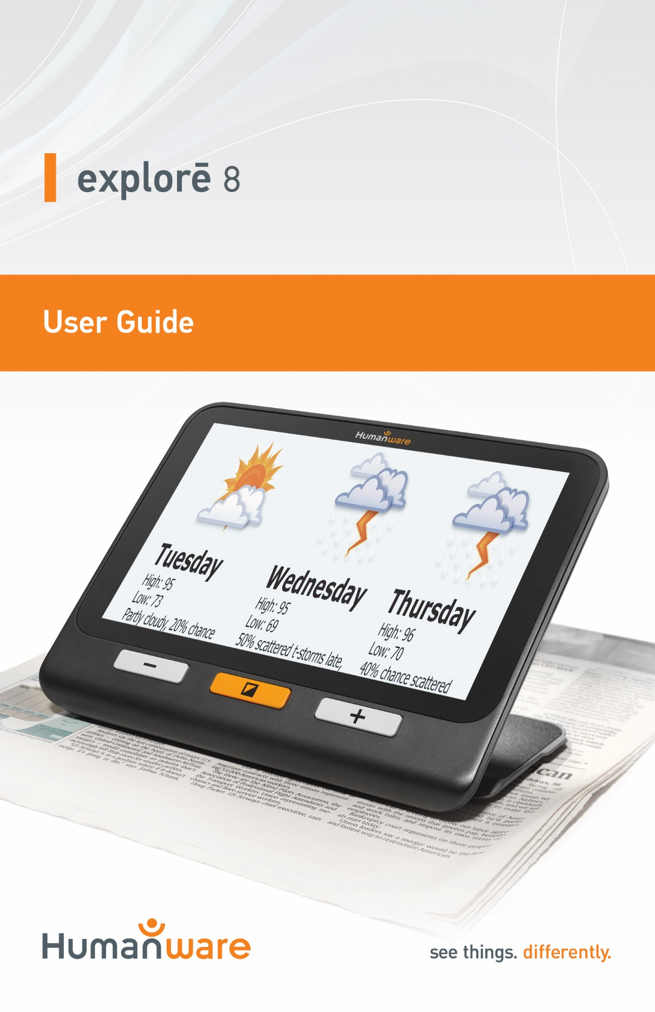

Table of Contents
Chapter 1 – Overview 3
Introduction 3
Box Contents 4
Physical Description 5
Getting Started 7
Chapter 2 – Using Your System 8
Powering On 8
Powering Off 9
Magnifier Mode 9
Zooming In and Out 9
Changing Contrast 10
Turning off and on the lights 10
Lines and Blinds 11
Autofocus 11
Freezing an Image 12
Navigating on a Frozen Image 13
Gallery Mode 13
Accessing the Gallery 14
Deleting Images from Gallery 15
Using an External Screen 16
Chapter 3 – Exporting Images to Computer 16
Chapter 4 – Menu 17
Accessing the Menu and Changing Settings 17
Chapter 5 – Updating Your System 21
Chapter 6 – Recharging Your System 22
Chapter 7 – Troubleshooting 24
Appendix A – Safety and Maintenance 27
Appendix B – Specs 30
Appendix C – FCC Info 31
Appendix D – Warranty 33

Chapter 1 – Overview

Introduction
Thank you for purchasing the HumanWare explorē 8, the light and easy to use portable electronic handheld magnifier with a large, easy to read 8” screen. With your explorē 8, you’ll be reading those fine prints in a matter of seconds.
Being magnifier users ourselves, we at HumanWare know that in addition to the best available image quality, a good magnifier needs to be simple, portable, comfortable to use, and should always be ready when you need it, where you need it. Your explorē 8 was designed with just that in mind, for we take great pride in offering you a quality product that will meet both your needs and expectations. Carefully read the operating and safety instructions described in this user guide prior to using your device. If you have any questions about your system, please contact HumanWare Customer Service by consulting the contact information in the back of this user guide.
Copyright 2019 by Technologies HumanWare Inc., all rights reserved. No part of this publication may be reproduced or distributed in any form or by any means, or stored in a database or retrieval system, without the prior written permission of Technologies HumanWare Inc.

Box Contents
- explorē 8 electronic magnifier | - Product registration card
- USB charger | - Warranty card
- USB cable | - Protective case
- High-Resolution video cable | - LCD protector
- User Guide | - Microfiber cloth

Physical Description
Front face
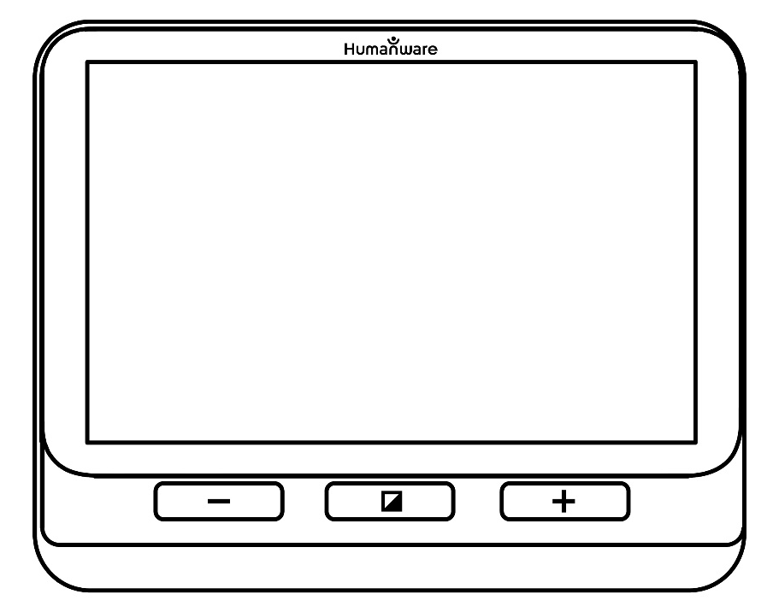
Zoom+
Contrast
Zoom-
Left side
High-Resolution video
Power
USB

Top edge
Freeze

Back side
LEDs

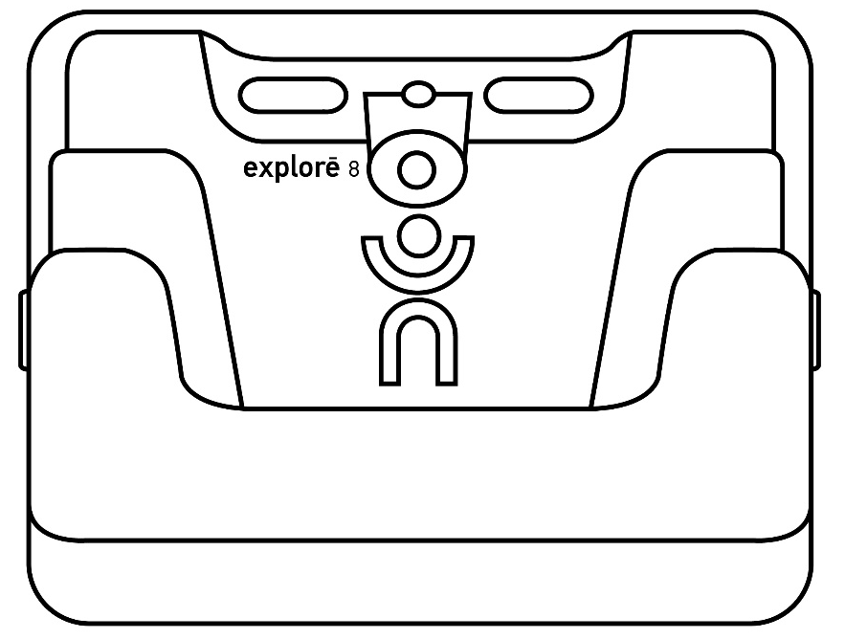
Cameras
Stand

Getting Started
- Connect the USB cable to the USB charger.
- Hold explorē 8 so that the screen side is facing you. Make sure the tactile USB symbol on the cable’s USB connector is on the opposite side of the screen. Carefully connect the cable to the USB port located on the left side of your device and plug the charger into an outlet.
IMPORTANT: Use caution while inserting the cable into the USB port.
- Let your device recharge until your battery is full. The device will become warmer during the charge – this is normal.
- Once the device is fully charged, carefully disconnect the cable.
- Press Power or unfold the reading stand to start using the device.

Chapter 2 – Using Your System

Powering On
To start your magnifier, simply press Power on the left side of the device. The device can then be held by the sides, just like you would hold a tablet.
Alternatively, you can turn on your device by simply unfolding the reading stand behind the device and placing it over what you wish to read.
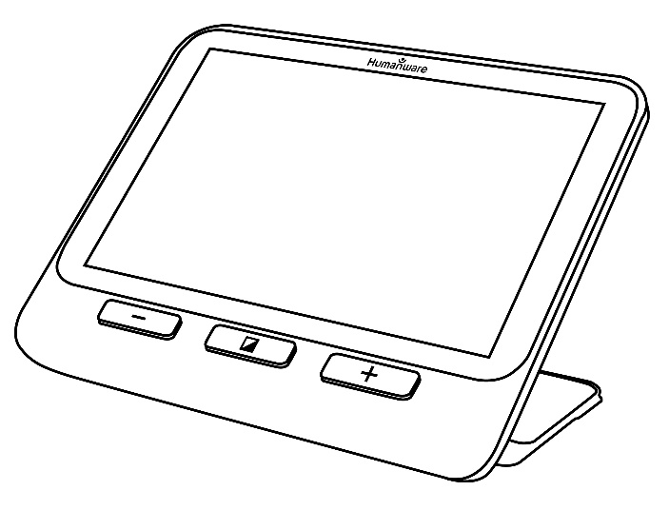
After a few seconds, the explorē 8 screen will turn on and display the image from the camera. This is the magnifier mode.

Powering Off
To turn off your device, simply press Power.

Magnifier Mode
Magnifier mode is explorē 8’s main mode of operation. With the stand closed, you will be able to magnify distant objects. With the stand open, you will be able to magnify close objects or documents on a table.

Zooming In and Out
To zoom in, simply press or press and hold Zoom+ until the image is of the appropriate size. Similarly, you can zoom out by pressing or pressing and holding Zoom- until you are satisfied with the image size.
Alternatively, you can enable the pinch and zoom gesture (decrease and increase the distance between two fingers) from the menu to zoom in and out of a live image (see Ch. 4).

Changing Contrast
explorē 8 allows you to customize contrast to better suit your needs and preferences. Simply press Contrast to change contrast until you find one you are comfortable with.
The available contrast modes are listed below:
- Full color, Black on white, White on black, Black on yellow, Yellow on black
Other contrast modes are also available from the menu (see Ch. 4):
- Black on orange, Orange on black, Black on cyan, Cyan on black, Black on purple, Purple on black, Black on green, Green on black, Blue on yellow, Yellow on blue, White on blue, Blue on white

Turning off and on the lights
Press and hold Zoom+ and Zoom- simultaneously to turn off the lights if necessary, and to turn them back on.

Lines and Blinds
With the explorē 8, you can add a horizontal line or blinds over your image for easier reading.
To add or remove a line, press and hold Contrast and Zoom+ simultaneously.
To add or remove blinds, press and hold Contrast and Zoom- simultaneously.

Autofocus
explorē 8 features an autofocus that can be set to locked, unlocked, and manual from the menu (see Ch. 4).
When autofocus is set to unlocked (by default), explorē 8 will dynamically adjust its focus to the object currently being viewed. The focus can be forced by touching anywhere in the screen.
When autofocus is set to locked, or you are using your magnifier in tabletop position, explorē 8 will maintain its current focus regardless of any movements or changes.
When autofocus is set to manual, you can touch any position on the screen to have explorē 8 focus on that particular location. Note that the manual setting only works in distance viewing mode. Tabletop mode will continue to be locked when manual mode is selected.

Freezing an Image
explorē 8 enables you to freeze an image while in magnifier mode for easier reading, an especially useful feature when reading labels on products on stores’ top shelves. To freeze an image, simply press Freeze while aligning your magnifier towards what you wish to read. This will take a snapshot of what your device was oriented towards. The snapshot will be displayed on your screen until you decide to return to Magnifier mode.
To return to magnifier mode, simply press Freeze once again.

Navigating on a Frozen Image
To zoom in on still images, simply press or press and hold Zoom+ until the image is of the appropriate size. Similarly, you can zoom out by pressing or pressing and holding Zoom- until you are satisfied with the image size.
Alternatively, you can enable the pinch and zoom gesture (decrease and increase the distance between two fingers) from the menu to zoom in and out of a frozen image (see Ch. 4).
Hold your finger down and slide it across the screen to see other parts of a frozen image.
As for a live image, press Contrast to change contrast until you find one you are comfortable with.

Gallery Mode
To save a live or frozen image to your Gallery, simply press and hold Freeze for a half-second while in Magnifier mode. You should see a Save message displayed briefly on your screen meaning your image is now saved inside explorē 8’s Gallery.
Alternatively, you can enable the tap and hold gesture (keep your finger down on the screen) from the menu to save an image in the Gallery (see Ch. 4).

Accessing the Gallery
To access your images in the Gallery, press Contrast and Freeze simultaneously. Swipe your finger left or right on the screen to select an image. You can also press the arrows on the screen to select an image.
You can zoom in and out of saved images by pressing or pressing and holding Zoom+ and Zoom-. Alternatively, you can enable the pinch and zoom gesture (decrease and increase the distance between two fingers) from the menu to zoom in and out of a saved image (see Ch. 4).
To exit the Gallery and return to Magnifier mode, press Back (on screen) or press and hold Contrast.

Deleting Images from Gallery
To delete an image from the Gallery, access the Gallery and navigate to the image you wish to delete (by swiping your finger left or right on the screen or using the arrow buttons), then press and hold Freeze.
Alternatively, you can enable the tap and hold gesture (keep your finger down on the screen) from the menu to delete an image (see Ch. 4).
You will have the option to Delete or Cancel. Press Delete to confirm deletion. To cancel deletion, press Cancel or Contrast.
You can delete all your images at once from the menu (see Ch. 4). Press and hold Contrast and select Delete Gallery.

Using an External Screen
For a larger image, you may want explorē 8’s content to be displayed on an external screen (like a TV). To do so, simply connect your explorē 8 to an external screen using the included High-Resolution video cable. Please refer to Appendix B for a list of supported High-Resolution video formats.

Chapter 3 – Exporting Images to Computer
To export Gallery images saved on explorē 8 to your computer, connect your device to your computer with the USB cable provided. You should see a “PC connected” message appear on your device. You can now copy and paste the images from your Gallery to your computer using your computer’s file browser.
When connected to a personal computer, the device will act exactly like a USB thumb drive or an external drive. Gallery images are located in the Images folder on your explorē 8.
When you are copying or deleting images from the device, never disconnect the USB cable as some images could be lost in the process.

Chapter 4 – Menu

Accessing the Menu and Changing Settings
Press and hold Contrast to enter the menu. You can navigate the menu by swiping up or down with your finger on the screen, pressing the up/down arrows on the screen, or pressing Zoom+ to scroll up and Zoom- to scroll down. You can also press the up and down arrows on the screen.
To select an item, press on it. To go back to the previous menu, press Contrast or Back. Press Contrast again to return to Magnifier mode. To quickly exit the menu, press and hold Contrast or Back.
The menu contains the following items:
- Gallery (Access Gallery images)
- Autofocus: Unlocked*, Locked (Locked* in stand mode), Manual (Locked in stand mode)
- Screen Brightness (Change the screen’s brightness level): 1 to 9 (8*)
- Touchscreen (submenu, tap to enable gestures and vibrations)
- Pinch & zoom (decrease/increase distance between two fingers to zoom out/in)
- Vibrations
- Tap & hold (hold finger down in Magnifier to save image to Gallery)
- Auto-off (Choose how long the device stays on): 1 minute, 2 minutes, 5 minutes*, 10 minutes
- Preferred Zoom (Change the default zoom level when you open your device): Previous (the zoom level you were at when you closed your device), 2x* to 30x
- Contrast (submenu)
  - Preferred Contrast (select contrast in which your explorē 8 starts up): Previous* (last used contrast), Color, enabled contrasts
  - Menu (change menu colors): Black on white*, White on black, Black on yellow, Yellow on black, Black on orange, Orange on black, Black on cyan, Cyan on black, Black on purple, Purple on black, Black on green, Green on black, Blue on yellow, Yellow on blue, White on blue, Blue on white
  - Enabled contrasts (select enabled color pairs for magnifier mode): Black on white*, White on black, Black on yellow, Yellow on black, Black on orange, Orange on black, Black on cyan, Cyan on black, Black on purple, Purple on black, Black on green, Green on black, Blue on yellow, Yellow on blue, White on blue, Blue on white
- Lines and blinds: Line, Blinds, None*
- Lights: On*, Low, Off
- Menu Text Size: Small, Medium*, Large
- Language: English US*, English UK, French (CA), French (FR), Spanish (US), Spanish (ES), German, Dutch, Danish Polish, Portuguese (PT), Portuguese (BR), Norwegian, Italian, Swedish, Finnish, Russian, Czech, Japanese, Korean, Icelandic, Estonian, Turkish, Lithuanian, Hungarian, Latvian, Arabic, Chinese (Simplified), Chinese (Traditional), Hebrew, Georgian, Farsi, Kurdish
- Display: 50Hz , 60Hz*
- Delete Gallery
- Factory Defaults
- About (View information about your device): Date and time, Software, Hardware, Serial Number

Chapter 5 – Updating Your System
First, go to:
http://support.humanware.com/en-canada/support/explore
Then, download the latest version of the explorē 8 software. Connect your device to your computer using the provided USB cable. Using your computer’s file explorer, paste your downloaded file directly into your explorē 8 root. When the transfer is completed, unplug your USB cable from your computer. Restart your explorē 8. Your device should automatically update itself.

Chapter 6 – Recharging Your System
IMPORTANT: The battery becomes warm during recharging. This is normal. Do not recharge the battery near a heat source.
To recharge the battery using a household power outlet:
- Connect the USB cable to explorē 8’s USB charger. Then, carefully connect the USB cable to your device and plug the charger to an outlet.
- Let your device charge until your battery is full. It should take approximately 3.5 hours to recharge an empty device.
During the recharge process, the image below will show momentarily when the battery starts charging or when the device is turned on.
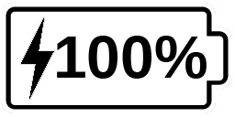
The lightning bolt icon means your device is being charged. The number to the right represents the percentage of battery charge remaining.
Due to lower voltage, charging from the computer USB may be slower. In some cases, your device may not charge at all depending on the amount of power supplied by the computer. The most effective way to recharge the device is to use the supplied USB cable connected to the USB charger and recharge it from a household power outlet.
Although it may lengthen the charging time, the device can be used when it is recharging.
Please note that if the battery is fully discharged or hasn’t been used for a very long period, there will be a delay of up to a few minutes before the device shows any activity. This is normal.
Also note that like all electronic devices, your explorē 8 will become warm when in use or when being charged – this is normal.
Battery safety precautions:
- Do not disassemble or modify the battery.
- Use only the specified HumanWare charger.
There is a risk of overheating, fire or explosion if the battery is put in a fire, heated, subjected to impact, put in contact with water, or if its terminals are shorted.

Chapter 7 – Troubleshooting
explorē 8 does not power on:
Press and hold Power. If the unit still does not turn on, your device’s battery may need recharging.
Connect the provided USB cable with the USB charger into a power outlet or just the USB cable into a running computer. If the battery was completely discharged, it may take a few minutes before the device shows any signs of activity (see Ch. 6 for more info).
Screen is black:
If the unit is laying on a table or any flat surface, the image may be black. Lift your magnifier to see whether this is the reason why your screen is black.
If this does not solve the problem, try restarting your device.
Image is out of focus in magnifier:
Make sure Autofocus is set to Unlocked in the menu. Move the device back and forth over the document you are viewing. This will make explorē 8 re-focus on the document.
explorē 8 shuts down after inactivity:
This is a normal behaviour intended to preserve the battery. By default, explorē 8 will shut down after 5 minutes of inactivity. It is possible to configure the default auto-off timer to 1 minute, 2 minutes, 5 minutes or 10 minutes.

Colors are difficult to detect:
First make sure there is sufficient ambient light around you.
Choose a different color combination by pressing Contrast while in magnifier mode.
There is a lot of glare:
Tilt the object you are looking at in a different direction to reduce glare. You can also try turning off the lights by pressing and holding Zoom+ and Zoom- simultaneously.
explorē 8 does not respond:
Make sure explorē 8 is not connected to power via USB cable; if it is, unplug it. Press Power for 10 seconds. The system will shut down. Then, press Power for one second to turn explorē 8 back on.
Other problems:
Restore to factory defaults in the menu.
Press and hold Contrast. Scroll down to Factory Defaults and select Yes.

Appendix A – Safety and Maintenance
You must not stare at the LED light source located on the back side of the magnifier.
Keep away from water or high humidity. Do not submerge.
Power off your explorē 8 before cleaning it.
Use only cables provided with your explorē 8.
Battery:
The explorē 8 has an internal rechargeable Li-Ion battery. The battery must be replaced by a qualified HumanWare technician.
- Do not use or leave the unit near heat source and fire. Do not store in high temperatures.
- Only use USB-compliant power supplies to charge the battery.
- Do not disassemble or modify the unit.
- Do not immerse the unit in water, do not allow it to get wet.
- Do not strike or throw the unit.
- Do not pierce or strike the unit with sharp objects or a hammer.
- If the battery leaks and liquid gets into the eyes, do not rub eyes. Instead, rinse the eyes with clean running water and seek immediate medical attention to prevent injury.
- If the battery leaks and comes into contact with skin, immediately rinse area with clean running water to prevent injury.
Cleaning the LCD screen:
Make sure your device is off and unplugged.
Make sure you only use microfiber cloths to clean the LCD screen like the one included with your device.
Carefully and gently wipe the microfiber cloth across the LCD screen.
If you choose to clean your LCD screen with a liquid cleaner, make sure this cleaner is appropriate for LCD screens. Distilled water, isopropyl alcohol and a vinegar-water solutions (no more than 10% vinegar) are safe cleaning liquids for your LCD screen.
Use only the minimal amount of liquid to prevent spills inside the device. If liquid seeps in, damages to the device might occur. Make sure no liquids remain on your screen. Repeat the previous steps for spots that are harder to remove.
Never use household cleaners to clean your explorē 8.
Never spray any liquid directly on your LCD screen.
Never use cleaning products that contain ethyl alcohol, ethyl acid, ammonia, acetone or methyl chloride.
Never use paper towel to clean your LCD screen.

Appendix B – Specs
Size: 24 x 204 x 153.2 mm
Display: 8’’ ISP LCD
Weight: 580 g
Power Input: USB Type C connector. 5V@3A, 9V@2A or 12V@1.5A
Battery life: 4.5 hours
Charge Time: 2 hours (when device is off)
Supported High-Resolution video formats:
1280x720p 60Hz, 50Hz
No support of DVI emulation
Operating conditions:
Temperature: 10 ˚C to 40 ˚C / 50 ˚F to 104 ˚F
Humidity: 20% to 80%
Transport and storage conditions:
Temperature: -20 ˚C to 60 ˚C / -4 ˚F to 140 ˚F
Humidity: 10% to 95%

Appendix C – FCC Info
FCC Statement:
This device complies with part 15 of the FCC Rules. Operation is subject to the following two conditions: (1) This device may not cause harmful interference, and (2) this device must accept any interference received, including interference that may cause undesired operation.
FCC Warning:
Changes or modifications not expressly approved by the party responsible for compliance could void the user's authority to operate the equipment.
Note: This equipment has been tested and found to comply with the limits for a Class B digital device, pursuant to part 15 of the FCC Rules. These limits are designed to provide reasonable protection against harmful interference in a residential installation. This equipment generates, uses and can radiate radio frequency energy and, if not installed and used in accordance with the instructions, may cause harmful interference to radio communications. However, there is no guarantee that interference will not occur in a particular installation. If this equipment does cause harmful interference to radio or television reception, which can be determined by turning the equipment off and on, the user is encouraged to try to correct the interference by one or more of the following measures:
—Reorient or relocate the receiving antenna.
—Increase the separation between the equipment and receiver.
—Connect the equipment into an outlet on a circuit different from that to which the receiver is connected.
—Consult the dealer or an experienced radio/TV technician for help.
Note: This unit was tested with shielded cables on the peripheral devices. Shielded cables must be used with the unit to ensure compliance.

Appendix D – Warranty
HumanWare warrants explorē 8, effective from the date of purchase, to be free of any defects in material and workmanship for a period of 2 years unless otherwise required by law in the country or region of purchase.
This warranty is non-transferable and applies to all cases where the damage is not a result of improper use, mistreatment, or negligence. Improper use is use of this device other than described in this manual. In no event shall HumanWare or its distributors be liable for indirect or consequential damages.
No replacement or repair covered by the warranty will be carried out unless the system is accompanied by a copy of the original bill of purchase. Please keep your original receipt. If the system has to be returned, please use the original packaging.
[End of document VER-10-2019-10-18]

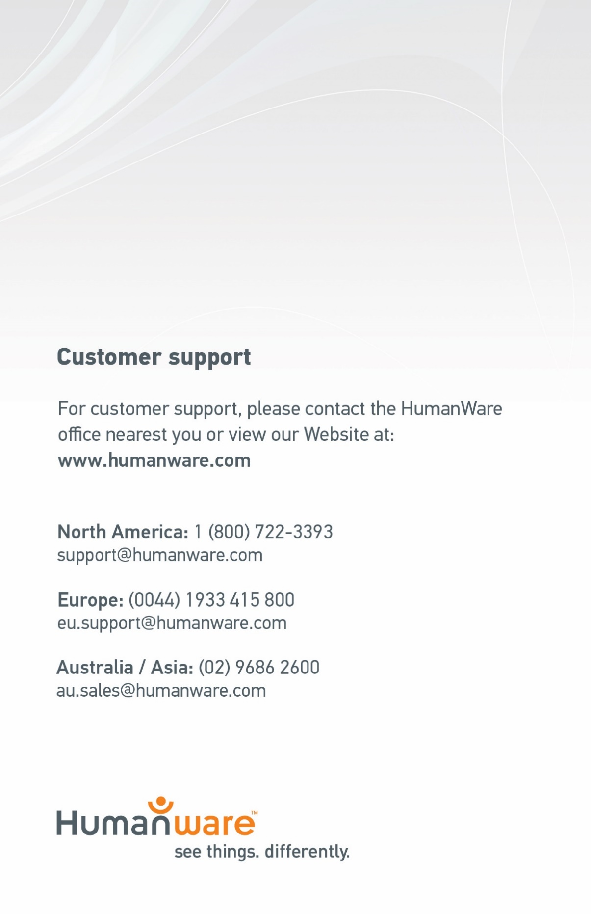

ACCD-0186
REV 10

ACCD-0186
REV 04

ACCD-0186
REV 02

