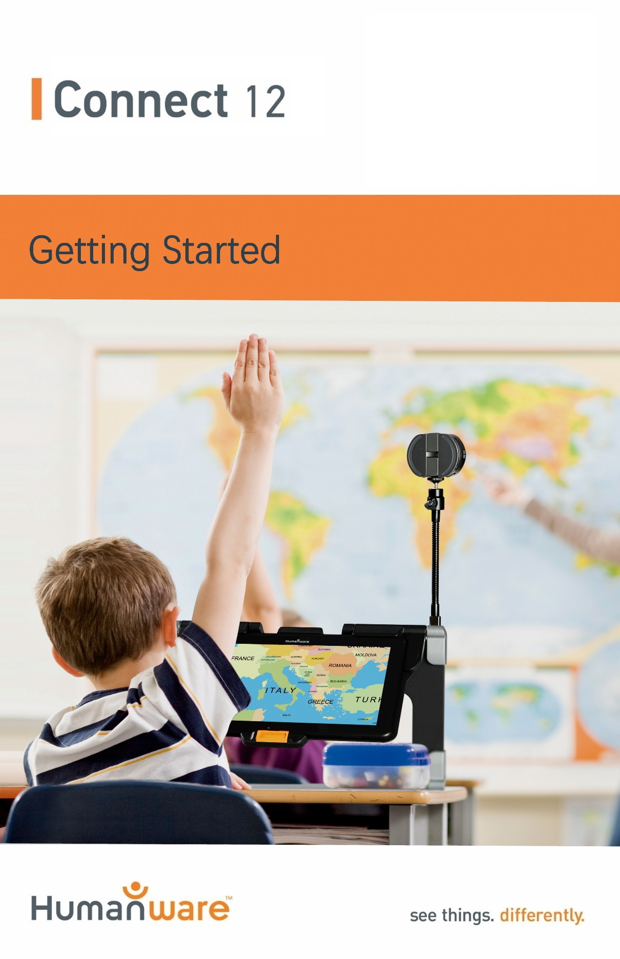

Getting Started
- On a flat and stable surface, hold your Connect 12 stand in an upright position making sure the panel with the word “Connect” is facing towards the back. Hold the handle with one hand, and unfold the lower panel with your other hand until it is flat on the table.
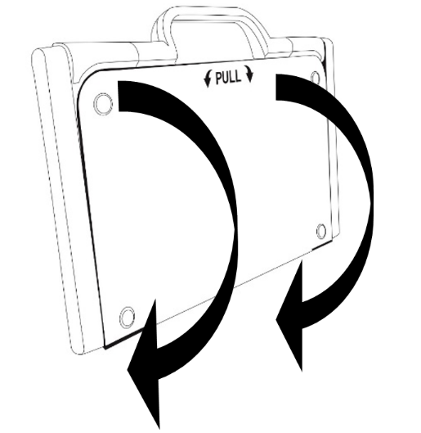

- Next, unfold the top panel until it is roughly parallel with the lower panel.
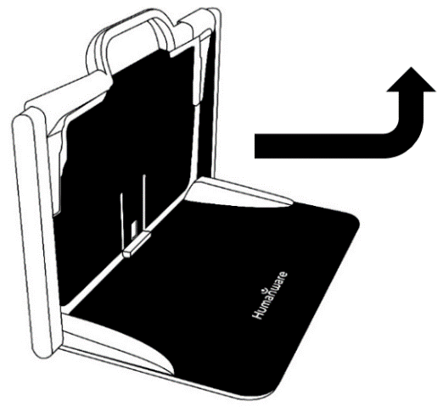
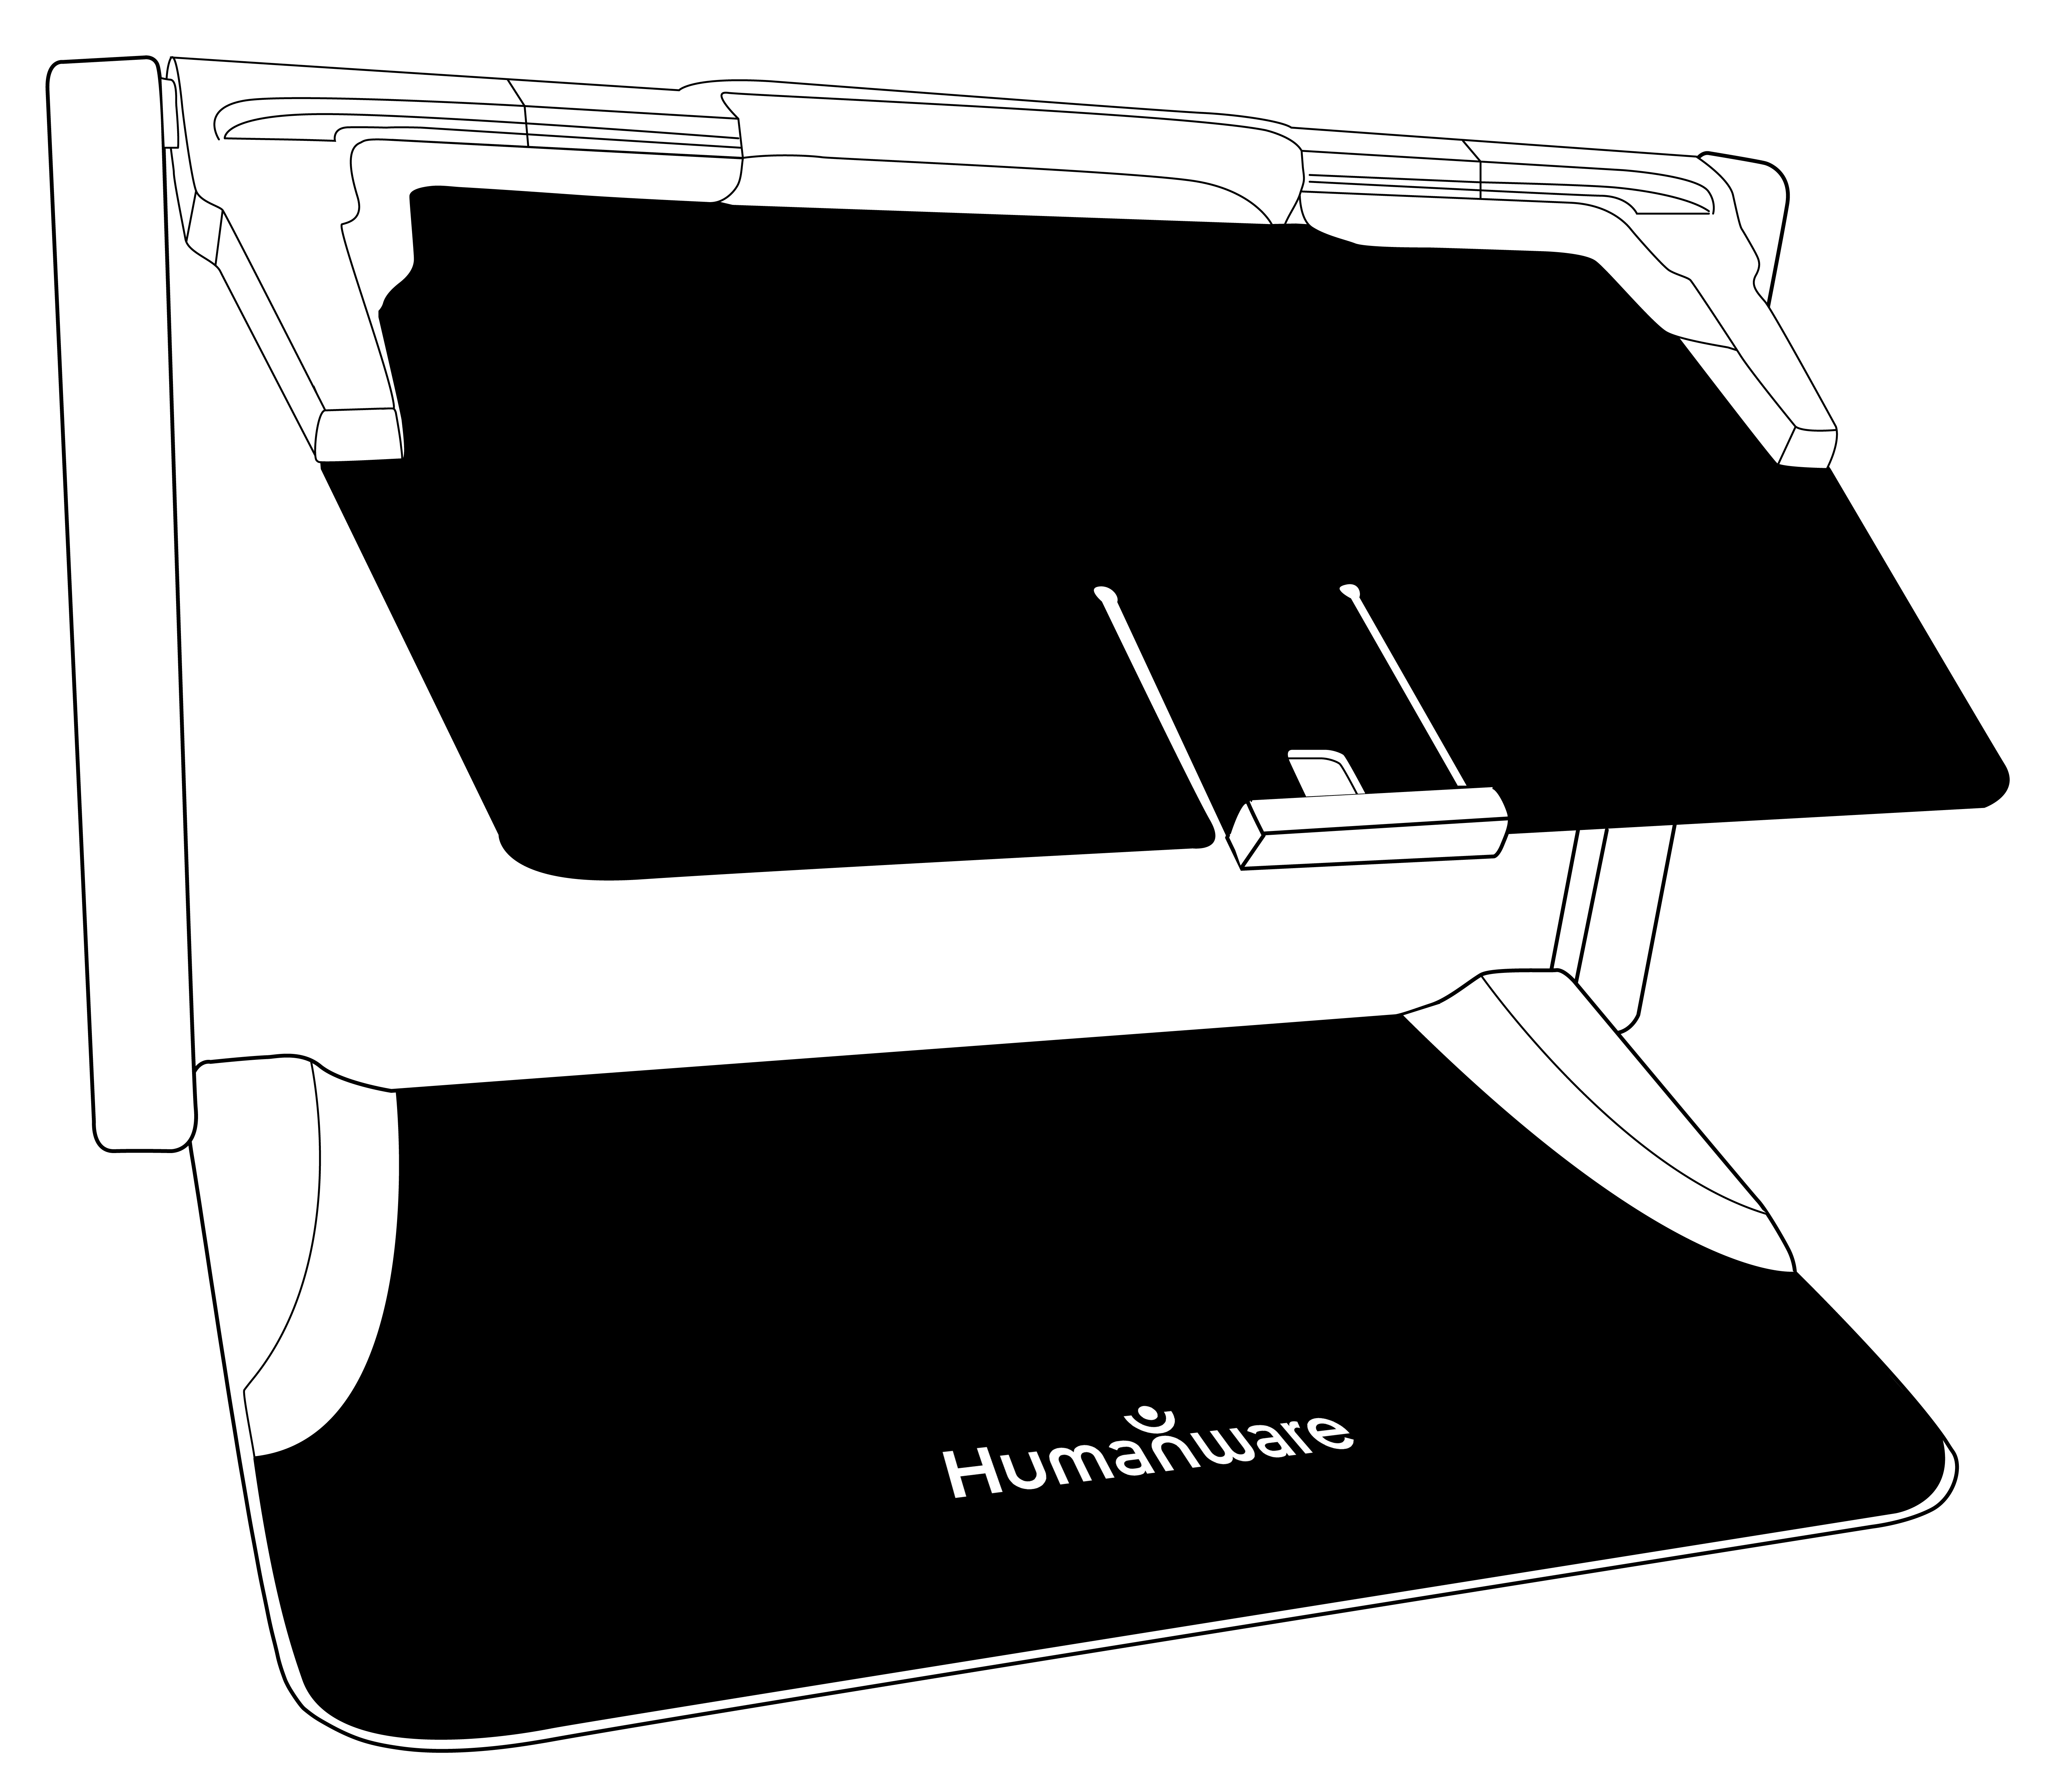
- Hold your tablet with the screen side facing you, making sure the HumanWare logo is at the top. Carefully insert your tablet into the slot and slide it forward until you reach the back end of the slot. Push the bottom part of the tablet down; you will hear a click indicating that your tablet is fastened.
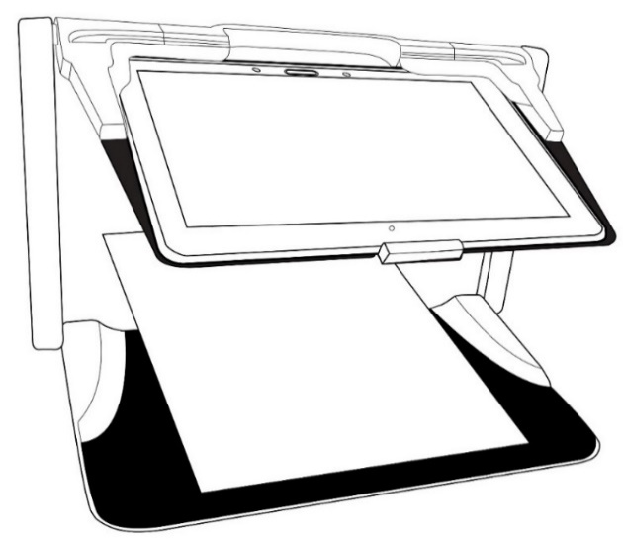

- Connect the USB Cable to the Power Supply.
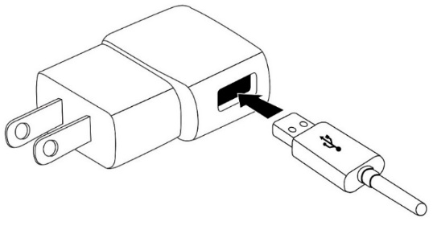
- Carefully connect the cable to the USB-C port and plug it to an outlet. The USB-C port is located on the left side of the tablet.
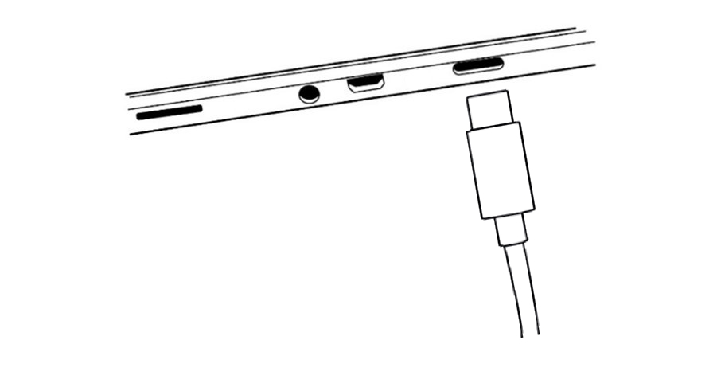
IMPORTANT: Use caution while inserting the cable into the USB-C Port.
IMPORTANT: Do not close your folding stand with your tablet in it when the USB cable is plugged in. You could damage the USB cable or tablet.
- Allow the tablet to charge until the battery is full (initial charge is 8 hours).

- Press and hold the Power button to power on your tablet. Your tablet will take about 30 seconds to initialize. The HumanWare and Android logos will appear on the screen.

- You will now be guided through several setup wizards. IMPORTANT NOTE BEFORE STARTING, visual accessibility settings are available for use before completing the wizards. Please be sure to tap “Vision settings” at the bottom of the screen and make any required adjustments prior to entering the wizard.

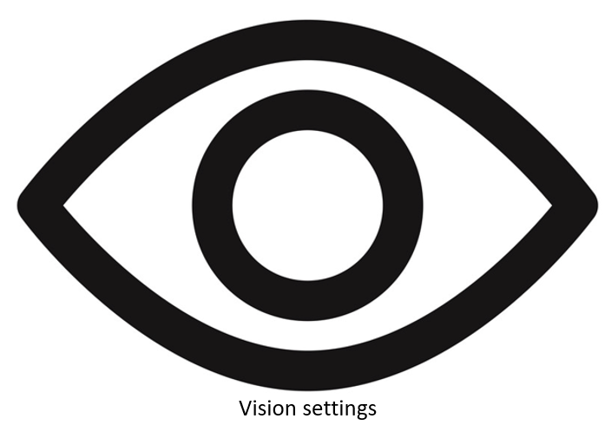

For more information on how to use your Connect 12, Android, and the Prodigi software, please refer to the User Guide.

Customer support

For customer support, please contact the HumanWare office nearest you or visit our website at:
www.humanware.com/connectsupport

Global: support@humanware.com

North America: 1 (800) 722-3393
us.support@humanware.com

Europe: (0044) 1933 415 800
eu.sales@humanware.com
Australia / Asia: (02) 9686 2600
au.sales@humanware.com
ACCD-0314
REV 02

