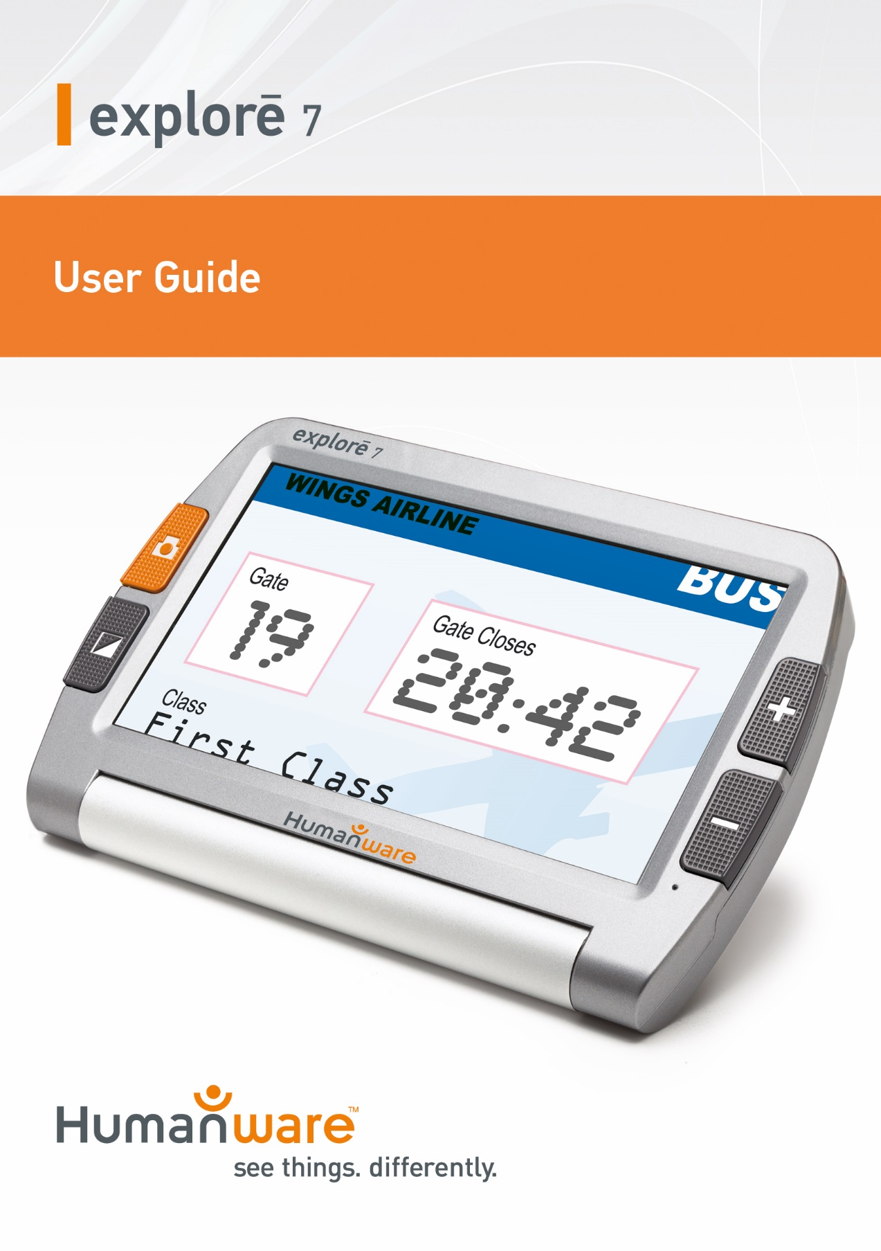

Introduction 1
1. Parts and Accessories 2
2. Structure 2
3. Using your explorē 7 4
3.1 Operating your explorē 7 4
3.1.1 Power on/off 4
3.1.2 Zoom In/Zoom Out 5
3.1.3 Contrast color mode and Camera function 5
3.1.4 Brightness Adjustment 7
3.1.5 Freeze Function 7
3.1.6 Setting memory function 8
3.1.7 Power saving function 8
3.1.8 High-Resolution video output function 8
3.1.9 Distance View/ Close View function 8
4. Troubleshooting 9
5. Safety Guide 10
6. Technical Specifications 11

Introduction
explorē 7 is a big screen, HD, handheld electronic magnifier for near and distance viewing. With its 7-inch HD and high contrast display screen, explorē 7 is the perfect companion to help you see better, and farther. And for an even larger and clearer image, it even features a High-Resolution video output and cable you can connect easily connect to your TV.
With a viewing range between 6.8 cm and 600 cm and a rotatable camera that makes it easy to change between distance and near viewing, your explorē 7 will soon become an integral part of your daily routine.

1. Parts and Accessories
Accessories | Qty
Video magnifier | 1
AC power adapter | 1
High-Resolution video cable | 1
User Manual | 1
Protective case | 1

2. Structure
Zoom Out
Power Indicator
Zoom In
Freeze Button
Color Mode
7 inch
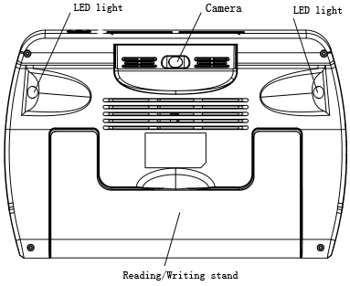

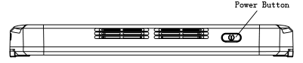

3. Using your explorē 7

3.1 Operating your explorē 7

3.1.1 Power on/off
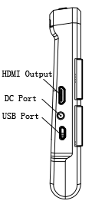
High-Resolution video output
- To turn on the device, press and hold the power button for 3 seconds until a beep is heard. The screen will show the opening image for 2 seconds and then the unit will enter into video magnifier mode
- Press and hold the power button for 2 seconds to turn off.

3.1.2 Zoom In/Zoom Out
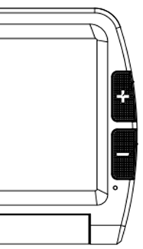
Zoom out
Zoom In
- Press the “+” button to zoom in, and press the “-”button to zoom out. You can choose the right and preferred magnification.

3.1.3 Contrast color mode and Camera function
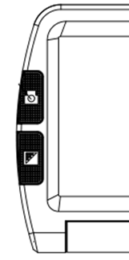
Contrast Color mode
- Normal mode and favorite modes are available for contrast color mode.
- Press and hold the contrast color mode button for 2 seconds to change between normal mode and favorite mode.
- In favorite mode, press the mode button to cycle through 3 basic modes: full color, your favorite contrast color and reverse (such as white on blue & blue on white).
- In Normal mode, press the mode button to cycle through the following 12 color modes:
- Full color
- Grey mode
- White text on black background mode
- Black text on white background mode
- White text on blue background mode
- Blue text on white background mode
- Yellow text on black background mode
- Black text on yellow background mode
- Blue text on yellow background mode
- Yellow text on blue background mode
- Green text on black background mode
- Black text on green background mode
- Press and hold the contrast color mode for 5 seconds to turn on/off the camera lights.

3.1.4 Brightness Adjustment
- Hold the “Freeze” button and “Zoom in ”button together to enter into brightness adjustment.
- A brightness bar shows, then press “Zoom in” to increase brightness and “Zoom out” to decrease it.

3.1.5 Freeze Function
Freeze Button
- Take the unit closer to have a better look at the object. You can also magnify or scale down images by pressing the zoom in and zoom out buttons, and switch contrast modes by pressing the Mode button.
- Press the Freeze button again to exit

3.1.6 Setting memory function
- The unit will memorize automatically the most recent settings (e.g. color mode, magnification, video output format, button beeps, brightness) and use them the next time your device is powered on.

3.1.7 Power saving function
In magnification mode, the unit will turn off automatically if not operated for 3 minutes.

3.1.8 High-Resolution video output function
- If the unit’s screen size is not large enough, you can use the TV output function to connect to the TV screen for magnification.
- Once the TV output is connected to the TV, turn the unit on. The image will automatically appear on the TV screen.

3.1.9 Distance View/ Close View function
- When you read paper materials such as books, you can select close view mode.
- When you want to see objects at certain distances, you can choose distance view mode.
- To switch between the distance view and close view modes, you simply need to rotate the camera.

4. Troubleshooting
Problem | Solutions
Black screen | - Make sure device is on.  - Make sure the camera lens is clean.  - Decrease magnification.
Unable to turn on device | - Make sure battery is in the device and that the battery is charged.  - Try to use the power adapter to turn on your device.  - Press and hold the power button and color mode button for 3 seconds to turn on
Image on screen is dark and twisted | - Make sure your reading material is laid flat.  - Make sure the camera lights are turned off.
Nothing is displayed after connecting to the TV | - Make sure the TV is on.  - Make sure the cable is correctly connected to the High-Resolution video output and to the TV.  - Make sure you are in the correct High-Resolution video output mode.
Unable to charge battery | - Make sure the power adapter is connected.
Blurry image | - Press and hold the Freeze button for 6 seconds to set the auto-focus.

5. Safety Guide
To keep the video magnifier in good conditions, please read the following safety guide carefully:
- Do not expose explorē 7 to excessive heat or direct sunlight to avoid the risk of fire.
- Keep device away from humidity, rain, liquid and chemicals.
- Do not use this magnifier near inadequately shielded medical devices.
- Only use explorē 7 within the 10°C and 40°C temperature range
- Do not try to repair the magnifier by yourself or open its case as this will void the warranty. Contact your dealer to service this equipment if necessary.
- Always unplug the system before cleaning it. Use a soft damp cloth to clean the exterior. Do not use cleaning agents or abrasive materials as they will damage your unit.
- Only use a compatible power adapter to charge the device, otherwise it will damage the unit.

6. Technical Specifications
- Magnification: 2.3X ~ 19X
- High contrast color modes: 12 modes (3 favorite color modes)
- Screen: 7-inch ISP LCD screen
- Camera: Auto focus: 5M pixels
- Continuous magnification: Select the suitable magnification
- Viewing distance: 6.8cm ~ 600cm (2.68~ 236.22“)
- Functions: Freeze image, Switch color mode, Zoom in/out
- Settings saved after power-off
- Power-Saving: IView7 HD turns off automatically if non-use in 3 minutes
- Connect to High-Resolution video/Monitor
- Power adapter: Input: 110—240V
- Continuous use: 5 hours maximum
- Charging time: 4~5 hours
- Total weight: < 440g
- Dimension: 195mm*139.5mm*25mm

