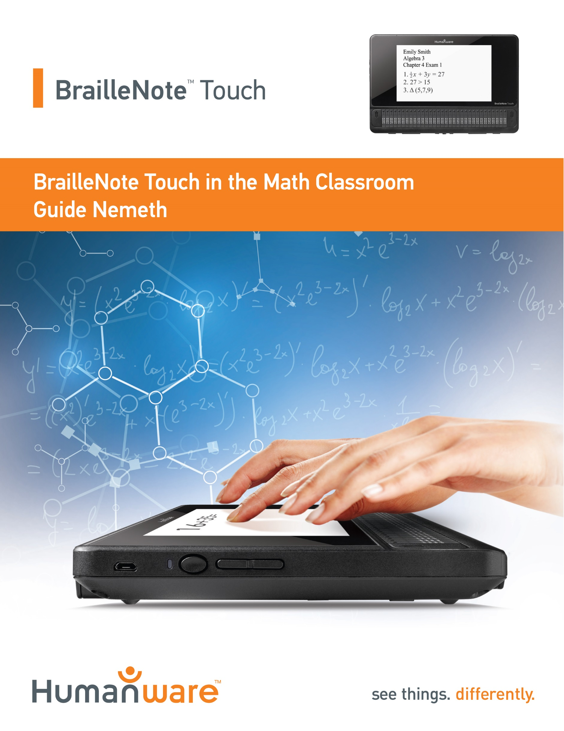
The BrailleNote Touch:
The Most Efficient Braille Tool in the Math Classroom

For the first time ever a portable Braille device can now provide real time Braille math to print translation in a math class. In the past, students would use tools such as a Braille writer to write their math in hard copy Braille. They would then hand the Braille copy to their teacher of the visually impaired, who would then spend a significant amount of time transcribing the print on top of the Braille copy for the classroom teacher. Once the assignment was finally turned in to the classroom teacher, the sighted students in the class typically had already received their assignment back, while the blind student would continue to wait for the teacher’s feedback.

The BrailleNote Touch makes this problem a thing of the past. This guide will walk you through:
- Creating a math assignment file
- Using the revolutionary KeyMath application to write math expressions in your preferred Braille code and instantly see the perfect-looking visual math
- Adding those print and Braille math expressions to your math assignment document
- Ultimately saving and printing out the final version to share with the classroom teacher

Creating a Math Assignment Document

Regardless of whether you plan on writing a literary document or a math assignment, the process to create a file is the same:

Let’s Create a Math Document:
- From the Main Menu, press your Next thumb key repeatedly to get to the Word Processor, and then press ENTER. Alternatively, just type a W followed by ENTER
- Using the Next and Previous thumb keys, navigate to the “Create” option and activate it. Alternatively you can just press C to jump to “Create” and press ENTER
- You are now immediately placed in a blank document
- Type your name, the date, and class and chapter number on the first three lines:
  - John Smith
  - 10/23/2016
  - Algebra 2 Chapter 7

Writing Braille Math:
Now to write the math content in your preferred Braille code you will need to switch to the BrailleNote Touch’s KeyMath app. This app is used to instantly translate the Braille math dots into perfect looking print math.

- Still in KeyWord, Press BACKSPACE with M (BACKSPACE with dots 1-3-4) to insert mathematics. Alternatively, you can find this feature in your context menu under “Editing Functions”
- Now you have been switched into KeyMath, a separate app designed specifically for converting Braille mathematics to perfect print math. You will notice KeyMath say that it is in Nemeth code by default. If you want this changed you will need to close the app completely from the recent apps list by holding the square button on the front of the Touch, navigating to KeyMath and pressing BACKSPACE with C to close it. Then, open KeyMath again from the All applications menu. From there, choose the settings item and activate the Preferred Braille code item and choose Nemeth, UEB or French Math
- Back in the KeyMath edit box, you can type the following expressions.
The following examples are using Nemeth math, if you wish to see the dot configurations for the UEB math code, please refer to the UEB version of this document.
- Type 22+5 = 27
  - (dots 3-4-5-6 dots, 2-3 dots, 2-3 dots, 3-4-6 dots, 2-6, space dots 4-6, dots 1-3 space, dots 3-4-5-6, dots 2-3,
dots 2-3-5-6).
- Type 82-7 = 75
  - (dots 3-4-5-6, dots 2-3-6, dots 2-6, dots 3-6,
dots 2-3-5-6 space, dots 4-6, dots 1-3 space, dots 3-4-5-6, dots 2-3-5-6, dots 2-6).
- Type 4 times 4 = 16
  - (dots 3-4-5-6, dots 2-5-6, dot 4, dots 1-6,
dots 2-5-6 space, dots 4-6, dots 1-3 space, dots 3-4-5-6,
dot 2 dots 2-3-5).
- Type 16 divided by 4 = 4
  - (dots 3-4-5-6, dot 2, dots 2-3-5, dots 4-6, dots 3-4,
dots 2-5-6 space, dots 4-6, dots 1-3 space, dots 3-4-5-6,
dots 2-5-6).

- Type 2X times 3x = 6x squared
  - (dots 3-4-5-6, dots 2-3, dots 1-3-4-6, dot 4, dots 1-6,
dots 2-5, dots 1-3-4-6 space, dots 4-6, dots 1-3 space,
dots 3-4-5-6, dots 2-3-5, dots 1-3-4-6, dots 4-5, dots 2-3).

- Type circle
  - (dots 1-2-4-6, dots 1-4)
- Type triangle
  - (dots 1-2-4-6, dots 2-3-4-5).
- Type 15 < 20
  - (dots 3-4-5-6, dot 2, dots 2-6, space dot 2, dots 4-6, space dots 2-3,
dots 3-5-6).
- Type 20 > 15
  - (dots 3-4-5-6, dots 2-3, dots 3-5-6 space, dots 4-6,
dot 2 space, dot 2, dots 2-6).
- Type 1 half plus 2 thirds equals 1 and 1 over 6
  - (dots 1-4-5-6, dot 2, dots 3-4, dots 2-3, dots 3-4-5-6 dots 3-4-6 space, dots 1-4-5-6, dots 2-3, dots 3-4,
dots 2-5, dots 3-4-5-6 space, dots 4-6, dots 1-3 space,
dots 3-4-5-6, dot 2, dots 4-5-6, dots 1-4-5-6, dot 2,
dots 3-4, dots 2-3-5, dots 4-5-6, dots 3-4-5-6).

If you forget how to write a specific Nemeth symbol, KeyMath’s Symbol Selector can help you find the one you are looking for. When typing your math, simply press BACKSPACE with dots 3-5 and the Symbol Selector offers you different symbol categories. Choose the appropriate category and desired symbol. After you press ENTER, it is inserted in your math content correctly.

Bringing the Math Expressions into Your KeyWord Document

Now that you have typed all your math expressions in KeyMath, you need to bring them over to your math assignment to be eventually printed for the classroom teacher. Do the following to paste both the print and Braille math into your KeyWord document:

- Press BACKSPACE with E (BACKSPACE with dots 1-5) to export all the math content you have written to your clipboard. Alternatively you can find this in your context menu by tapping your square button on the front of your Touch
- At this point, you will automatically be switched back to your KeyWord document. Position your cursor where you want the math content placed and press BACKSPACE with V (BACKSPACE with dots 1-2-3-6), to paste the math. You will see that an image has been pasted here with your Braille math dots visible in both print and Braille
- If a sighted person wants to validate that the visual math looks correct, press ENTER with V (ENTER with dots 1-2-3-6), to generate an instant visual preview, where they will see the math content
- Now that you are satisfied with your math assignment it needs to be saved. Press SPACE with S to save the file.
- You will be in a saving screen in the file name edit box. Type the name of your file such as “Math”. If you press your Previous thumb key you will see which folder the file is saved in. If you prefer to save in a different folder, navigate to and activate the “Location button”.
- When you are sure you know where your file is going, navigate to and activate the save button. Your math assignment is now a Microsoft Word file available for any sighted recipient

Providing a Print Copy

Now that the math assignment has been saved as a Microsoft Word document, this guide will walk you through three methods of providing it to a sighted classroom teacher.

- Printing the assignment directly to a print printer.
- Copying the file to a thumb drive.
- Attaching the assignment to an email and sending it to your classroom teacher.

Printing the Assignment to a Print Printer

Before you are able to print an assignment to a printer, you will need to be sure the BrailleNote Touch and the printer is connected to the same network, or connect the printer to the USB port of the BrailleNote Touch. Download an app supported by your brand of printer from the Play Store. We will use the example of setting up and preparing an HP printer.

- From the main menu, navigate to and activate the Play Store app. You can also type the letter P until Play Store is selected and press ENTER.
- Navigate to the Search item or type the letter S to quickly jump to “Search”, and press ENTER.
- If you have an HP printer type HP Print Service Plugin and press ENTER.
- Use the Next thumb key repeatedly to reach the Option button immediately following the app name and press ENTER.
- Navigate to the Install button and press ENTER.
- Type the letter A to select the Accept button and press ENTER. The app is now installed.

The next step in the printing process is to enable the printer service:
- From the main menu press SPACE with O (SPACE with dots 1-3-5) to reach the Options menu.
- Type the letter A to select Android System settings and press ENTER.
- Press the Next thumb key repeatedly until printing is selected and press ENTER. Alternatively, type a P to jump directly to printing.
- Press the Next thumb key to select HP Inc. off and press ENTER.
- Press the Next thumb key to select HP Inc. off switch. Press ENTER to check the check box.
- Type the letter O to jump to the Okay button and press ENTER.

Now it is time to print the document:
- From the Main Menu, navigate to the Word Processor and press ENTER. Alternatively, type the letter W to jump directly to it.
- Navigate to, or Type the letter P to select Print and press ENTER.
- Type SPACE with D (SPACE with dots 1-4-5), to jump directly to the drive list.
- Using your Next thumb key, navigate to the “Storage” option and press ENTER.
- Navigate to and choose the folder where you saved your math assignment and press ENTER.
- Navigate to the file you wish to print and press ENTER.
- Press ENTER to check the check box Drive PDF Viewer. Type the letter A to jump to the always button to always choose this PDF viewer and press ENTER.
- Navigate to, or type the letter M to select the More Options button and press ENTER.
- Navigate to, or type the letter P to select print and press ENTER. The document is now printed and ready to hand in to the teacher.

Copying to a Thumb Drive:

Insert your thumb drive into the Touch’s USB port on the back of the device. You should hear “USB Storage Added”.
- From the Main Menu, press F (Dots 1-2-4) for File Manager and press ENTER.
- Type SPACE with D (SPACE with dots 1-4-5), to jump directly to the drive list.
- Using your Next thumb key, navigate to the “Storage” option and press ENTER.
- Navigate to and choose the folder where you saved your math assignment.
- Now navigate to but do not activate your math assignment file. Instead, copy this file with the command BACKSPACE with Y (BACKSPACE with dots 1-3-4-5-6). You will hear “Copied”.
- Now go back to your drive list with that SPACE with D command (SPACE with dots 1-4-5).
- Using your Next thumb key navigate to and press ENTER on the USB item.
- If you have a specific folder you want the file pasted in, first navigate to it and select it. Otherwise, simply press the paste command BACKSPACE with V (BACKSPACE with dots 1-2-3-6). You will hear “Pasted” and see the file on the thumb drive.
- Lastly before pulling out the thumb drive, safely eject it by pressing ENTER with E (ENTER with dots 1-5). Navigate and select the “Eject USB Storage” item. After a few seconds, you will hear that it is safe to remove the USB storage.

Emailing to the Classroom Teacher as a Microsoft Word Attachment
This assumes you have an email account set up in your BrailleNote Touch and your device is connected to the Internet.

To email your assignment to your teacher:

- From the Main Menu, press E (dots 1-5) for email and press ENTER.
- Select the first option “New Message”.
- In the “To:” field, type your recipients email address using computer Braille. Remember that the @ symbol is written by typing BACKSPACE with dot 4. Press ENTER when finished. If you need to add a second email address, simply separate them with commas (Dot 6).
- Type a subject and press ENTER.
- Type your email message to your teacher.
- When finished with your email message, activate the context menu by pressing the square button on the front of the Touch.
- Using your thumb keys navigate to and select the item called “Attach File”.
- Press SPACE with D (SPACE with dots 1-4-5), to select your drive where you saved your math assignment.
- Choose the “Storage” option if you saved it on your Touch’s internal storage by pressing ENTER on it. Now navigate to and select the folder where the assignment was saved. And lastly navigate to and select the math file.
- Back in your email message, the file has been attached. Simply press BACKSPACE with S (BACKSPACE with dots 2-3-4), to send the message.

