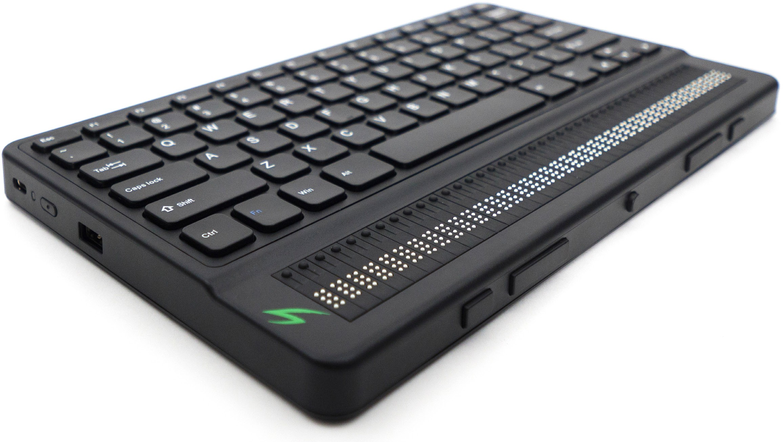

Getting Started Guide

Overview

Front view
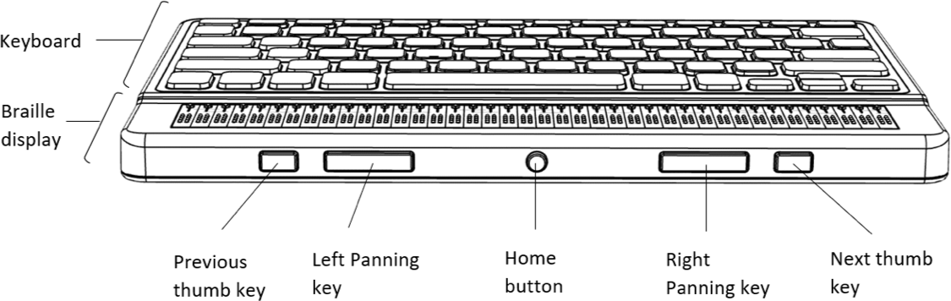

Left side view
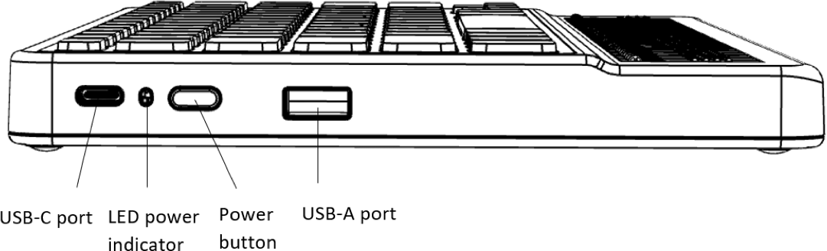

Rear view

Getting Started
Thank you for purchasing the Mantis Q40 braille reader. This getting started guide provides instructions for charging the device, orientation, powering on and off, navigating menus, panning text, using the Context Menu, and accessing the Mantis Q40 User Guide. For more information on how to use your Mantis, please refer to the digital user guide integrated in your Mantis.

In the Box
Check that the listed items have been included. Contact Customer Service at 1-800-223-1839 or cs@aph.org with any problems.
- Mantis Q40 braille display
- USB-C to USB-A cable
- USB to AC adapter
- Green thermoplastic polyurethane (TPU) bumper case
- Braille Getting Started Guide
- Print Getting Started Guide

Orientation and Description
With the device on a flat surface in front of you, the proper operational orientation is with the braille cells closest to you.

Top Surface
The top surface includes the braille display and the QWERTY keyboard. Beginning with the braille cells (closest to you) and moving away from you are the small round Cursor Routing buttons, located just above the braille cells. You use the routing buttons to move the braille cursor when reading and editing, and to activate items in a menu.

Continuing away from you, on a small rise in the surface is the QWERTY computer keyboard. The layout of the keys for the QWERTY keyboard is similar to many laptop keyboards.

Front Edge
Along the front edge of the device closest to you are five controls. The two outermost rectangular buttons are the Previous and Next thumb keys. When editing, they act much the same as the Up and Down Arrow keys on the keyboard. You also use them to move between items in a menu.
Moving inward along the front edge, are two more rectangular buttons called the Panning keys. These allow you to move
to the previous and next 40-cell section of the text you are reading.
In the center of the front edge is the small, round Home key. Use this key to return to the Main Menu at any time, as well as to exit the braille terminal when in Terminal mode.

Left Edge
On the left edge of the device, from front to back, is the USB-A port, used to connect a USB drive or other external USB storage device to the Mantis. Next is the Power button, which has a small dot on it for easy recognition. Next is a
small LED display, which shows the status of your device. The last port is the USB-C connector, used to connect the Mantis to a host device or the AC adapter.

Back Edge
On the back edge of the device and to the far left is an SD Card slot. Use an SD card for storing documents and for updating the software and firmware on the device.

Charging the Device
NOTE: Make sure to charge your Mantis completely prior to use.

Connect the USB-C end of the USB cable to the USB-C port located on the left edge of your Mantis. Very little effort is required, and forcing the connection can damage the cable or the device.
Connect the other end of the USB cable to the power adapter, then plug the adapter into a power outlet. The USB connector and power adapter are included with your Mantis. Use the provided power adapter for optimal recharge.

Powering On and Off
If your device is charged, press and hold the Power button on the left edge of the device for approximately 2 seconds to turn on your Mantis.
“Starting” should appear on the braille display with a tactile loading animation that circles during start-up.
A few moments after you boot your device for the first time, you will be welcomed with a language selection menu. Press Enter to open the list of languages, select one and press Enter to close the list.
Another item available is “Start in terminal”. If you prefer the Mantis to start up in terminal mode each time from a complete shutdown, you can activate this by pressing Enter. Refer to the user settings section for more information on activating or deactivating the start up in terminal.
Close the dialog box once the changes are completed.
After a few seconds, loading is complete. The “Editor” application is shown as selected on the braille display. Your Mantis is now ready for use.
If however you turned on start in terminal, the Mantis Q40 will prompt “USB connection”.
To turn the device off, press and hold the Power button for 2 seconds.

Navigating Menus
To navigate from item to item in menus, press the Previous (leftmost) and Next (rightmost) thumb keys, located on the front edge of your device. You may also use the Up and Down Arrow keys on the QWERTY keyboard. As you press the Previous and Next thumb keys, the menu item changes
on the braille display. Each item represents an application or option you can activate.
To activate a menu item, press one of the Cursor Routing keys. You can also press the Enter key on the keyboard to activate a menu item.

Panning Text
Often, sentences may exceed the 40 characters allowed by your Mantis. To continue reading through the end of a sentence or backward towards the start of a sentence, use
the Left and Right thumb keys to pan the text. The keys are located on the front edge of your device immediately to the left and right of the Home button.

Using the Context Menu
The Context Menu is accessible from almost everywhere in your device. It offers useful contextual functions that are relevant to what you are currently doing on your Mantis. For example, if you are looking for a specific action or shortcut, chances are you can find it in the Context Menu.
To activate the Context Menu, hold Ctrl then press M. The Ctrl key is located in the front-left corner of your QWERTY keyboard. A menu opens with a list of actions you can perform at that particular moment. Scroll through this menu until you find what you are looking for, and then press Enter or any Cursor Routing button.

Accessing the Built-in User Guide
Activate the built-in User Guide item from the Main menu. There you find the complete user guide along with a command reference. This is where to find the most up-to-date information as well as other resources to help you make the most of your Mantis Q40.
Alternatively, you can download the user guide from www. aph.org/product/mantis-q40/.

Specifications
Power requirement: +5VDC@1.5A Battery: Li-Ion 3.7V nominal, 2000 mAh
Operating temperature range: +5 ~ +45 degrees Celsius
Battery charging temperature range: +5 ~ +35 degrees Celsius
Storage temperature: -20 ~ +65 degrees Celsius Operating humidity: 5% ~ 95% (non-condensing)
Storage humidity: 5% ~ 95% (non-condensing)

Warnings

Battery Safety Precautions:
CAUTION:
- Risk of explosion if battery is replaced by an incorrect type.
- Dispose of used batteries according to the instructions below.
- Do not disassemble or modify the battery.
- Use only the specified APH charger.
- There is a risk of overheating, fire or explosion if the battery is put in a fire, heated, subjected to impact, put in contact with water, or if its terminals are shorted.
- Do not attempt to charge or use the battery outside of the unit.

Disposal Instructions:
At the end of the Mantis Q40’s operational lifetime, its internal components must be disposed in compliance with local authorities.
The Mantis Q40 contains no hazardous materials. For disposal, follow local governing ordinances or hospital procedure.

SD Card Opening
Do not insert foreign object except SDHC cards

FCC Warning
This device complies with part 15 of the FCC Rules. Operation is subject to the following two conditions: (1) This device may not cause harmful interference, and (2) this device must accept any interference received, including interference that may cause undesired operation.
Changes or modifications not expressly approved by the party responsible for compliance could void the user’s authority to operate the equipment.
Note: This equipment has been tested and found to comply with the limits for a Class B digital device, pursuant to part 15 of the FCC Rules. These limits are designed to provide reasonable protection against harmful interference in a residential installation. This equipment generates, uses and can radiate radio frequency energy and, if not installed and used in accordance with the instructions, may cause harmful interference to radio communications. However, there is
no guarantee that interference will not occur in a particular installation. If this equipment does cause harmful interference to radio or television reception, which can be determined by

turning the equipment off and on, the user is encouraged to try to correct the interference by one or more of the following measures:
- Reorient or relocate the receiving antenna.
- Increase the separation between the equipment and receiver.
- Connect the equipment into an outlet on a circuit different from that to which the receiver is connected.
- Consult the dealer or an experienced radio/TV technician for help.

Industry Canada statements
This device complies with Industry Canada license-exempt RSS standard(s). Operation is subject to the following two conditions: (1) this device may not cause interference, and (2) this device must accept any interference, including interference that may cause undesired operation of the device.
Le présent appareil est conforme aux CNR d’Industrie Canada applicables aux appareils radio exempts de licence. L’exploitation est autorisée aux deux conditions suivantes
: (1) l’appareil ne doit pas produire de brouillage, et (2) l’utilisateur de l’appareil doit accepter tout brouillage radioélectrique subi, même si le brouillage est susceptible d’en compromettre le fonctionnement.

CAN ICES-3 (B)/NMB-3(B)

Copyright © 2022

1839 Frankfort Avenue,
Louisville, KY 40206
502-895-2405
info@aph.org www.aph.org

