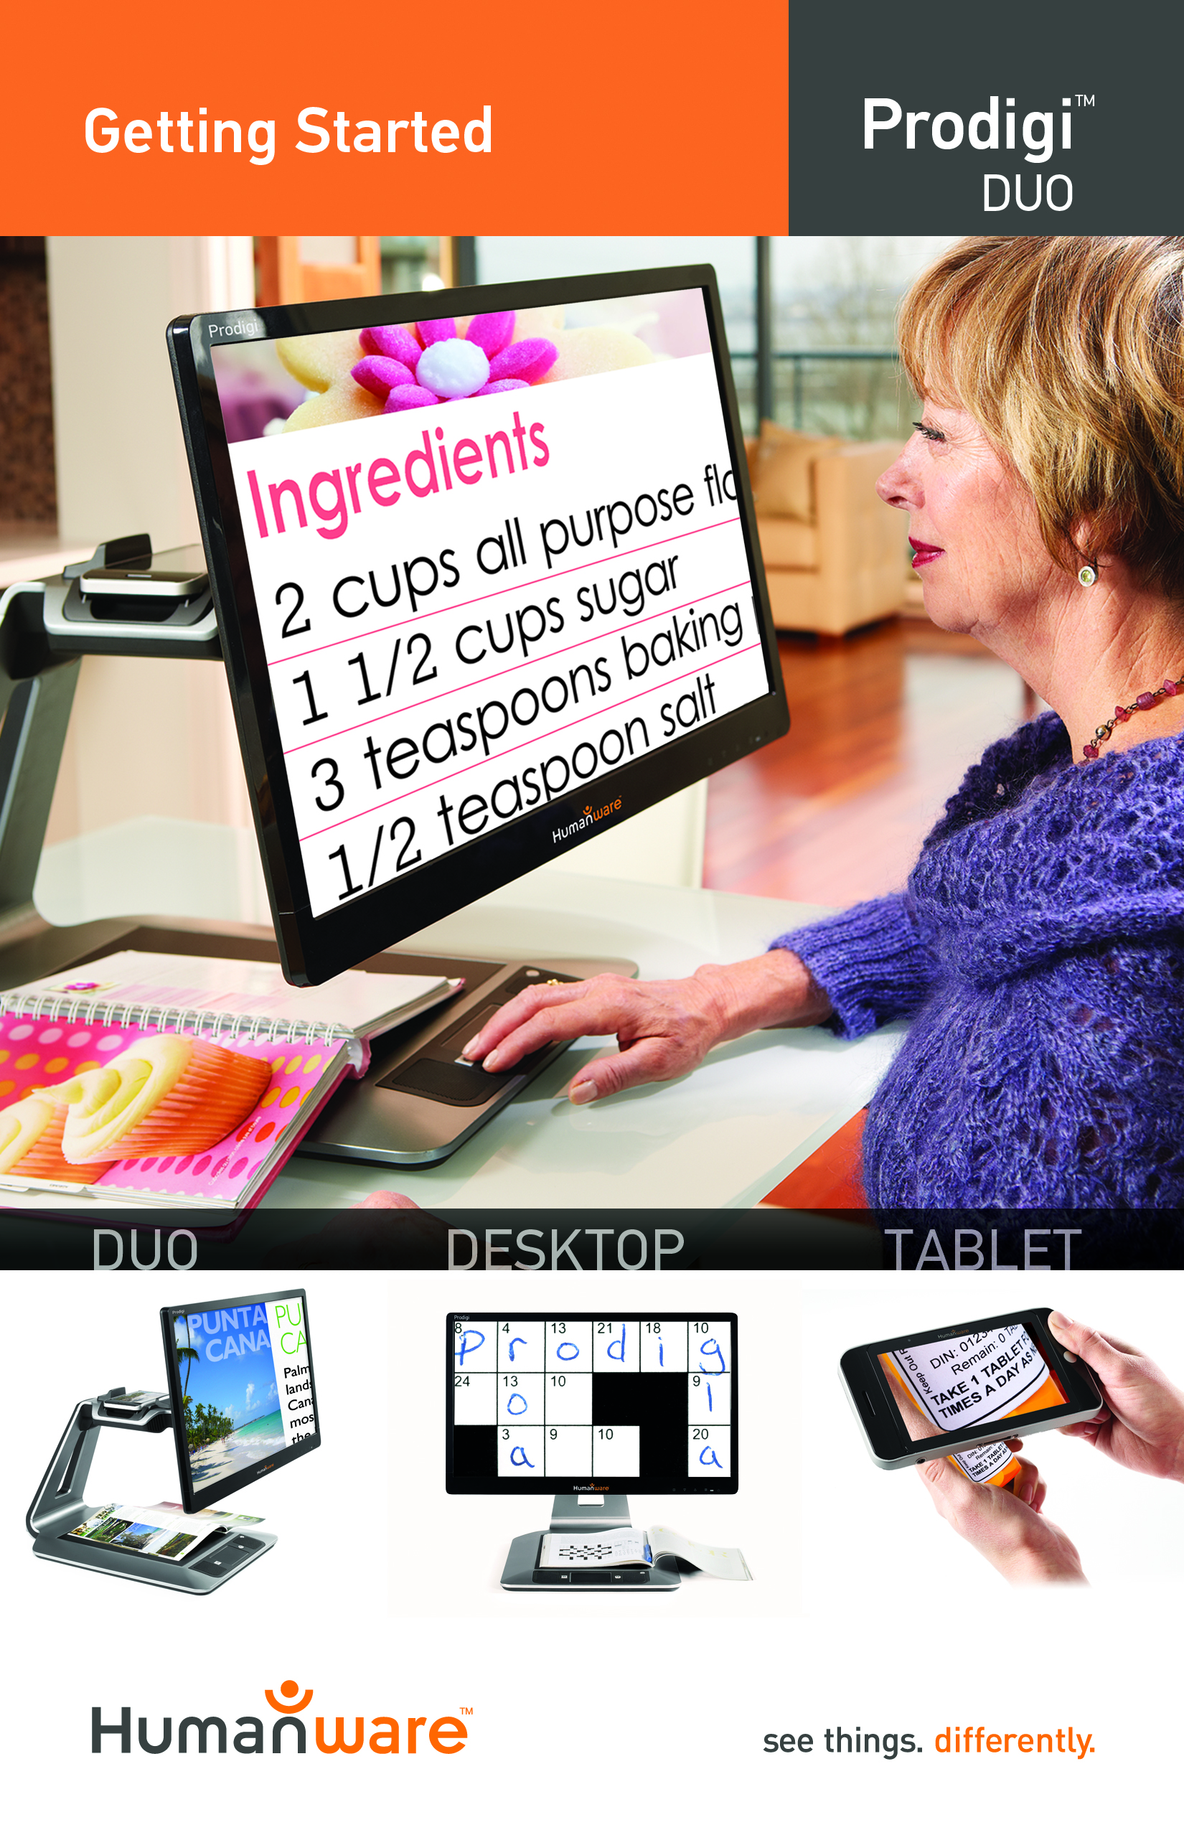

Getting Started
- Pull the Base out of its box by holding the temporary cardboard handle, and place it on a flat and level surface.
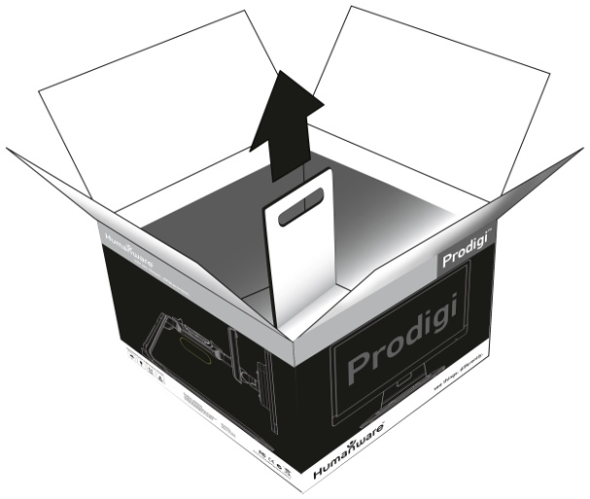

- Make sure the capture and front panel surface is clean before placing the overlay stickers on your front panel, then carefully place the stickers at their appropriate location based on the images below:
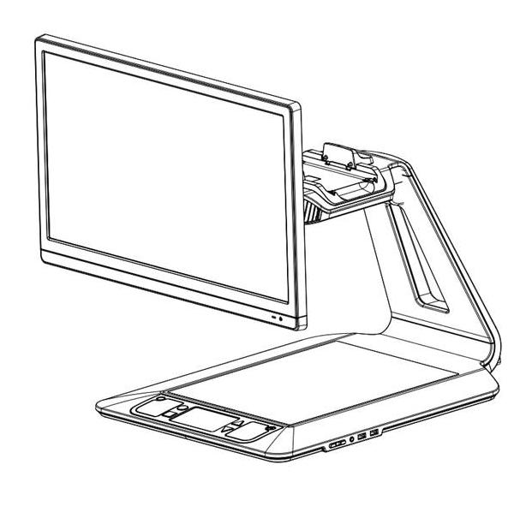
Once you have placed the stickers, wait 10 minutes to make sure they are well in place.

- Connect the Power Supply to the Power Cable. Then, connect the cable to the Power Connector and plug it to an outlet.
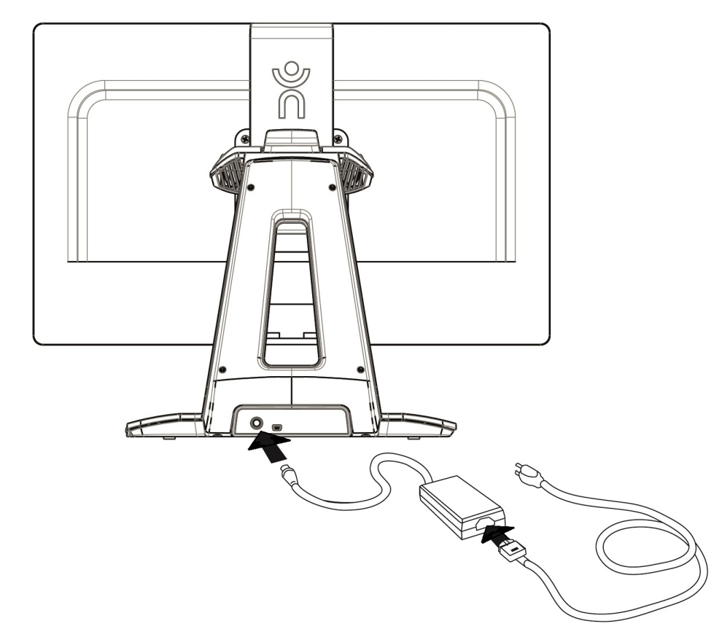
- Position the screen: The center of the screen should be at the same height as your eyes, ideally 16 inches (40 cm) away. To adjust the screen’s position, lift it up or down, tilt it forward or back, and swivel it left or right.
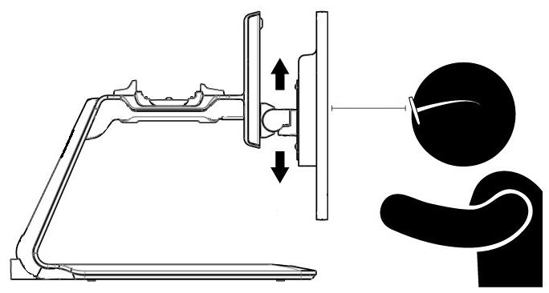
40 cm/16”

- Place the Tablet on the Docking Station, screen side up and top edge facing towards the back. Push the two latches inward to connect the Tablet and power on the Base. Prodigi will take about 1 minute to initialize. HumanWare’s logo will appear on the screen, followed by Prodigi’s startup screen.
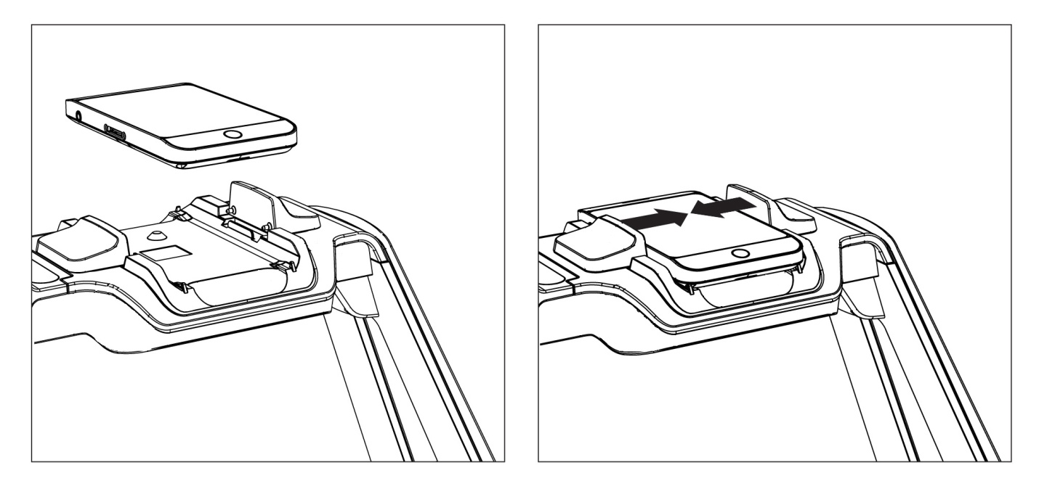
Note: If the Tablet’s battery is drained, it may take a few minutes of recharge for Prodigi to initialize. Let the Tablet recharge initially on the docking station for 8 hours to fully recharge the battery.

[End of document VER 06-2016-05-31]

ACCD-0051
REV 06

REV01

