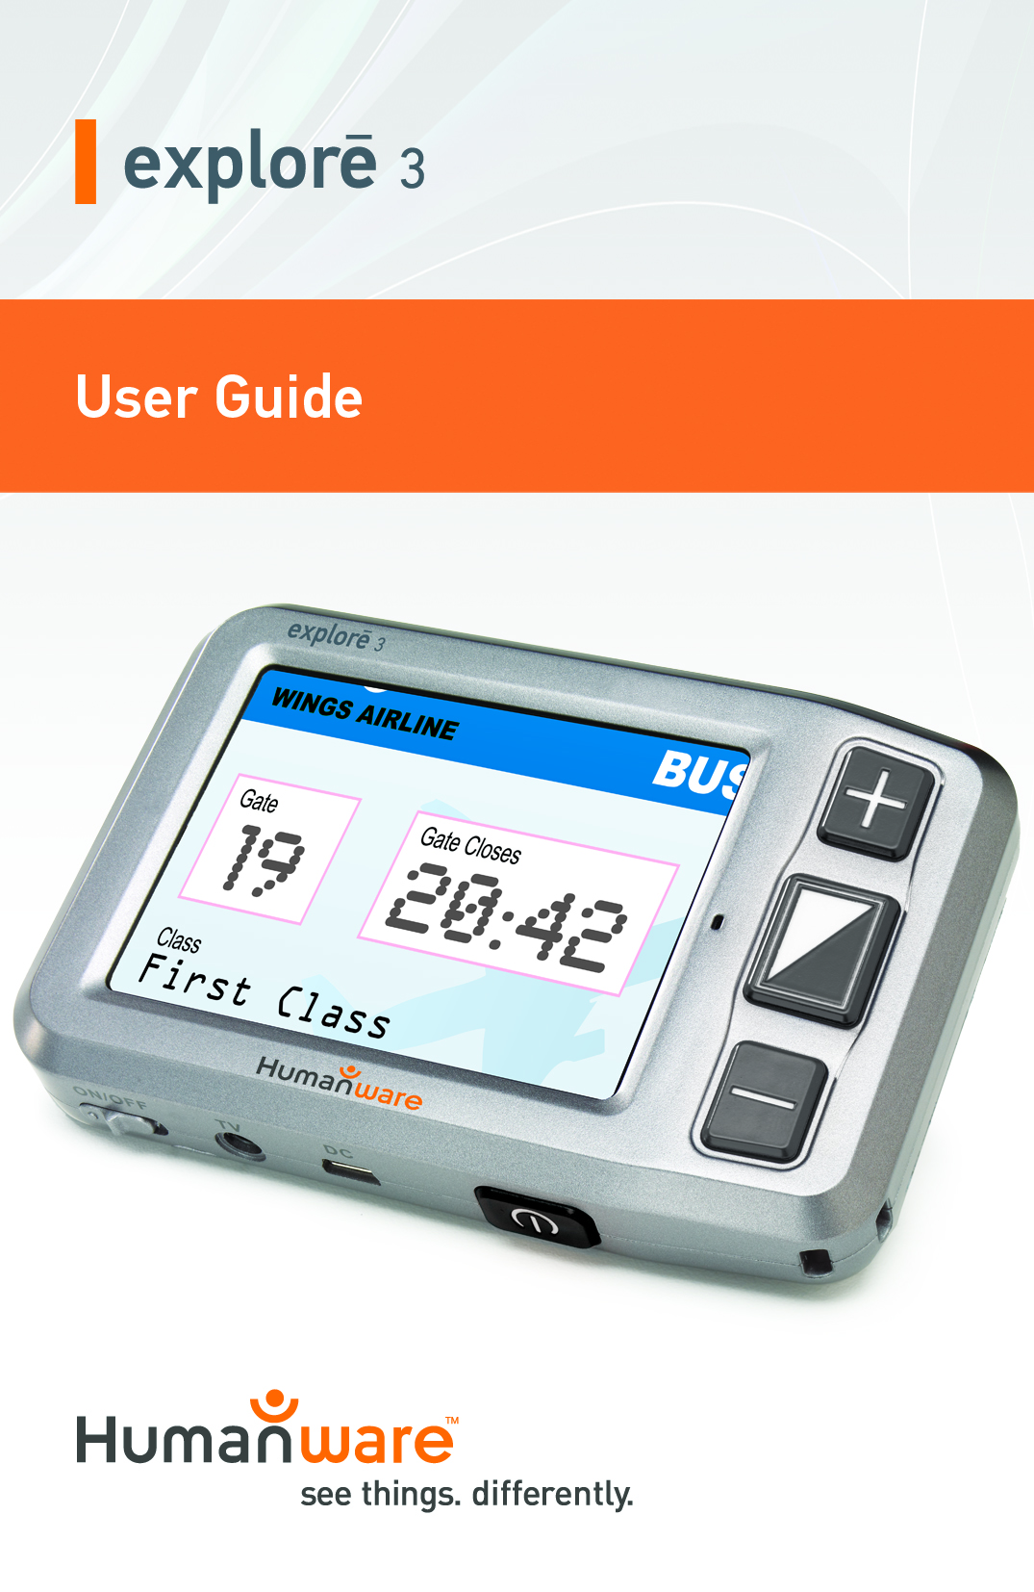

Introduction 1

1. Parts & Accessories 2

2. Structure 3

3. Using your explorē 3 4

3.1 Attaching the strap 5

3.2 Operating your explorē 3 5

3.2.1 Power On/Off 5

3.2.2 Zoom In/Zoom Out 7

3.2.3 Color mode & camera lighting. 8

3.2.4 Brightness Adjustment 10

3.2.5 Freeze Function 10

3.2.6 Memory function 11

3.2.7 Power saving function 11

3.2.8 TV output function 12

4. Troubleshooting 12

5. Safety Guide 14

6. Technical Specifications 15

Warranty 17

Introduction

The explorē 3 handheld electronic magnifier is designed to be portable, elegant and polished. It easily fits into your pocket so you always have it on you when you need it, where you need it. Its advanced auto-focus and clear image technology is a breakthrough that solves image blur, shadows and vertigo. The foldable writing stand makes writing easy and convenient. 8 contrast modes are available to users. Compared to other 3.5 inch magnifiers, explorē 3’s elegant and portable design brings convenience, clarity, and stability so you can enjoy your reading experience as much as possible.

# 1. Parts & Accessories

|  |  |  |
| --- | --- | --- |
| Video Magnifier | Short Strap | User manual |
| Video cable | Protective case | AC power Adapter |
| USB Cable |  |  |

# 2. Structure

Freeze Button

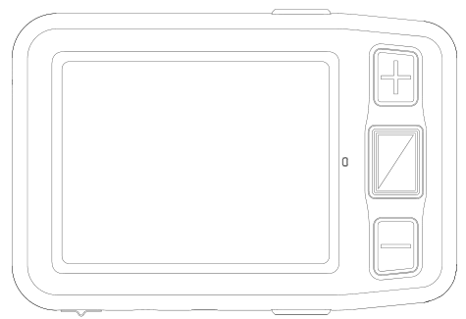

3.5 Inch

Zoom In

Color mode

Zoom out

Power button

# 

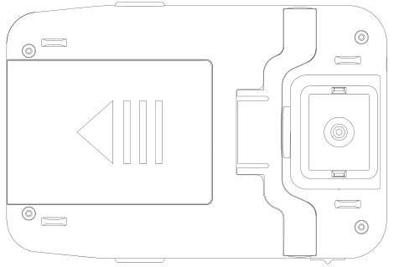

Camera

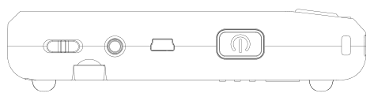

Battery Slot

Writing stand

On/Off button

USB port

TV out port

# 3. Using your explorē 3

## **3.1** Attaching the strap

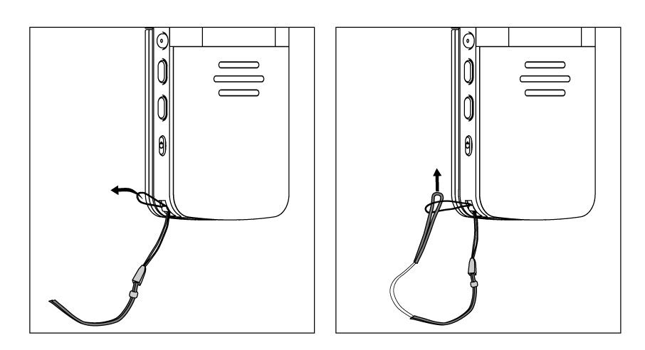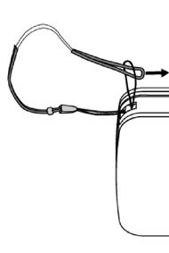

## **3.2** **Operating your explorē 3**

### ****3.2.1 Power On/Off****

On/Off button



* To turn on your unit, press and hold the power button for 3 seconds until you hear a beep. The screen will show the opening image for 2 seconds and enter magnifier mode.
* Press and hold the power button for 3 seconds to turn off your device.

### **3.2.2 Zoom In/Zoom Out**

Zoom In

Zoom Out

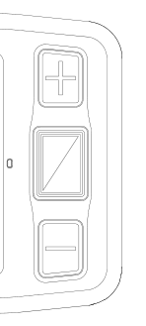

* Press the “+” button to zoom in, and press the “-”button to zoom out.

### ****3.2.3 Color mode and camera lighting****

Color mode



* Normal mode and favorite mode are available for contrast color mode.
* Press and hold the contrast mode button for 2 seconds to switch between normal and favorite modes.
* In favorite mode, press the mode button to cycle through 3 basic modes: full color, your favorite contrast color and reverse (such as white on blue and blue on white).
* In Normal mode, press the mode button to cycle through the following 8 color modes:
  + Full color mode
  + Grey mode
  + High contrast white text on black background
  + High contrast black text on white background
  + High contrast yellow text on black background
  + High contrast black text on yellow background
  + High contrast blue text on yellow background
  + High contrast yellow text on blue background
* Press and hold the contrast color mode for 5 seconds to turn the camera lights on and off.

### ****3.2.4 Brightness Adjustment****

* Hold the “Freeze” and Zoom in” buttons together to adjust brightness.
* A brightness bar will appear. Now press “Zoom in” to increase brightness and “Zoom out” to decrease it.

### ****3.2.5**** ****Freeze Function****

Freeze

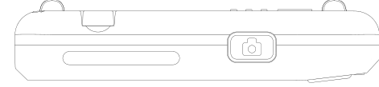

* Use the Freeze button to capture images and letters. Take the unit closer to have a better look at the object. You can also magnify or scale down images by pressing the zoom in and zoom out buttons, and switch contrast modes by pressing the Mode button.
* Press the Freeze button again to exit

### ****3.2.6 Memory function****

* The unit will automatically memorize the most recent settings (e.g. color mode, magnification, video output format, button beeps, brightness) and use them the next time your device is powered on.

### ****3.2.7 Power saving function****

* In magnification mode, the unit will turn off automatically if not operated for 3 minutes.

### ****3.2.8 TV output function****

* If the unit’s screen size is not large enough, you can use the TV output function to connect to the TV screen for magnification.
* Once the TV output is connected to the TV, turn the unit on. The image will automatically appear on the TV screen.

# 4. Troubleshooting

|  |  |
| --- | --- |
| **Problem** | **Solutions** |
| Black screen | * Make sure device is on. * Make sure the camera lens is clean. * Decrease magnification. |
| Unable to turn on device | * Make sure battery is in the device and that the battery is charged. * Try to use the power adapter to turn on your device. |
| Image on screen is dark and twisted | * Make sure your reading material is laid flat. * Make sure the camera lights are turned off. |
| Nothing is displayed after connecting to the TV | * Make sure the TV is on. * Make sure the cable is correctly connected to the TV output and to the TV. * Make sure you are in the correct TV output mode. |
| Unable to charge battery | * Make sure the power adapter is connected. |

# 5. Safety Guide

To keep the video magnifier in good condition, please read the following safety guide carefully:

* Do not expose explorē 3to excessive heat or direct sunlight to avoid the risk of fire.
* Keep device away from humidity, rain, liquid and chemicals.
* Do not use this magnifier near inadequately shielded medical devices.
* Only use explorē 3 within the 10°C and 40°C temperature range
* Do not try to repair the magnifier by yourself or open its case as this will void the warranty. Contact your dealer to service this equipment if necessary.
* Always unplug the system before cleaning it. Use a soft damp cloth to clean the exterior. Do not use cleaning agents or abrasive materials as they will damage your unit.
* Only use a compatible power adapter to charge the device, otherwise it will damage the unit.

# 6. Technical Specifications

* 3.5-inch TFT LCD screen
* 2x -16x continuous zoom
* Focus: Auto-focus
* TV Out: PAL/NTSC
* Power saving mode: the unit will turn off automatically after inactivity for 3 minutes
* Writing stand
* Fast reading with no blur
* Charging time: About 3.5 hours
* Functions: Freeze image, change color mode, zoom in/out
* Settings saved after power off
* Lighting function
* Battery level indicator：Positive
* Lightweight design at 150 g
* 8 high-contrast color viewing modes (3 favorite color modes)
* Battery: rechargeable lithium battery with 4 hours of continuous use
* Accessories: user manual, AC power adapter, short strap, protective case, video output cable
* Operation and storage conditions: Humidity < 70% Temperature: 10-40°C

# Warranty

* Main case: one year
* Power adapter and accessories: one year
* If you encounter any problems, please contact the after-sale service. If you are unable to solve the issue by yourself, please read the warranty card carefully and mail us the unit with the card. We will get back to you once we receive the unit.

