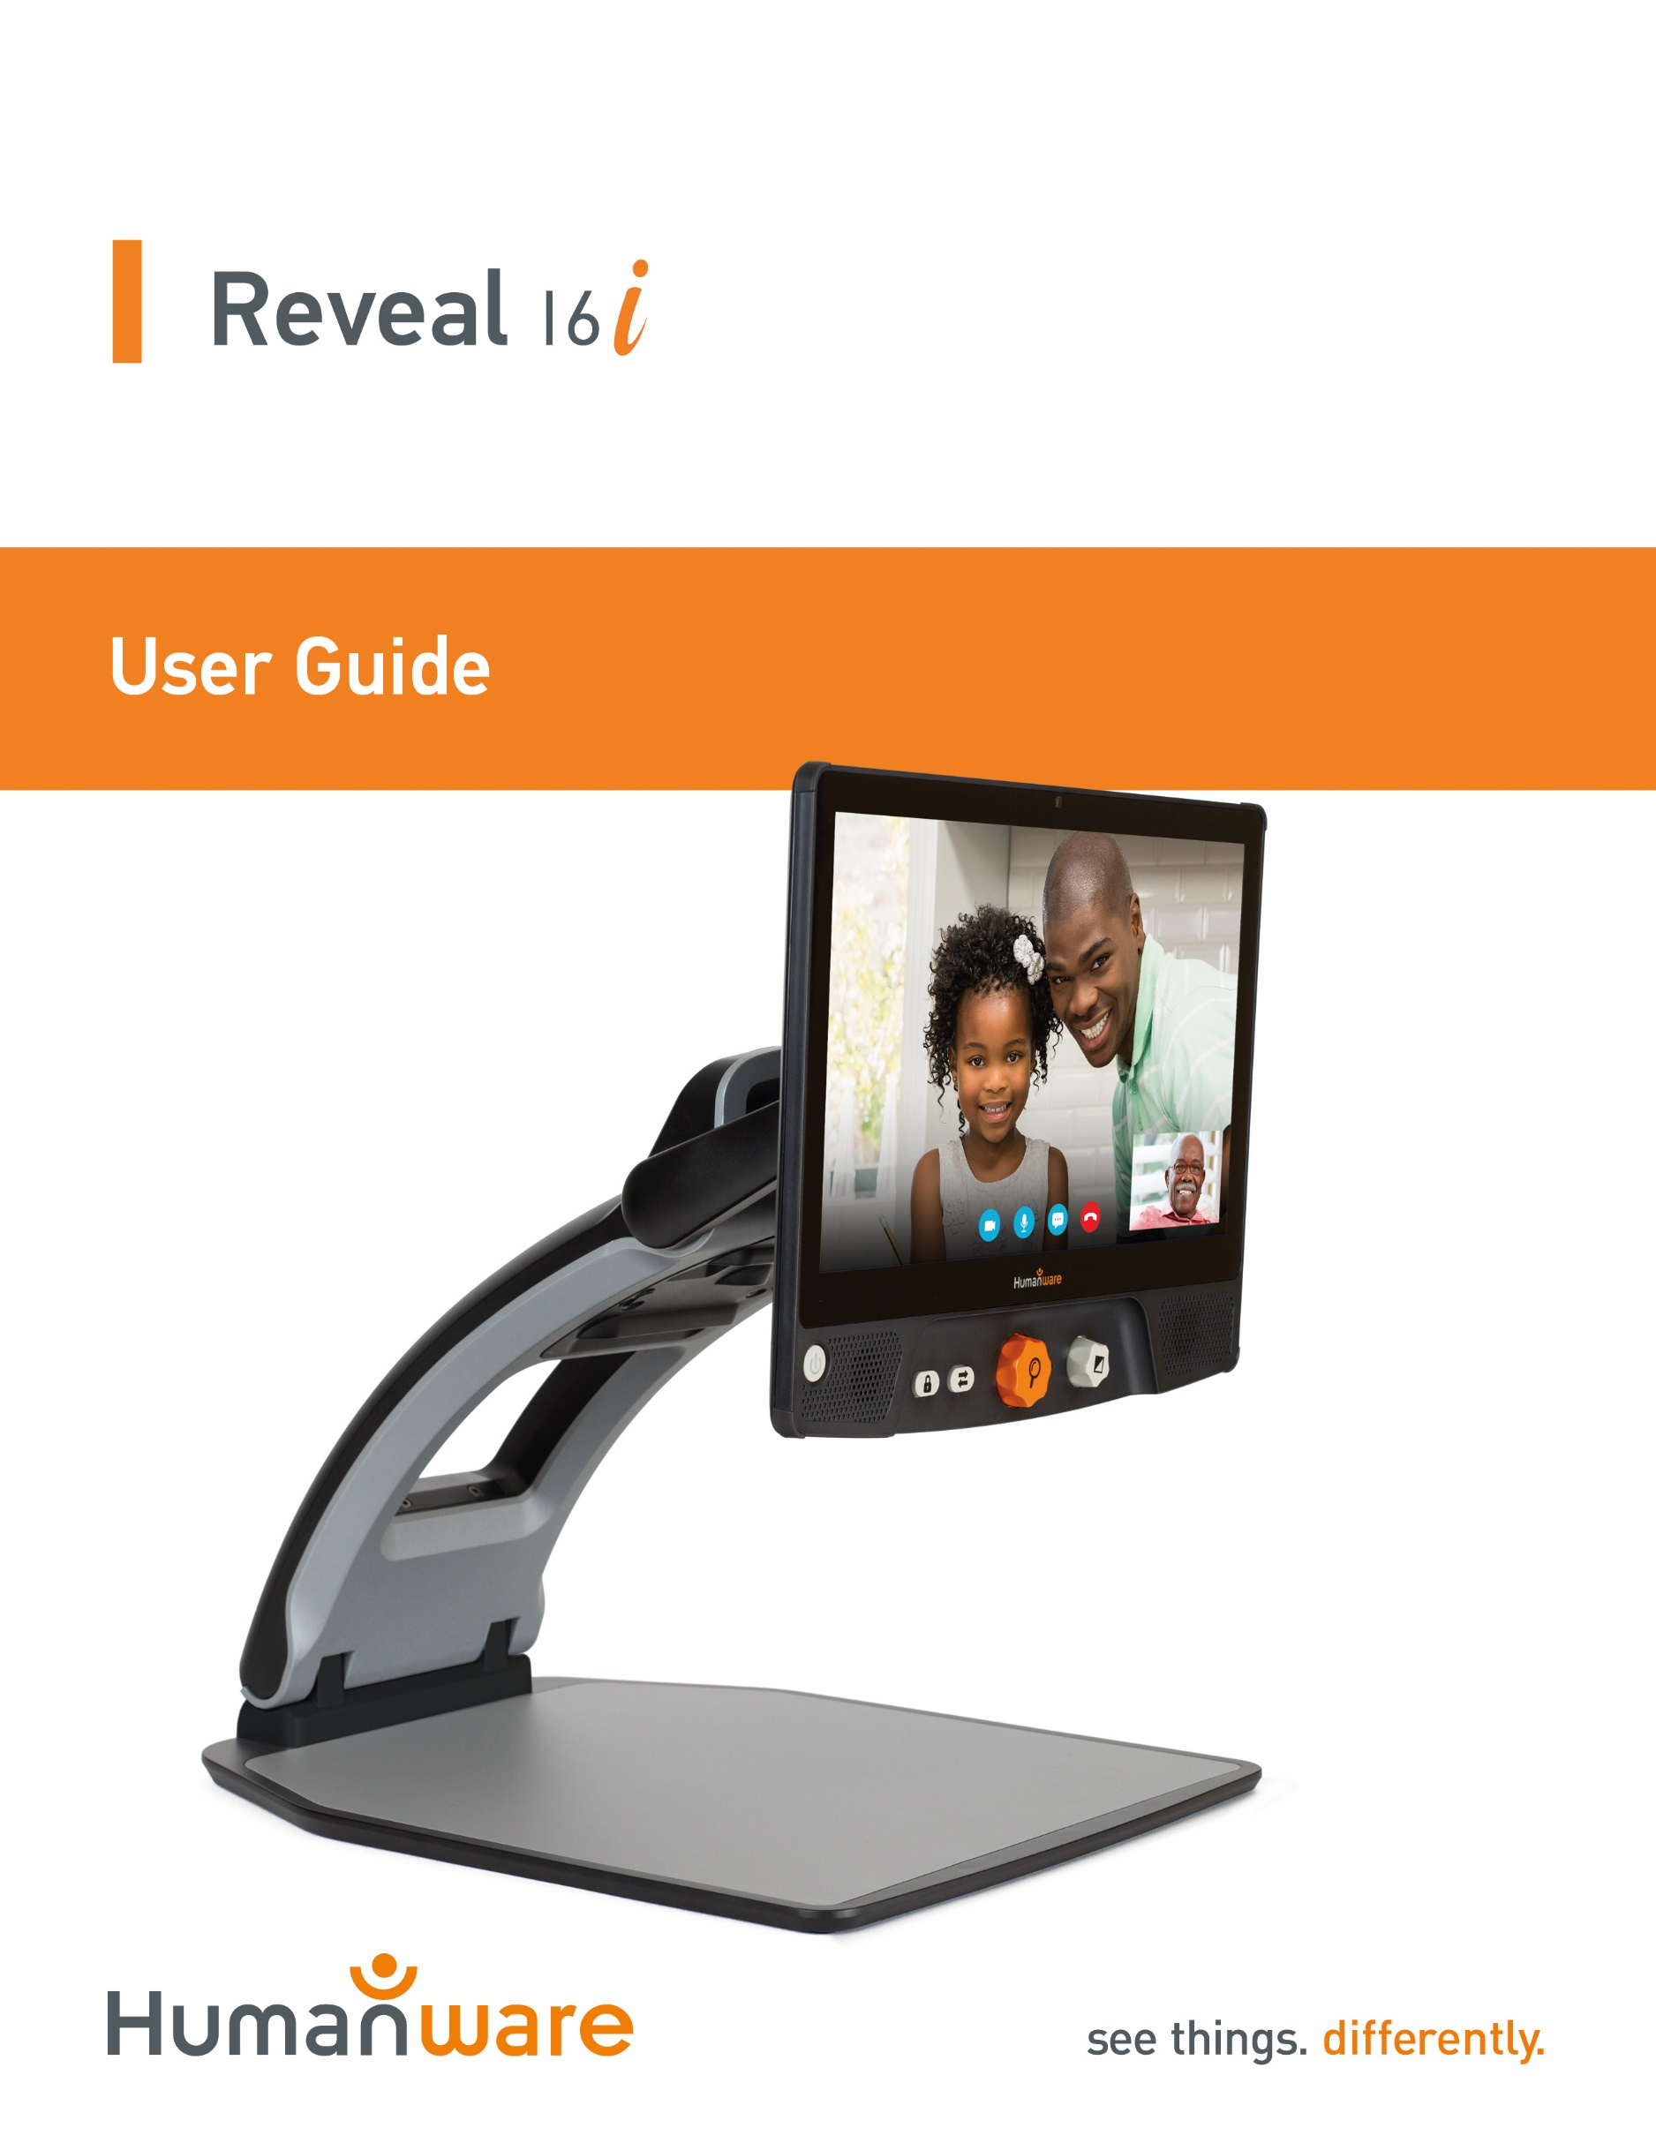
Contents
Introduction 5
Getting to Know your Reveal 5
Box Content 5
Setting Up 6
Overview of your Reveal 9
Reveal 16i Operation Modes 12
Live Mode 12
Turning on your Reveal 12
Using the Reveal for Desktop viewing 13
Using the Reveal for Distance Viewing 14
Zooming In and Out 15
Changing Contrast 15
Adjusting the Contrast Ratio 16
Autofocus Lock 17
Settings Menu 17
Line and blinds 19
Adding a line or blinds 19
Adjusting a line or blinds 19
Advanced Mode 20
Adjusting the Volume 20
Using Prodigi 21
Navigating in Prodigi 21
Capturing a Document 21
Saving a Document 23
Multi-Capture 24
Reading 25
Reading Modes 25
Reading Speed 26
Turning Speech Off 26
Navigating in your Captured Document 27
Zooming in and out on a Document 27
Panning your Document 27
Choosing your contrast 28
Handwriting Tool 29
Viewing saved documents 31
The Action Menu 32
Viewing text files in Prodigi 33
Downloading books 35
Using the Calculator 37
Simple Mode 38
Changing your Settings 38
Accessing Android 42
Help Menu 42
Software update 42
Setting up your Wi-Fi 42
Automatic update 43
Manual update 43
Release Notes 43
Bluetooth Keyboard 44
The HumanWare Keyboard 44
Connecting a Bluetooth Keyboard 44
Stowing your reveal 45
Using Reveal on another Screen 46
Troubleshooting 46
Safety and Maintenance 47
Specifications 48
FCC/Industry Canada Info 49
FCC / Industry Canada Two Part Statement: 49
Per Industry Canada RSS rules: 49
FCC Warning: 49
Warranty 50

Introduction
Congratulations on purchasing the Reveal 16i, the touch-controlled personal vision assistant system from HumanWare with the best image quality in the market. The Reveal 16i is a simple, intelligent, portable, and adaptable line of products aimed at restoring and maintaining the independence of people living with vision loss.
Reveal 16i, is a complete magnification system that will allow you to magnify, read documents, and capture images. Press the Switch Button, and you have access to your own personal computer running on one of Android’s™ latest operating system, Nougat.
Carefully read the operating and safety instructions described in this user guide prior to using your Reveal. If you have any questions about your system, please contact HumanWare Customer Service by referring to the contact information in the back of this user guide.
Copyright 2019 by Technologies HumanWare Inc., all rights reserved. No part of this publication may be reproduced or distributed in any form or by any means, or stored in a database or retrieval system, without the prior written permission of Technologies HumanWare Inc.

Getting to Know your Reveal
This section provides basic information to help you familiarize yourself with your Reveal.

Box Content
- Reveal 16i
- Printed User Guide
- Getting Started Sheet
- Power Adapter
- North American Power Cable
- European Power Cable
- UK Power Cable
- Australian Power Cable

Setting Up
The Reveal 16i was designed with simplicity in mind. Follow the steps below to quickly get your device up and running.
- Carefully remove your Reveal from its box. It will be folded in its carrying position.
- Place your Reveal on a flat and stable surface, such as a table, while making sure the HumanWare Logo is upside down in front of you.
- With one hand, hold the reading tray down onto the table, and with your other hand, lift up the top of the bridge (where the camera is located). The bridge should lock into place in its open position. This may require a bit of force.
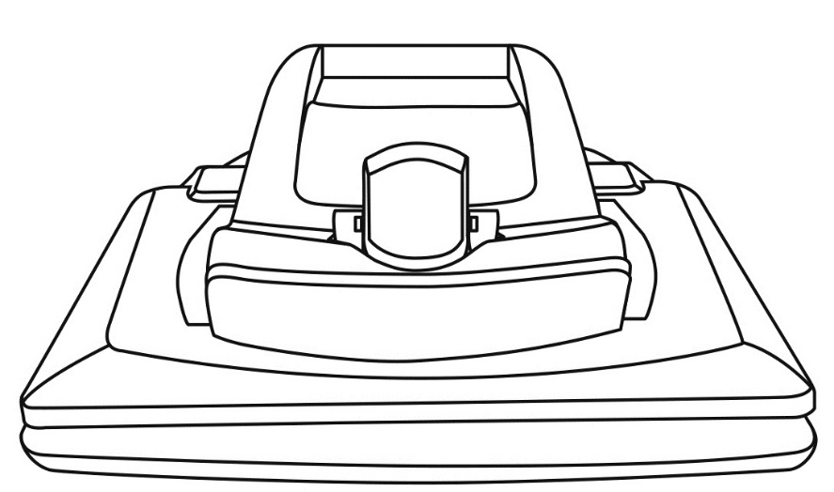
- Carefully hold the screen by the sides and pull the bottom of the screen towards you until you reach a comfortable viewing position.
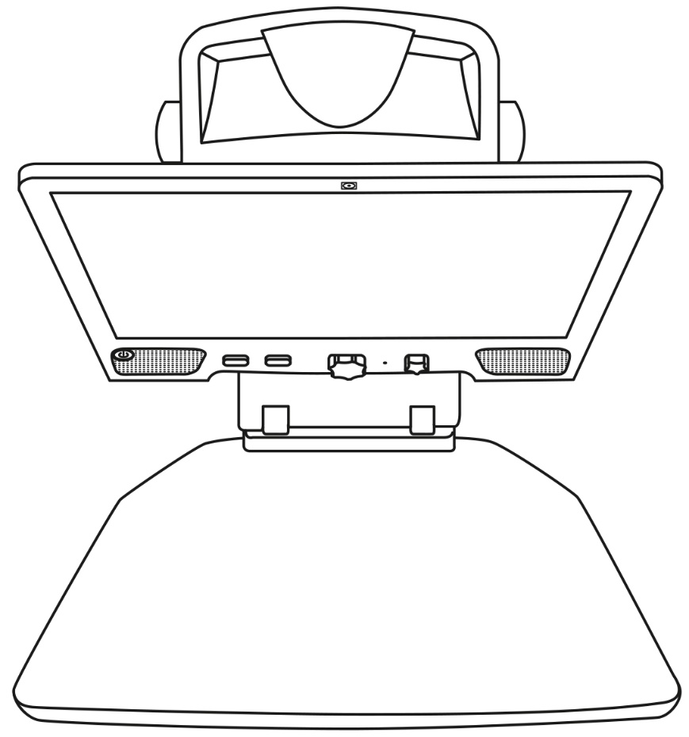

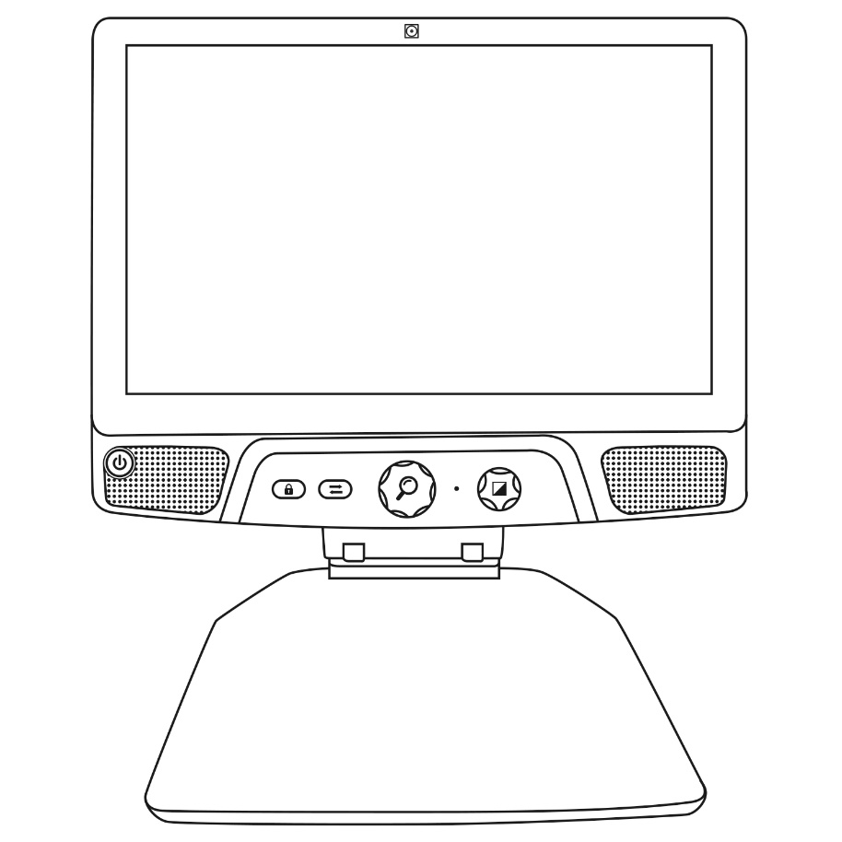

- There will be multiple cables in the box
  - A universal power adapter cable
  - Country-specific power cables
- Plug the power cable into the back of your Reveal.
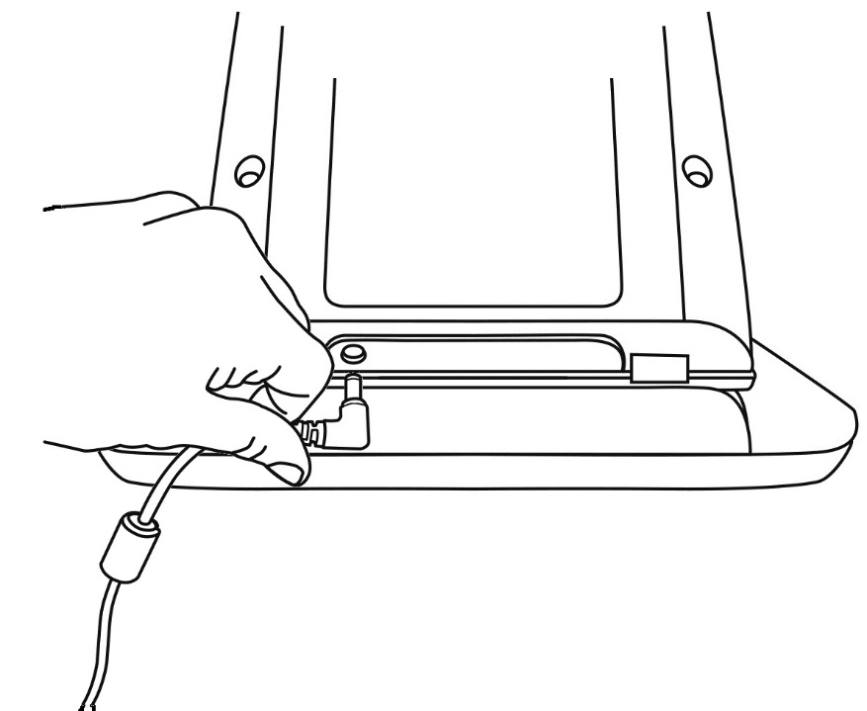

- Plug the other end of the power cable into a power outlet.
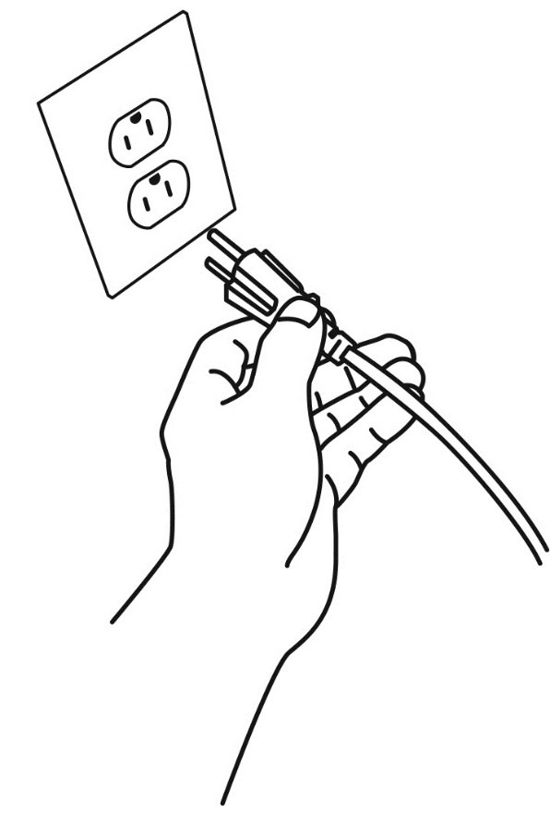
Note: Your Reveal's Power button should now light up red meaning your device is powered and ready to use. If you have an optional battery installed, the light will be orange meaning your battery is recharging.

- Press and hold the red Power button for 1 second and your Reveal will open immediately.

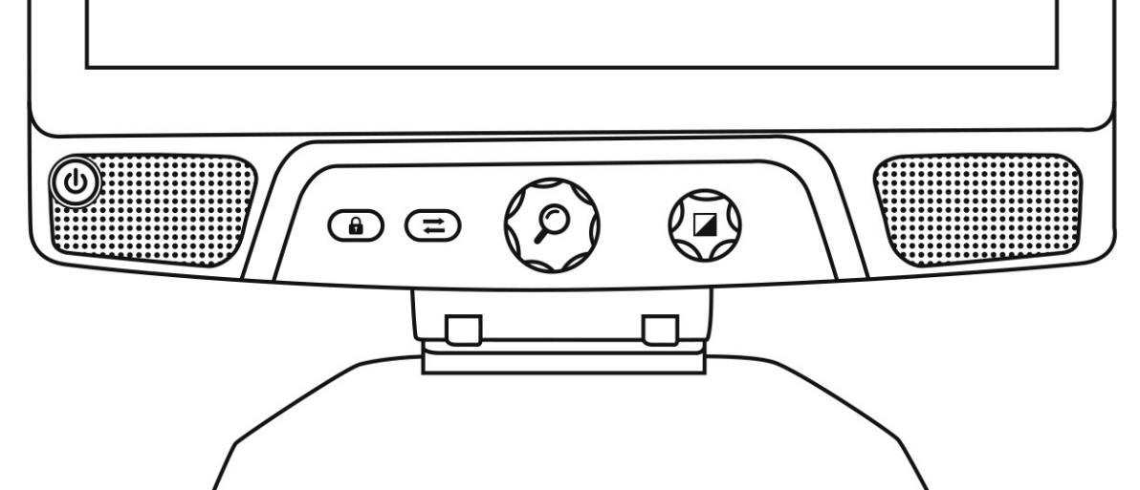
Press the Power button for
1 second

Overview of your Reveal
Front
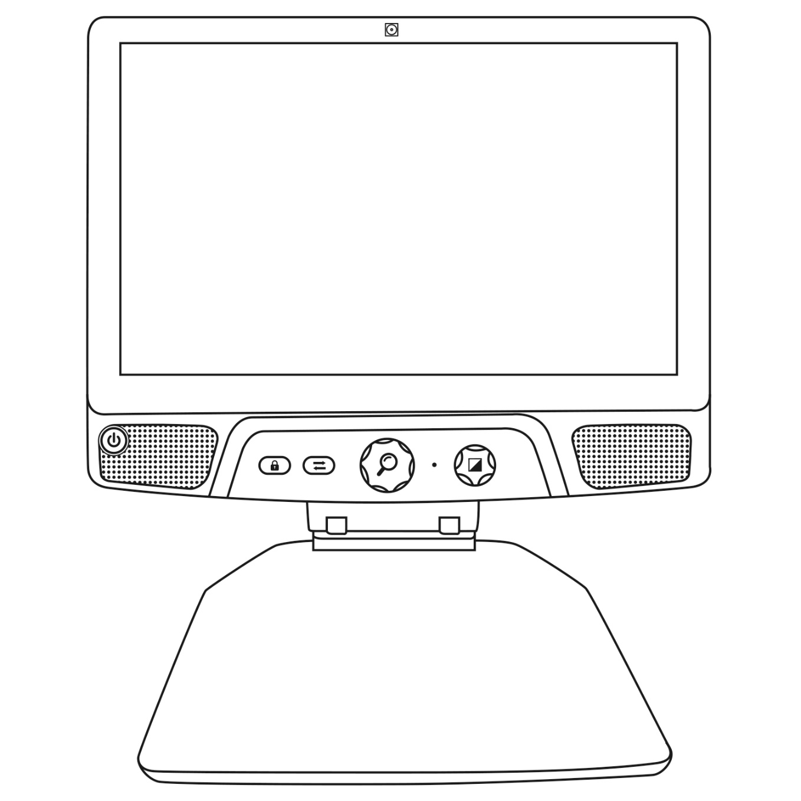
4
9
8
7
5
6
3
1
10
2
- Front Facing Camera
- Touch Screen
- Power Button
- Speakers
- Autofocus Lock Button
- Switch Button
- Zoom Button
- Microphone
- Contrast/Volume Button
- Reading Tray
Side
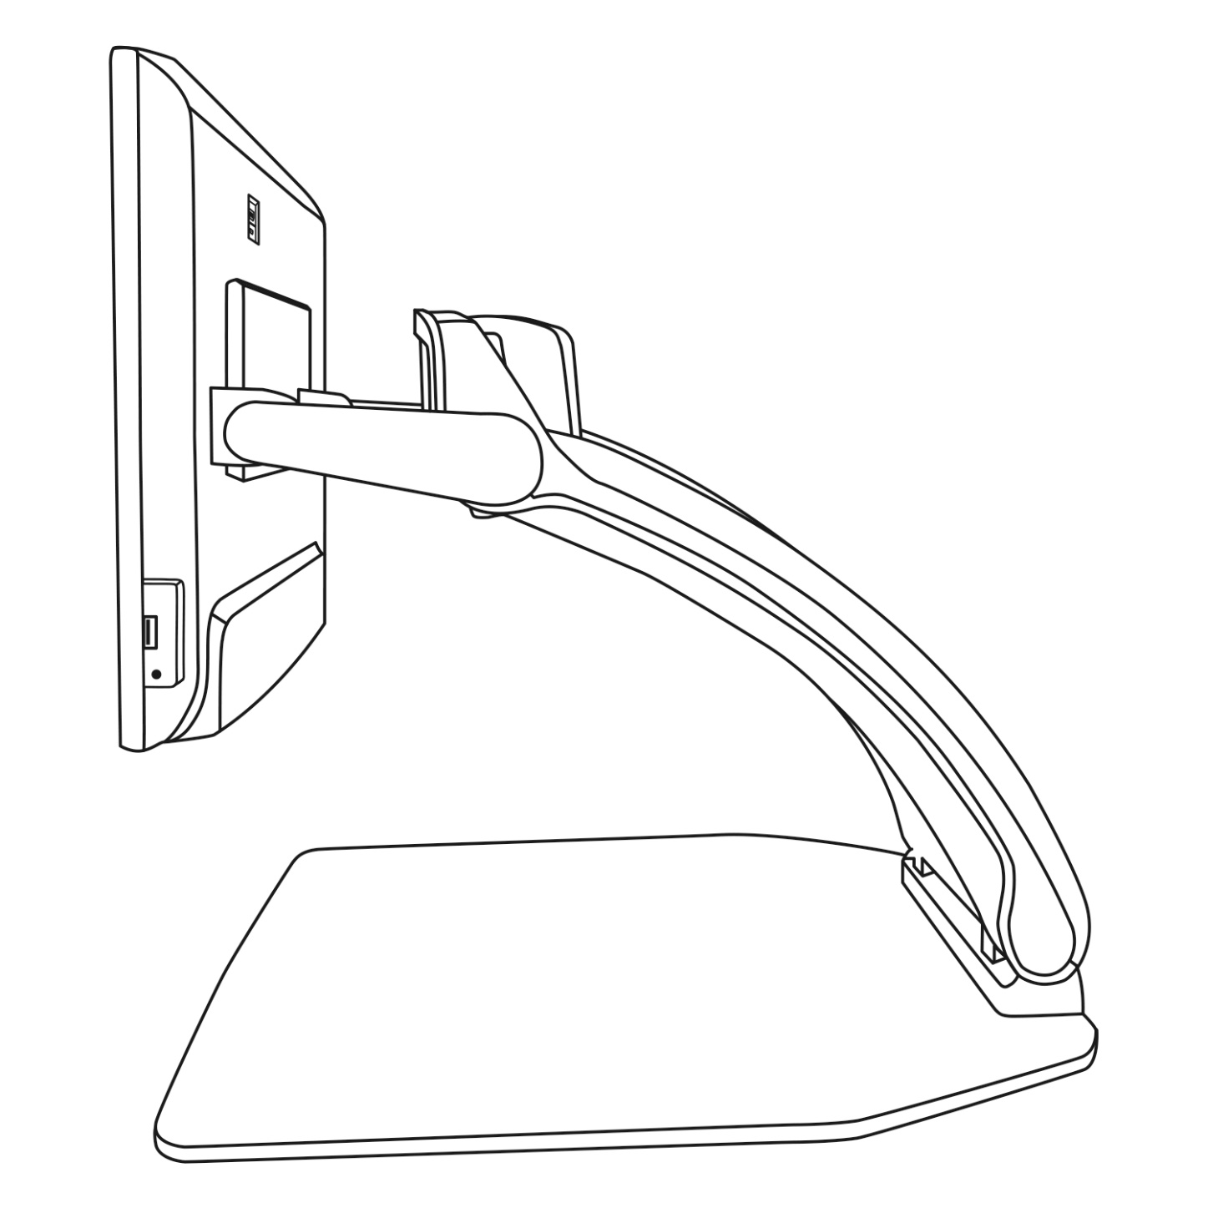
1
2
3
5
8
6
7
4
- High-Resolution video port
- Micro-USB Port (for service only; do not use)
- Touch Screen
- Rotatable Camera
- USB Port
- Audio Jack
- Bridge
- Reading Tray

Back

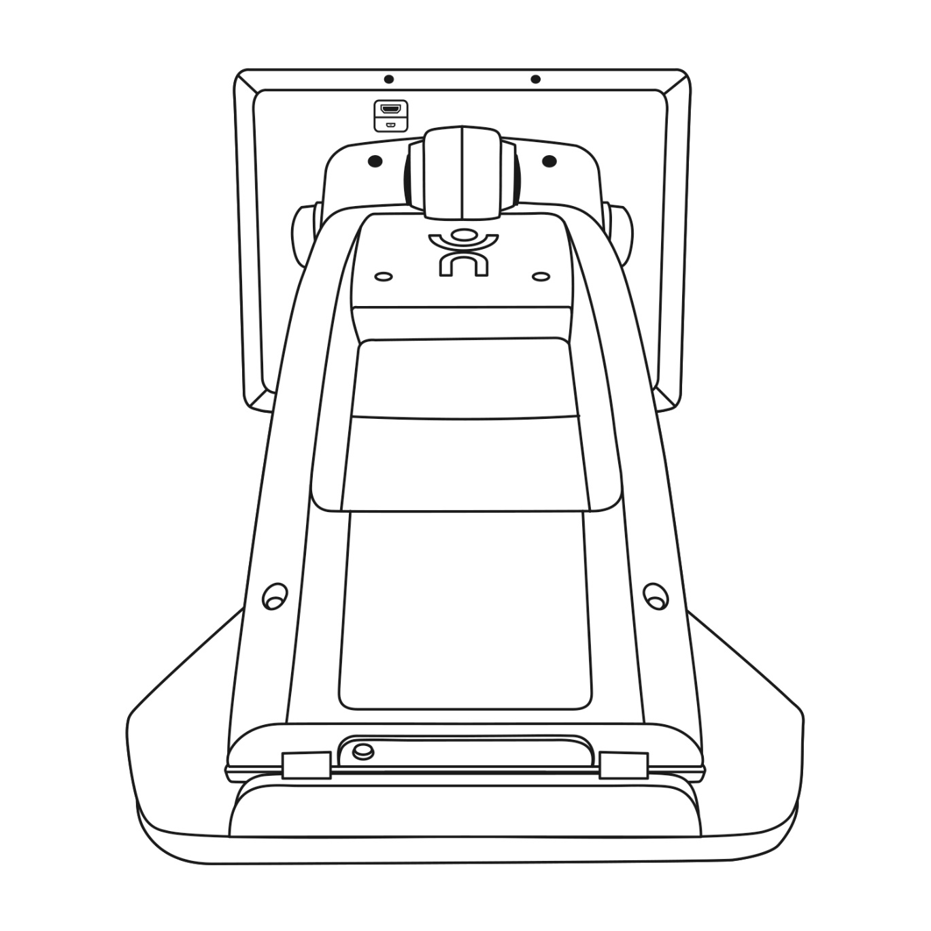
1
2
3
5
4

- High-Resolution video port
- Micro-USB Port
- Bridge
- Battery (if available)
- Power Connector

Reveal 16i Operation Modes
Your Reveal 16i has two main operation modes: Live Mode and Advanced Mode.
At any time, you can toggle seamlessly from one mode to another by pressing the Switch Button just below the screen.
Live Mode is the mode you’re used to if you have used CCTVs or digital magnifiers in the past. It is a very simple but very powerful mode that lets you magnify documents on the reading tray or view distant objects by simply rotating the camera on top of the device. Live Mode is the default operation mode. You will start in this mode every time you power on your device.
Advanced Mode is where you can use your device at its full potential. Advanced Mode gives you access to many more advanced features in a high-contrast user interface. Such features include Prodigi’s Optical Character Recognition (OCR), Bookshare, a large calculator and a picture gallery. Advanced Mode also gives you access to Android so you can use your Reveal just like a regular PC or Android device.

Live Mode

Turning on your Reveal
When your Reveal is off, the circular Power Button on the bottom-left side of your screen will glow red, or orange if you have an optional battery installed that is charging.
To turn on your Reveal, simply press the Power button for 1 second.
The screen will turn on and the button light will change from red (or orange if you have a battery) to green. If the Power button is not lit up, make sure your Reveal is properly plugged in a power outlet.

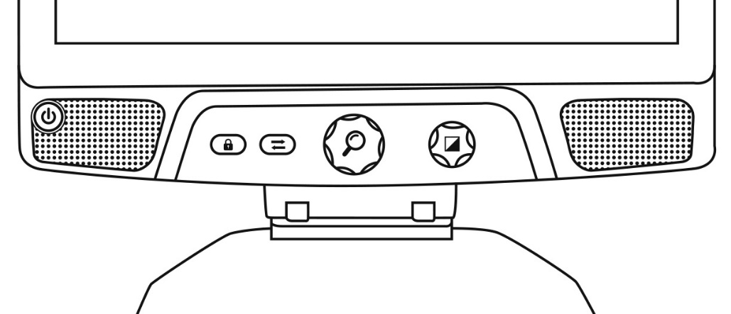
Power Button

Using the Reveal for Desktop viewing
When opening your Reveal 16i, you will be in Live Mode. Live mode works like an electronic magnifier or regular CCTVs. When the camera is pointing downwards, towards the reading tray, everything placed on the reading tray will be shown in real time on the 16-inch screen. This is the simplest way to use the device.

. 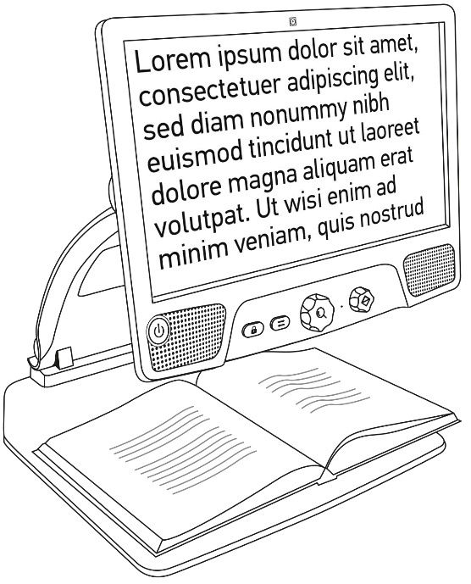

Using the Reveal for Distance Viewing
Your Reveal can also be used to view distant objects. To do so, simply rotate the camera located on top of your device.
- Locate the camera on top of your Reveal 16i. It is the small box on the top of the bridge.
- Pinch the lower section of the camera.
- Pull the bottom section upwards, rotating the camera towards you.
- Point the camera towards your subject (school board, landscape, etc.).
- When you are done, simply rotate the camera back into its initial position.

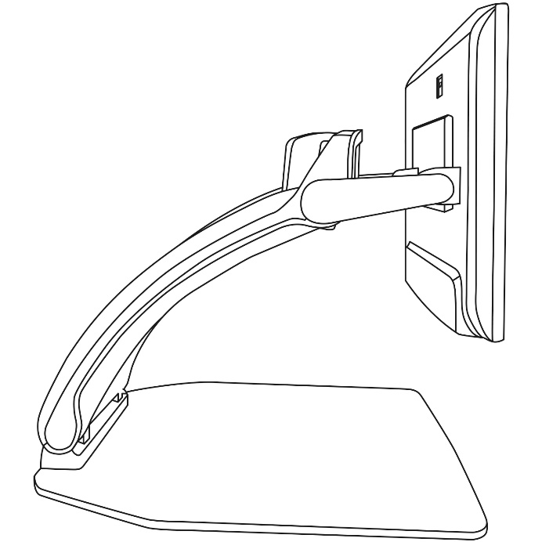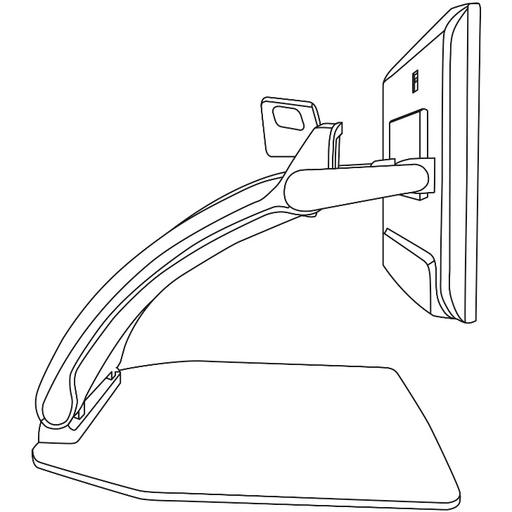
Distance View
Desktop View

Note: The camera can be rotated sideways when it is used for distance viewing.

Zooming In and Out
The center button can be used to zoom in and out of the image.
Turn the Zoom Button clockwise to zoom in.
Turn the Zoom Button counterclockwise to zoom out.
When zoomed in, press and hold on the Zoom Button to get a temporary 1X view of your document. Release the Zoom Button to return to your previous zoom.
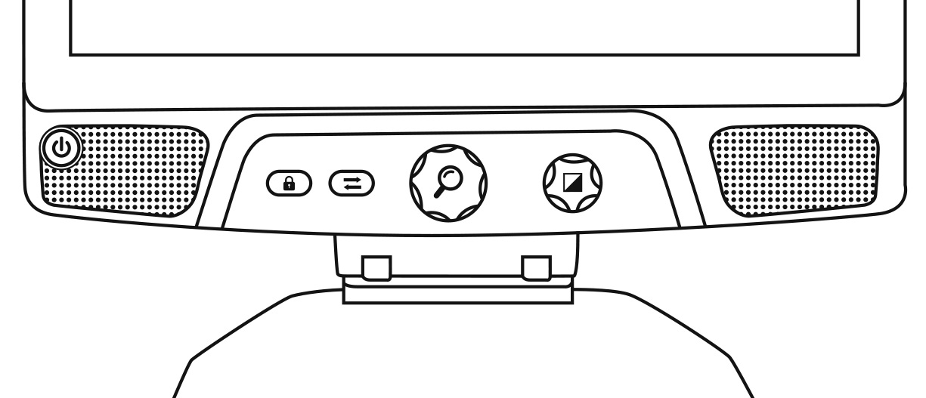
Press and hold for 1X view
Zoom +
Zoom -
.

Changing Contrast
Reveal allows you to customize contrast to better suit your needs and preferences.
Turn the Contrast/Volume Button to change contrast colors.
Keep turning the button until you find a contrast you are comfortable with.

Change contrast
The default contrast modes are color, black on white, white on black, black on yellow, and yellow on black. More contrasts are available in the menu.

Adjusting the Contrast Ratio
The “intensity” of the contrast, or contrast ratio, can be adjusted to your preferences when you are in a contrast mode other than “Color”.
To adjust the contrast ratio:
- Press the Contrast/Volume Button. You will now be in contrast adjustment mode.
- Turn the Contrast/Volume Button counterclockwise to lower the ratio, or clockwise to increase it.
- Wait 2 seconds to return to the normal operation mode.
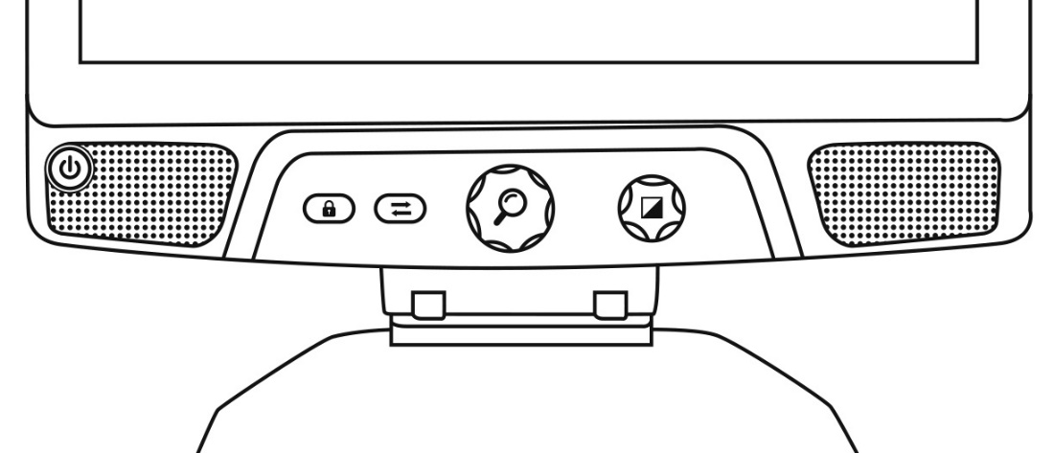
Adjust contrast ratio

Press to enter Contrast Adjustment Mode

Autofocus Lock
Reveal includes an autofocus system that will constantly attempt to find the best focus possible. Despite this, you always have the option to enable or disable the camera’s autofocus. This is useful when you are performing a manual task like writing on a piece of paper and want to prevent your device from refocusing on your hand or pencil.
To lock the autofocus, press the Autofocus Lock button once. Press again to unlock it. Autofocus will also unlock when changing the zoom level.
Press and hold the Autofocus Lock button to reset the focus.

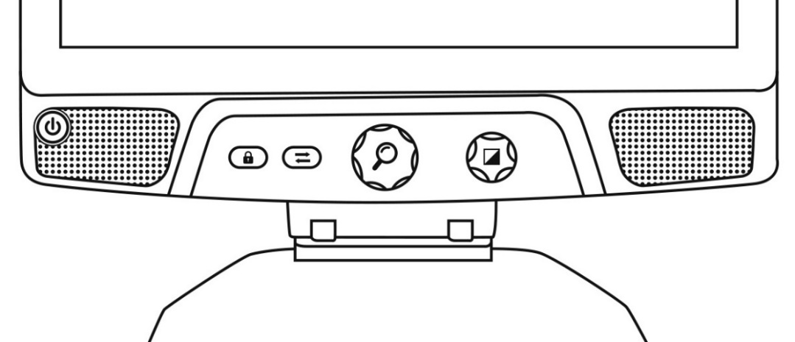
Press and hold to reset focus
Short press to lock or unlock autofocus
The icon will appear on the top right of your screen when autofocus is locked.
Note: Pressing the autofocus lock button in distance mode will freeze the image. Pressing again will unfreeze it. No zooming can be done when the image is frozen.

Settings Menu
To enter the Settings menu, press and hold the Contrast/Volume Button.

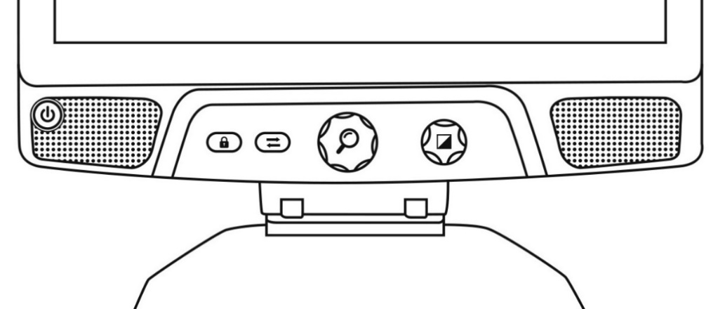
Press and hold to enter or leave Settings

To navigate the menu, turn the Zoom button.
To select an item or enter a submenu, press on the Zoom button.
To go back to the previous menu, press Contrast, or press and hold Contrast to return to the live camera view.

Navigate in menu
Press to select menu item

The menu includes the following items:
Line and blinds: Add a line or blinds on the image for easier reading. Select the adjust menu item to adjust the position on screen.
Enabled Contrasts: Select contrasts available when turning the Contrast/Volume Button.
Preferred Zoom: Choose the zoom level your device starts in.
Display: Select the display frequency of your Reveal 16i.
About: Information about your Reveal 16i.

Line and blinds
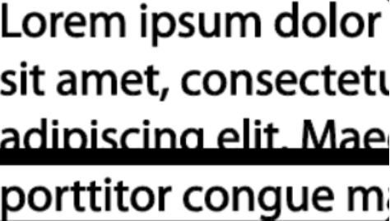
You can add a horizontal line or blinds over your image for easier reading. See images below for an example.
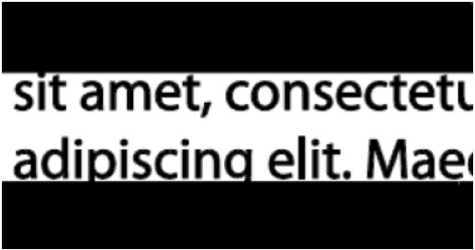
Blinds
Line

Adding a line or blinds
To add a line or blinds to the screen:
Press the Autofocus Lock and Zoom buttons simultaneously to add/remove a line and blinds.
Alternatively, to add a line or blind as your default settings:
- Open the menu by pressing and holding the Contrast button.
- Press the Zoom button to enter the Line and blinds submenu.
- Select between None, Line, or Blinds according to your preferences.
- Press the Zoom button.

Adjusting a line or blinds
After selecting a line or blinds, a new “Adjust” option will appear in the menu.
- Select the adjust option to change the position of the line or the width of the blinds.
- Press the zoom button.
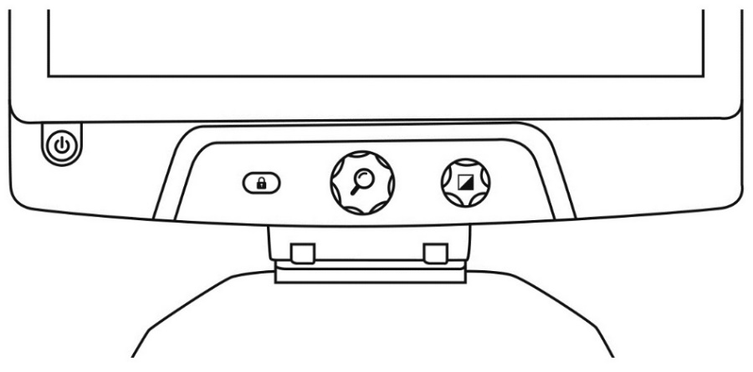
- Turn the Zoom wheel until you find the perfect position or width.

Adjust line or blinds

Press to confirm

Advanced Mode
To start using Android like a regular PC or Android device or to use Prodigi’s Optical Character Recognition (OCR), you will need to switch to the Reveal 16i’s more advanced mode of operation, Advanced Mode. Advanced Mode gives you access to Google’s Android™ platform as well as HumanWare’s renown low vision assistance application, Prodigi™.
To toggle between Live mode and Advanced mode, press the third button from the left, the Switch Button.
You can toggle between the two modes seamlessly at any time.
Note: The first time you press the Switch Button, you will be asked whether you want Android or Prodigi to be your Home Screen. This can be changed later through the Android settings.
Note: If you just turned on your Reveal, you may need to wait a few seconds for Advanced Mode to load after pressing the Switch Button. This will be indicated by an hourglass icon on your screen.

Adjusting the Volume
Unlike Live Mode, Advanced Mode supports sounds from the two stereo speakers located in the front of your device.
To adjust the volume, turn the Volume Button left or right.
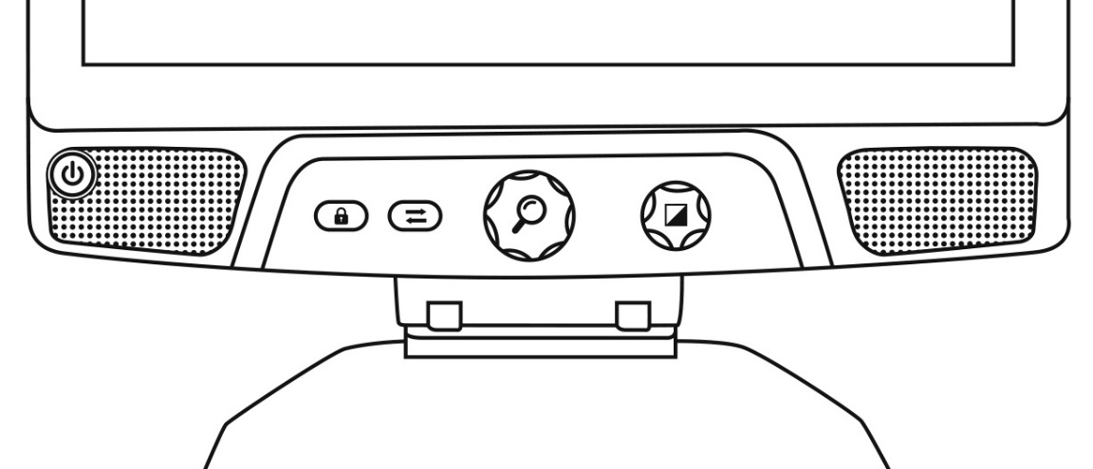
Volume +
Volume -

Using Prodigi

Navigating in Prodigi
Prodigi includes six sub-applications – Calculator, Books, Camera, Gallery, Settings, and Help. They are presented by the following icons in Prodigi’s Carousel menu:
Note: You can access the Carousel menu from anywhere within the Prodigi application by double tapping with two fingers anywhere on the screen.

Capturing a Document
Prodigi’s main feature is found within its Camera application, which allows you to capture and save documents and run Optical Character Recognition (OCR). When you run OCR on a printed document, Reveal can then read it for you out loud.
To capture a document in Prodigi:
- Swipe left or right in the Carousel Menu until you reach the Camera icon then tap on it once.
Note: Most of the Camera’s actions are performed by taping an icon on the Virtual Button banner located on the left side of your screen.
Back Button
Gallery Button
Multi-capture Button
Capture Button
The Button Banner

- Place your document on the reading tray as shown below. Your document should appear on screen.
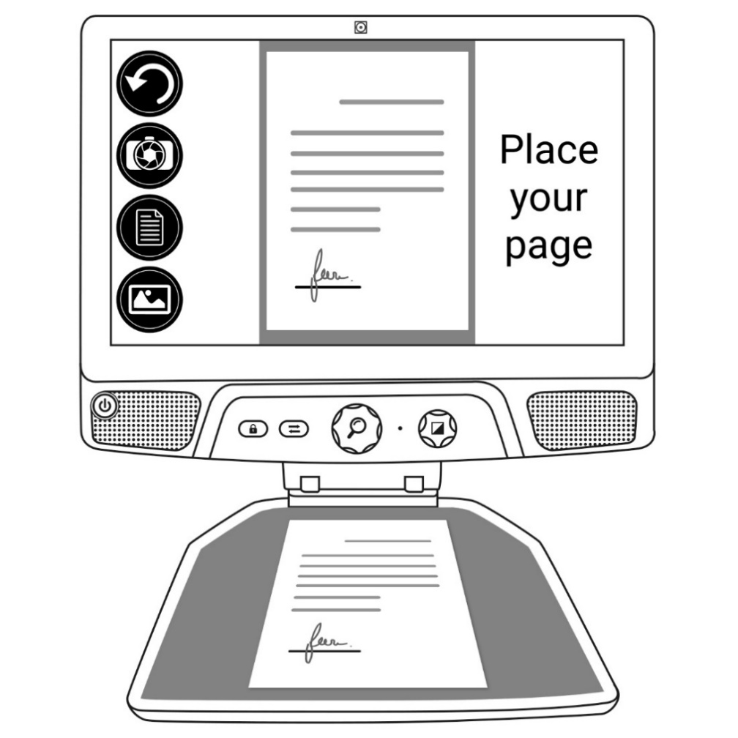

- Tap the Capture Button to take a picture of your document.
You will hear a camera shutter sound followed by a clicking sound which indicates that the document has been captured.

- Tap the Back Button if you want to return to Camera Preview mode.

Note: If you wish to hide the Button Banner to better see your screen, do a downward swipe on the Button Banner. The banner will be replaced by the Open Banner button at the bottom of your screen.
Tap this button or swipe upward to bring back the Button Banner.

Saving a Document
Once you make a capture, the button banner will now be in the bottom of the screen, and there will now be a Save Button on the button banner. The Save Button allows you to save the captured image in your Gallery.
- Tap the Save button to save your document in the Gallery for future use.

Multi-Capture
To capture a document containing multiple pages:
- Toggle to Multi-Capture mode by pressing on the Multi-capture button in the left button panel.
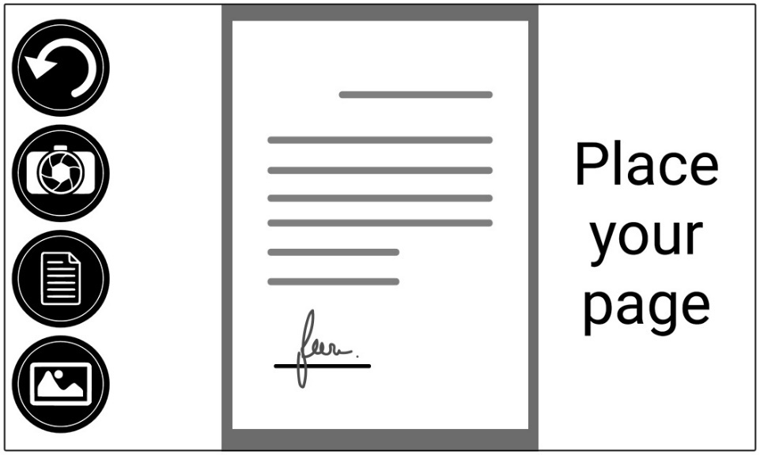

Multicapture
Button

- Place the first page of your document on the reading tray.
- Tap the Capture button.
You will hear a camera shutter sound followed by a clicking sound which indicates that the page has been captured.
- Repeat in the same way for each page you wish to capture. Your multipage document will be saved in the Gallery for future use.
- To end Multi-Capture and go back to single captures, tap the top left Multi-Capture button once again.

Reading
Once you make a capture, you will notice a play symbol in the Button Banner. This is the Read button.
To begin reading the document using the integrated text-to-speech engine:

- Tap the Read Button to read aloud the text according to your reading preferences. You can also do a long press on a specific word in the document to start reading on that word.

Note: When you press the Read Button, the Button Banner will collapse to provide a better view of your image. It can be re-opened by pressing the Open Banner Button or by doing an upward swipe on the lower section of the screen.

- To pause, tap the Read Button again or long press anywhere on the screen.
- While paused, tap the Back Button to exit reading view, and the Back Button again to return to the Camera view.
- To resume, tap the Read Button again or long press anywhere on the screen.

Reading Modes
The captured text can be presented in 3 different reading modes. Reading modes can be changed in the settings to a single line in the Line mode, a column in the Column mode (default), or you can read text without losing its configuration in the Page mode. Two “greater than” signs will identify the end of a paragraph in the Line and Column modes (˃˃).
- To set a different Reading Mode, tap the Settings button and swipe up until you reach Reading Mode.
- Tap Reading Mode to change the value. Choose a reading mode, then tap Back twice to exit the Settings.

Reading Speed
- You can temporarily increase the reading speed by swiping to the left on the touchscreen, and decrease the speech rate by swiping to the right. This must be done while the text-to-speech engine is reading your text.

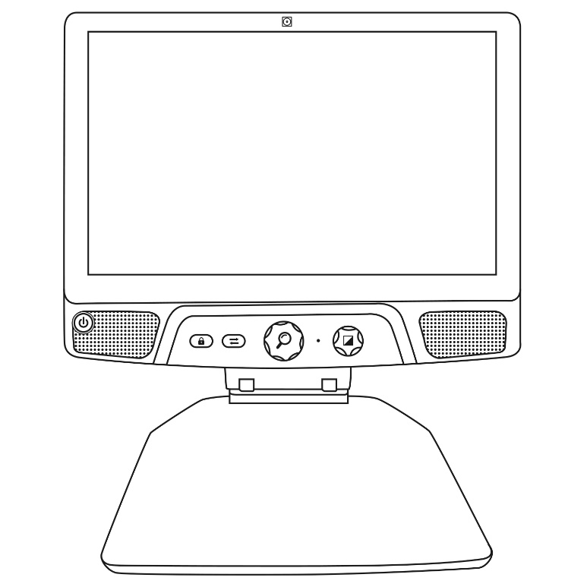
Swipe left or right to change reading speed

Note: You can also increase or decrease the speech rate permanently from the Settings. Tap the Settings Button, select Speech Rate, and select a value. Tap Back twice to exit Settings.
Note: You will be able to change the reading speed (text scrolling speed) by swiping left or right, or from the Settings even when speech is deactivated.

Turning Speech Off
It is possible to mute the text-to-speech engine when text is being read.
- To toggle between Speech On and Off, simply double tap on the screen while reading. Alternatively, tap the Settings button, select Speech, and select Documents only or Off.

Navigating in your Captured Document
Once you have captured the document, you can navigate through it to reach or zoom in areas of interest.

Zooming in and out on a Document
To zoom in and out on a captured document:
- Turn the Zoom Button to adjust the zoom level.
Alternatively, you can use the pinch and zoom gesture to adjust the zoom level.

Zoom out
Zoom in
- To instantly zoom to an area of interest, perform a single tap on the area you wish to view and the image will zoom at that location at your preferred zoom level.

Panning your Document
- If you are in a zoomed level over 1X, you can move around your zoomed document by doing a Pan Gesture (slowly move your finger on the screen without lifting it).

- Pan to reach other parts of the enlarged image.

Choosing your contrast
Reveal 16i allows you to view documents, pictures and objects in 3 types of contrast: color, positive or negative. For documents containing text, a 4th type of contrast can be used: Diamond Edge™. Positive, negative, and Diamond Edge contrasts are enhanced; they are meant to enhance the original color of a document or object to facilitate your visual experience.
Toggle between the different contrasts by swiping vertically on the right edge of the touchscreen while viewing an image or document:
Alternatively, tap the Settings button while viewing an image or reading, select Contrast, and swipe to choose a contrast. Tap Back twice to return to your document or object.
Color contrast is useful if you want to view documents, objects, and photographs in their original color.
Positive contrast shows text and images in 2 colors according to your selected color combination, the default combination being Black on White. This is a practical way to view text in the best color combination for your vision.
Negative contrast shows text and images in reversed contrast as compared to your selected color combination. For example, if your combination is Black on White, negative contrast will show text and images in White on Black. This is useful if you wish to reverse the contrast of a text that contains different contrasts.
Diamond Edge contrast combines the best of both worlds; it shows Diamond Edge Text™ in your selected color combination and images in their original color. This allows you to magnify text indefinitely without compromising its quality in the best color combination for your vision, while viewing images in their original color on the same page.

Handwriting Tool

Connect features a handwriting tool useful for highlighting, drawing on or writing text on your captured images and documents.

To open the Handwriting Tool:
- Open a saved image from the Gallery or save a captured image in the Camera application.
- Tap the pencil icon from the button banner. This is the Handwriting Tool button.
Once in the Handwriting Tool, you will notice 4 new buttons on the button banner.
The Tool Selection button allows you to select between the Pencil, the Highlighter or the Text Tool. The icon displayed will change depending which tool is currently selected.
The Pencil, Highlighter and Text tool icons are shown below.
The Eraser Tool is used to erase pencil/highlighter strokes and text.
The Color Selection button opens the color menu. Tap it to choose the color of your selected tool.

The Size Selection button opens the size menu. Tap it to choose the size of your text or the pencil/highlighter strokes of your selected tool.
To use the pencil or highlighter:
- Select either the pencil or highlighter by tapping the Tool Selection button on the Button banner (second button). Drag your finger on the screen to draw strokes with the pencil or highlighter.

To erase text or pencil/highlighter strokes:
- Select the Eraser Tool by tapping the Eraser Tool button (third button).
- Drag your finger over what you wish to erase.
- When you are done, deselect the Eraser Tool by tapping the Eraser Tool button again.
Note: The Eraser Tool will only erase strokes of the selected tool type.

To write text:
- Select the Text Tool by tapping the Tool Selection button on the button banner (second button).
- Press and hold your finger on the screen where you want to write your text.
- A virtual keyboard will appear on your screen; use it to type in your text. You can also use a physical Bluetooth keyboard if you have one paired with your device.
- When you are done typing, press the Paper Plane button on the top right corner of your screen to validate your text. Alternatively, you can press Ctrl + Enter to validate your text if you are using a keyboard.

To move your text:
- Select the Text Tool by tapping the Tool Selection button on the button banner (second button).
- Tap once on your text to select it. You will see a red box appear around your text meaning it is now selected.
- Drag your text to its new position.
- Tap anywhere on the screen to deselect your text.

To resize your text:
- Select the Text Tool by tapping the Tool Selection button on the button banner (second button).
- Tap once on your text to select it. You will see a red rectangle around your text which means it is now selected.
- Change the text size by making a pinch gesture: decrease the distance between 2 fingers to reduce text size, and increase the distance to enlarge your text.
- Tap anywhere on the screen to deselect your text.

To Pan in an image that is being edited:
- Place two finger on the image.
- Drag your fingers up, down, right or left.
- When finish lift your fingers of the image.
Note that if the distance between the fingers vary while panning, the image will zoom in or out.

Viewing saved documents
The Gallery contains all the documents you have saved.
- Select and tap on the Gallery icon in the Carousel menu:
- Swipe left or right in the Gallery to flip through your saved documents.
- The currently selected document is in the center of the screen. Reveal 16i will announce and indicate the first word contained in the currently selected document. If the document contains no words, Reveal 16i will tag it as an image. A notebook icon will indicate a multipage document:
- To open a selected document, simply tap.
- Tap somewhere on the document to see that section at your preferred zoom level.
- You can toggle between color, positive, negative, and Diamond Edge™ (if the image contains text) contrasts, and adjust the brightness in the same way as with the Camera application (see section Capturing a Document for more information).
- Once you are in a zoomed level over 1X, you can move around your zoomed document by doing a Pan Gesture.
- Pan to reach other parts of the enlarged image.
- Tap or tap Back to return to the full image view.
- When in full image view, tap Back to close a document and return to the Gallery.

The Action Menu
The Gallery features an “Action Menu” that includes many useful functions for your saved documents.
In the Action menu, you can:
- Share an image through other Android apps
- Create a new category
- Rename a document or category
- Delete a document, category, or the content of a category
- Move a document to a category
- Export a document to a JPG, text or PDF file in the Android file system
- Move an image captured with the distance camera to the Gallery for Diamond Edge processing
- Delete, replace, insert, or append pages in a multipage document
- Run the OCR on a PDF document (useful when parts of a PDF document are not properly rendered, usually within tables).
To access the Action menu, simply long press on a document or category icon in the Gallery. You will be directed to a menu listing available actions for your selected file.

To share an image through other Android apps
- Long press on the image you want to share
- Tap Share
- Select the app through which you wish to share your image (e.g. Gmail, Maps, Google Drive, etc.). Please note that the apps listed in the share menu may not be accessible
To delete a document, a category, or the content of a category
- Long press on the document or category you want to delete.
- Tap Delete, Delete category or Delete category content.
- Tap Yes to confirm deletion.
To rename a document or category
- Long press on the document or category you wish to rename.
- Tap Rename or Rename category.
- Type in the new name of your document or category.
- Tap DONE (Enter key on keyboard).
To create a new Category
- Long press on any document.
- Tap Create new category.
- Type in the name of your new category.
- Tap DONE. Categories will be sorted alphabetically in Gallery.
To move a document to a category
- Long press on the document you want to move.
- Tap Move.
- Tap the category where you wish to move your image.
To export a document to a JPG, text or PDF file in the Android file system
- Long press on the document you wish to export.
- Tap Export.
- Select in which file type you wish to export your document. It is possible to modify some JPG and PDF settings by pressing and holding either the PDF or JPG option (advanced users only).
- The file will be saved in the Reveal 16i/Export folder of your device.
To delete, replace, insert, or append a page in a multipage document
- Open the multipage document you wish to modify.
- To delete a page, long press on the page you wish to delete and tap Yes to confirm deletion.
- To replace a page, long press on the page you wish to replace. Tap replace, tap yes and capture a new page.
- To insert a page, long press on the page where you want to insert a new page. Tap insert and capture a new page.
- To append one or several pages, long press on any page in a multipage document and tap append. Capture your document. The page(s) will be added at the end of the multipage document.

Viewing text files in Prodigi
Reveal 16i allows you to paste text files into the gallery and then open them using the Reveal 16i interface.

To paste a text file in Reveal 16i:
- Copy to your device’s clipboard the text you wish to add to Reveal 16i. This can be done outside Reveal 16i in Android applications that allow you to copy text (e.g. your internet browser, Dropbox or your emails.).
- Tap Back to open the Carousel menu.
- Select and tap on the Gallery icon in the carousel menu.
- Swipe until the Text icon is selected, then Tap to open the text section of the Gallery.
- Swipe until the Paste icon is selected, then Tap to paste the text you copied earlier:
- Your text will appear in Diamond Edge in column reading mode (original layout and images are not available).
- Tap back to return to the Text section of the Gallery.
- The text you pasted will now be saved in the Text section of the Gallery and will be named after the first word of your text.

Downloading books
Reveal 16i’s Books application allows you to download eBooks using Bookshare, the world’s largest online library of accessible books.
To download books:
- Select and tap on the Books icon in the carousel menu:
- The first time you open Books, you will be required to enter your Bookshare login information using the virtual keyboard. First, enter your User Name and tap the blue button on the right side of the keyboard. Then, enter your password and tap the blue button again. Your login information will be saved.
Note: Your password will be hidden by default. Tap the Eye icon on the right of the password field to show your password in clear text. Tap again to hide your password.
- To search for books, select Search Books and tap. You can search by Title, Author, Category, Content and ISBN. Select your choice and tap.
- To search by title, author, or content, select your choice, enter your search criteria using the virtual keys on screen, and tap the blue Search button on the right side of the keyboard. Swipe up or down in the result list to select a book or category and tap to view book details.
- To search by ISBN, select ISBN and enter a 13-digit ISBN number. Note that certain ISBNs end with an X.
- To search by category, select and tap Category from the Search Books submenu, and swipe up or down in the list of categories to select one, and tap. Select a book and tap to view book details.
- To search for popular books, select and tap Browse Popular Books from the Books menu. A list of the most popular books will be displayed. Select a book and tap to view book details.
- To search for newspapers and magazines, select and tap Browse Periodicals from the Books menu. The results will be sorted alphabetically in categories beginning with the letters of the alphabet. Swipe up or down to select the first letter of the periodical you are looking for and tap. Then, select the periodical of your choice and tap to add it in My Library submenu.
- To download a periodical issue, select My Library submenu, select the periodical and issue you want to read, and tap to download it. Once the download is complete, tap to open the issue.
- To download a book you would like to read, tap the Download button while viewing book details. The book will be added in My Library submenu.
- To read a book or periodical issue you downloaded, select My Library submenu. Select the book or issue from your list and tap to open it.
- Press Read to start reading it as you would for any other document.
- Press Read again to pause. You will then be able to swipe left or right to navigate between the book’s pages.
- You can also navigate by chapter in your downloaded book using the Table of Contents button on the button banner:
- You will see a list of the downloaded book’s chapters, swipe up or down in the list, select a chapter, and press Read to start reading from that point.
- Press Back to exit and return to your list of downloaded books. Press Back again to return to Books’ menu.

Using the Calculator
Reveal 16i allows you to perform calculations with the Calculator application.
To use the Calculator:
- Select and tap on the Calculator icon in the Carousel menu:
- Tap on the numbers and signs. Your calculation will appear on the top section of the screen. Tap DEL to correct it if necessary, or equal to see the answer.
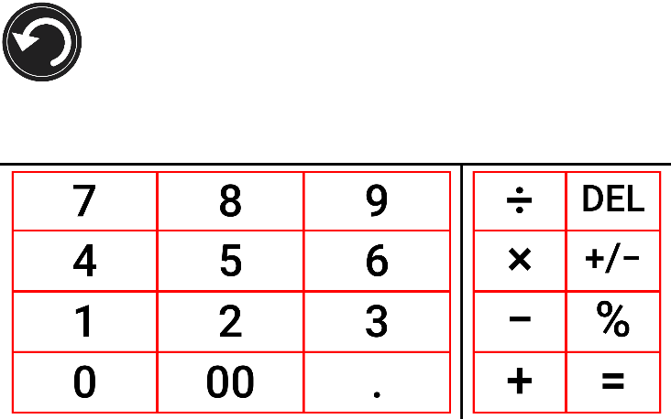
- Once you have your answer, you can tap CLR to clear the top section.
- By default, the Calculator is set to standard mode. To use mathematical functions such as sin, cos, tan, etc., you will need to toggle to scientific mode. To do so, press and hold the Back button, and tap to set the Calculator mode setting to scientific. Press Back to return to Calculator. You will then be able to tap the two arrows on the lower center of the screen to access scientific mathematical functions.
- Tap the Back button to return to the carousel menu.

Simple Mode
The simple mode allows you to access Reveal 16i’s main applications from the same screen. By default, Reveal 16i is set to standard mode.
To activate simple mode:
- From the carousel menu, swipe and select the Settings icon and tap. Tap User Interface, select and tap Simple, and tap Back twice to access simple mode menu:
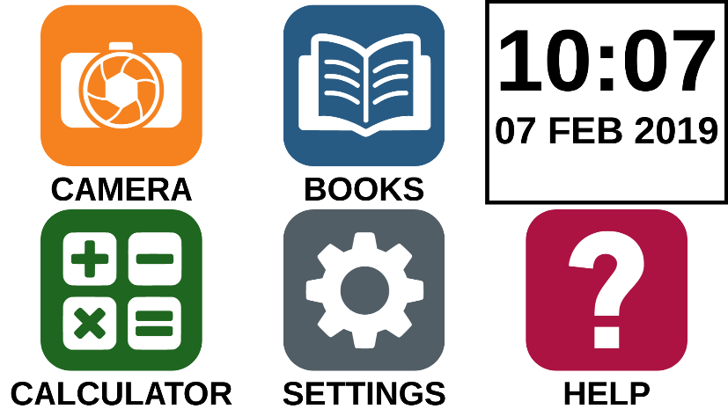
- The Camera, Books, Calculator, Settings and Help are now accessible from the same screen. You will also be able to see the time and date.
- Tap and hold your finger down on each app to hear their name and to know the time and date.

Changing your Settings
Reveal 16i’s settings menu is contextual; different settings will be displayed depending on what you are doing or where you are in the system.
To access the settings, tap the Settings button. Swipe up to select an item. The currently selected item is announced and highlighted by a frame. Scroll up or down to move the frame and select an item. The items will be read one at a time (by default). Tap to toggle the value or swipe when in a list of values. Tap Back (top left corner) to return to what you were doing.
Note: Your navigation mode will be different if your Speech setting is set to “Off” or “Documents only”. There will no longer be a frame, and each menu item will have a shadow below it. In this navigation mode, you can simply touch an item to select it instead of highlighting it with the frame.
Here is a list of Reveal 16i’s contextual settings:
(The values marked with a star (*) are default settings.)
- Brightness: 0 to 100% (50%*)
- Contrast: Diamond Edge (if captured image contains text), Color*, Positive, Negative
- Colors (Select from 20 color pairs): Black on white*, White on black, Black on yellow, Yellow on black, Black on orange, Orange on black, Black on cyan, Cyan on black, Black on purple, Purple on black, Black on green, Green on black, Blue on yellow, Yellow on blue, White on blue, Blue on white
- Mode (Standard mode only): Live*, Multi-Capture
- Autofocus (Live mode only): Locked, Unlocked*
- Speech: On*, Documents only, Off
- Voice: Voice 1*, Voice 2
- Speech Rate: Very slow, Slow, Normal*, Fast, Very fast
- Reading Mode: Page, Column*, Line
- Reading Speed: Very slow, Slow, Normal*, Fast, Very fast
- Diamond Edge: Always*, On Request
- Font Type: Regular, Bold*
- Preferred Zoom: 2x to 35x (4x*)
- Font Size: Minimum, Small, Medium, Standard*, Large, Very large, Extra large, Maximum
- Highlight (Column and Line modes only. Highlight on spoken words): Display*, Hide
- Delete Gallery content (in Gallery): Permanently delete all files in Gallery. Press and hold the Back button in the Gallery to reach this setting.
- Logout (in Books app): Log out of Bookshare. Press and hold the Back button in Books to reach this setting.
- Delete library content (in Books app): Permanently delete all downloaded books in Books. Press and hold the Back button in Books to reach this setting.
- Wi-Fi Setup (in Books app): Press and hold the Back button to reach this setting.
- Wi-Fi: Turn Wi-Fi On or Off.
- Wi-Fi Networks: List of available networks. When connected, shows network you are connected to.
- Saved Networks: Saved networks configurations. To forget a network configuration, tap network, tap Forget, and tap Yes.
- Mode (in Calculator app, press and hold Back to reach this setting): Standard*, Scientific
- Grid (in Calculator app, press and hold Back to reach this setting): Locator color*, Red, Orange, Yellow, Purple, Cyan, Green, Blue
- Gestures (while magnifying, viewing an image, or reading a document, allows you to enable/disable gestures. They are checked by default):
- Swipe on right edge / Contrast: Toggle between Color, Positive, Negative, and Diamond Edge contrasts (The last selection will be saved in Reveal 16i’s memory).
- Pinch and zoom: Adjust the zoom level by decreasing or increasing the distance between 2 fingers.
- Double tap: Access the carousel menu or toggle between Speech On and Off while reading by tapping twice quickly with 1 finger.
- Tap / Zoom: Press your finger down quickly on the touchscreen (tap) to zoom at your preferred zoom level.
You can access other general settings from the carousel menu by tapping the Settings icon:
You will see 5 main menus and 1 item: User Interface, Audio, System, Applications, Exit to Android, and About. Scroll up or down in the Settings to select a menu or item. Reveal 16i will announce “submenu” if a selected menu contains submenus and display an arrow on the right edge of the screen. To open a menu, submenu, or an item, simply select it and tap. Once you have reached the setting you want to modify, tap or swipe up in a list of values. Tap Back to return to a previous screen. Tap and hold the back button to exit the Settings from anywhere in the Settings menu.
Here is a list of Reveal 16i’s general settings:
(The values marked with a star (*) are default settings.)
User interface:
- Interface: Standard*, Simple
- System Language: Language 1*, Language 2, Configuration (will connect to the Internet to find downloadable language packs)
- Colors (See color pairs above in contextual settings)
- Locator color: Red*, Orange, Yellow, Purple, Cyan, Green, Blue
- Screen Brightness (Change the screen’s brightness level): 1 to 100% (60%*)
- Button Banner: Auto*, Hidden, Always
Audio:
- Speech: On*, Documents only, Off
- Speech Rate: Very slow, Slow, Normal*, Fast, Very fast
- Sounds: On*, Off
- Volume: 0 to 15
- Headphone Volume (when plugged in): 0 to 15
- OCR Sound: On, Off*
System:
- Wi-Fi Setup:
- Wi-Fi: Turn Wi-Fi On or Off.
- Wi-Fi Networks: List of available networks. When connected, shows network you are connected to.
- Saved Networks: Saved networks configurations. To forget a network configuration, tap network, tap Forget, and tap Yes.
- Bluetooth Setup
- Bluetooth: Turn Bluetooth on or off. When turned on, your Reveal 16i will both attempt to discover other Bluetooth devices and be discoverable by other devices.
- Paired Devices: Devices currently connected to Reveal 16i
  - Forget device: Unpairs the device. The device will remain discoverable in the Devices submenu.
  - Rename device: Choose another name for the device.
  - Reset name: Reverts to the device’s default name.
- Devices: Nearby Bluetooth devices discovered by Reveal 16i.

- Software Update: Update your device
- Auto Shutoff: 10 min*, 20 min, 30 min, Never
- Restore to Factory Defaults

Applications:
- Books: Checked*, Unchecked
- Calculator: Checked*, Unchecked
Exit to Android:
Exits Prodigi. You can return to Prodigi by pressing down the Zoom Button and tapping the Prodigi icon.

About:
- Software (Version)
- Prodigi (Version)
- Voices (Version)
- OCR (Version)
- Books (Version)
- Calculator (Version)
- Prodigi Updater (Version)
- Serial Number
- Model
- Android Version (Version)
- Android Build (Version)

Accessing Android
Reveal 16i allows you to access Android applications. Please note that HumanWare provides limited support for Android and Android applications.
Android is accessible from the Settings in the carousel menu. Tap the Settings icon and swipe down to select Exit to Android. You can also exit to android by placing and holding 4 or 5 fingers on the screen at the same time. This gesture is available anywhere in Reveal 16i. To come back to Prodigi once in Android select the Prodigi icon.

Help Menu
The rightmost item of the carousel menu is the Help Menu, where you will find many helpful videos showing you how to use your Reveal 16i. The Help Menu is represented by the question mark icon below:
Upon entering the help menu, you will have the following options:
Youtube tutorials: Here you have access to webinars and many useful tutorials on how to use your Reveal 16i . Make sure to check it out occasionally to see if there’s anything new.
Feedback: Tell us what you think of your Reveal 16i, what you like, and how you think we could improve in the future.

Software update

Setting up your Wi-Fi
Before initiating a software update, the Wi-Fi network needs to be configured.
- Tap the Settings icon from the carousel menu.
- Swipe to select System and tap.
- Tap to open Wi-Fi Setup.
- Select Wi-Fi Networks, and select the network you wish to connect to.
- Tap Connect. A keyboard will appear on the screen. Enter your password and tap on the blue button. Then, tap on Connect.

Automatic update
When Wi-Fi is configured, Reveal 16i will automatically check every week for updates.
If there is an update available, Reveal 16i will notify you and ask you if you wish to update your device. When this occurs:
- Tap Install to install the latest update. Your Reveal 16i will show the download progress.
- A new window will appear telling you that your software is now up to date. Tap OK to go back to Prodigi.

Manual update
At times, you may want to manually update Prodigi.
- Access the settings from the main menu, then select System.
- To initiate a software update, select Software Update and tap.
- Reveal 16i will verify if your software is up to date or if an update is available.
- If an update is available and you wish to install it, tap Install. If you wish to cancel, tap Cancel.
- If you chose to install the update, Reveal 16i will download the update and show the download progress.
- A new window will appear indicating that your software is up to date. Tap OK to go back to Prodigi.

Release Notes
To view the Prodigi software release notes:
- Access the settings from the main menu, then select System.
- Select software update.
- Select Release notes, if available.

Bluetooth Keyboard
With Reveal 16i, you can type and navigate using your own Bluetooth keyboard.

The HumanWare Keyboard
Though any Bluetooth keyboard will work, we encourage you to use the HumanWare keyboard shown below.
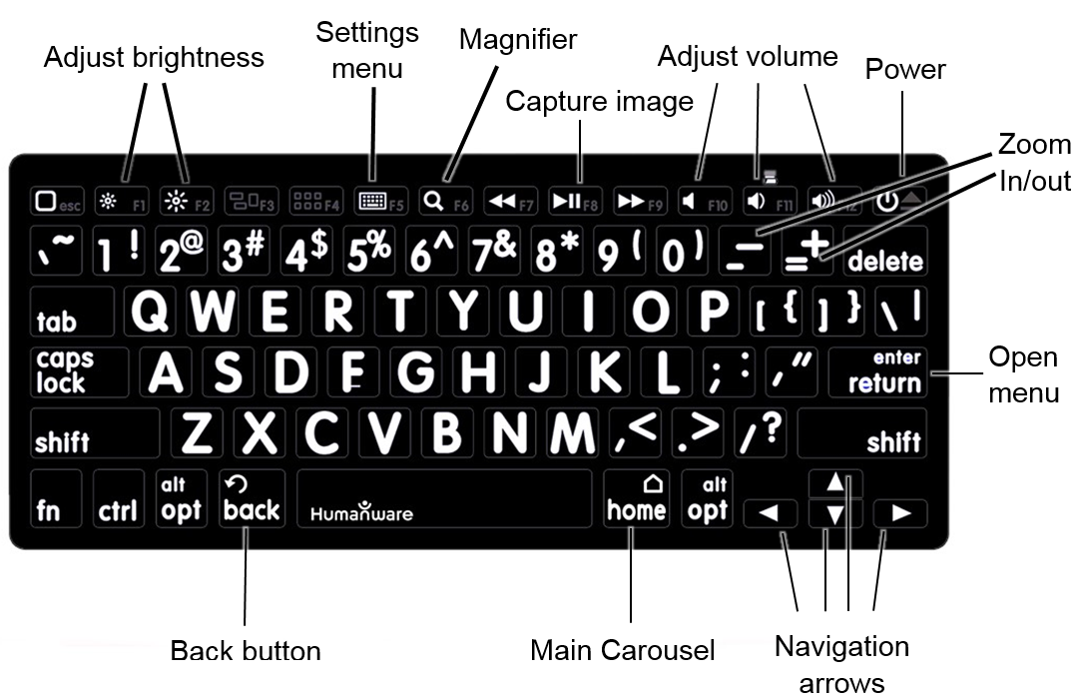
One of the advantages of using the Humanware keyboard is that all keys are printed in large, easy-to-read characters. In addition, icons of frequently used Reveal 16i commands are printed on the keyboard as a quick reminder of the key’s function.

Connecting a Bluetooth Keyboard
To connect your Bluetooth keyboard to your Reveal 16i:
- Make sure your Bluetooth keyboard is turned on.
- Access the general settings by tapping the Settings icon in the Carousel menu.
- Select and enter the System submenu.
- Select and enter Bluetooth Setup.
- Bluetooth will be off by default. Turn it on by tapping the Bluetooth menu item. After a few seconds, additional menu items will appear and your Reveal will become discoverable by other devices.
- Select and enter the Devices submenu.
- Select your Bluetooth keyboard and tap the screen.
- Tap Connect.
- Your Reveal 16i will display a PIN number. Type this number on your Bluetooth keyboard then press Enter.
- Your Bluetooth keyboard is now paired with your Reveal 16i and ready for use.

Stowing your reveal
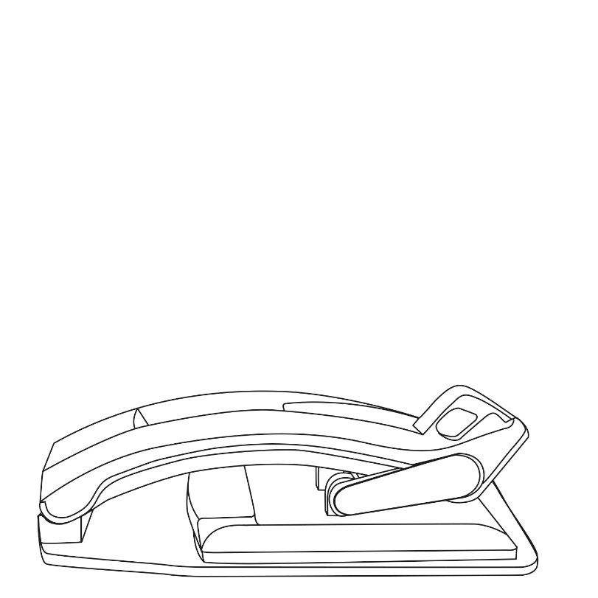
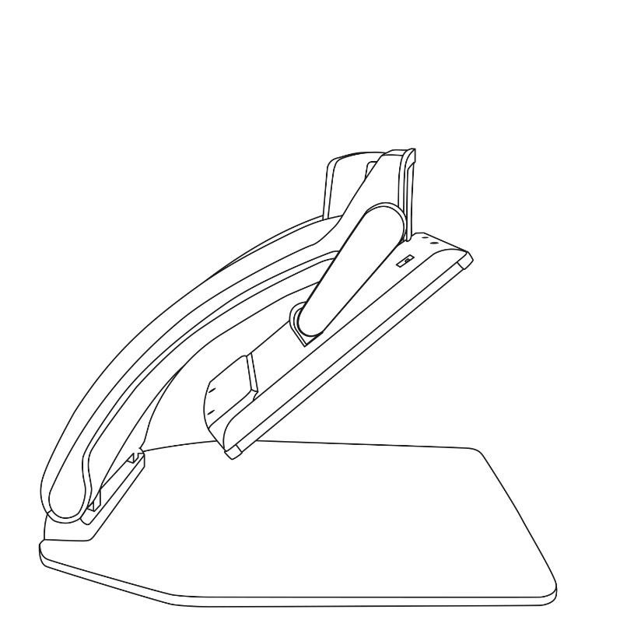
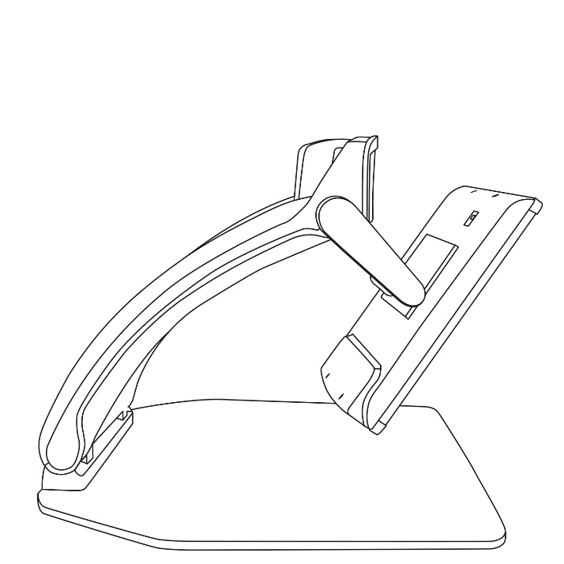
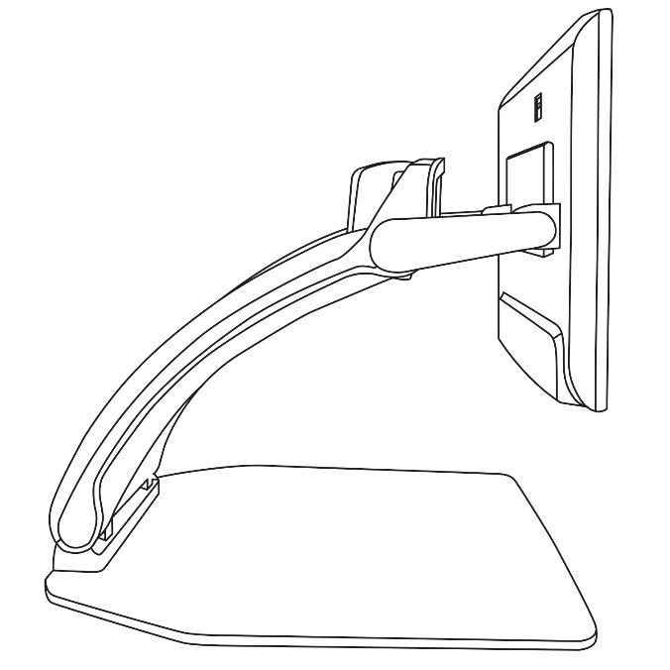
To stow your Reveal for later use, simply pack it as shown below.

Using Reveal on another Screen
For a larger image, you may want your Reveal's content to be displayed on an external screen (like a TV). To do so, simply connect your Reveal to an external screen using a High-Resolution video cable.

Troubleshooting
Reveal does not power on:
Press and hold Power. If the unit still does not turn on, make sure your device is plugged in the outlet.

Image is out of focus:
Press and hold the Autofocus lock button or move your hand back and forth over the document you are viewing. This will make your Reveal refocus on the document.

Screen is black:
Make sure the camera is in its default position, aiming at the reading tray.

Reveal shuts down after inactivity:
This is a normal behaviour intended to preserve your screen. By default, Reveal will shut down after 10 minutes of inactivity. It is possible to configure the default auto-off timer to 10 minute, 20 minutes, 30 minutes, or never.

Reveal does not respond:
Press Power for 10 seconds. The system will shut down. Then, press Power for one second to turn your Reveal back on.

If the audio reading does not make sense:
Make sure the voice setting is the same as your document’s language. Change it in the Settings if necessary.

Other problems:
Restore to factory defaults in the menu.
Press and hold Contrast.
Scroll down to Factory Defaults and select Yes.
*Warning! All your previous configurations will be lost!*

Safety and Maintenance
Do not stare at the LED light source located under the magnifier.
Keep away from water or high humidity. Do not submerge.
Power off your Reveal 16 before cleaning it.
Only use the cables provided with your Reveal 16.
Battery (Optional):
If the Reveal 16 has an optional internal rechargeable Li-Ion battery, the battery must be replaced by a qualified HumanWare technician.
- Do not use or leave the unit near a heat source or fire. Do not store in high temperatures.
- Do not disassemble or modify the unit.
- Do not immerse the unit in water, and do not let it get wet.
- Do not strike or throw the unit.
- Do not pierce or strike the unit with sharp objects or a hammer.
- If the battery leaks and liquid gets into the eyes, do not rub eyes. Instead, rinse the eyes with clean running water and seek immediate medical attention to prevent injury.
- If the battery leaks and comes into contact with skin, immediately rinse area with clean running water to prevent injury.
Cleaning the LCD screen:
Make sure your device is off and unplugged.
Make sure you only use microfiber cloths to clean the LCD screen.
Carefully and gently wipe the microfiber cloth across the LCD screen.
If you choose to clean your LCD screen with a liquid cleaner, make sure this cleaner is appropriate for LCD screens. Distilled water, isopropyl alcohol and a vinegar-water solution (no more than 10% vinegar) are safe cleaning liquids for your LCD screen.
Use only the minimal amount of liquid to prevent spills inside the device. If liquid seeps in, damages to the device might occur. Make sure no liquids remain on your screen. Repeat the previous steps for spots that are harder to remove.
Never use household cleaners to clean your Reveal 16.
Never spray any liquid directly on your LCD screen.
Never use cleaning products that contain ethyl alcohol, ethyl acid, ammonia, acetone or methyl chloride.
Never use a paper towel to clean your LCD screen.

Specifications
Size (unfolded): 370 x 380 x 464 mm
Size (folded): 150 x 380 x 473 mm
Weight (no battery): 6.8kg
Weight (with battery): 7.3kg
Display:
Size: 15.6 inches
Resolution: 1980x1080
Touchscreen
Live Camera:
4 Mpx
Zoom:
- 1-10x (Optical)
- 1-16x (Digital)
- 1-45x (Total)
Front Camera: 5 Mpx
Capture Camera:
21 Mpx
6-pt OCR on Latin characters
8-pt OCR on Chinese characters
3.5 mm Audio Jack
Type-A 3.0 USB port: UBS 3.0 compliant
High-Resolution video interface: 1920x1080
Wi-Fi: IEEE 802.11a/b/g/n/ac – 2.4 GHz, 5.0 GHz
Bluetooth: Bluetooth Low Energy Interface (BLE) and Classic interface (dual mode)
Power Adapter:
Input: 100-240V(50/60Hz), 2.0A
Output: 19VDC, 2.5A
Battery (in option): Li-Ion 6800 mAh
Battery Autonomy: 7 hours
Charge Time: 3.5 hours (when device is off)
Supported High-Resolution video output formats:
1920x1080p 60Hz,
No support of DVI emulation
Operating conditions:
Temperature: 10 ˚C to 40 ˚C / 50 ˚F to 104 ˚F
Humidity: 20% to 80% non-condensing

Transport and storage conditions:
Temperature: -20 ˚C to 60 ˚C / -4 ˚F to 140 ˚F
Humidity: 10% to 95% non-condensing

FCC/Industry Canada Info

FCC / Industry Canada Two Part Statement:
This device complies with FCC Part 15 and Industry Canada license exempt RSS standard(s). Operation is subject to the following two conditions: (1) this device may not cause interference, and (2) this device must accept any interference, including interference that may cause undesired operation of the device.

Per Industry Canada RSS rules:
This device complies with Health Canada’s Safety Code. The installer of this device should ensure that RF radiation is not emitted in excess of the Health Canada’s requirement. Changes or modifications not expressly approved by the party responsible for compliance could void the user’s authority to operate the equipment.

FCC Warning:
This equipment has been tested and found to comply with the limits for a Class B digital device, pursuant to part 15 of the Federal Communications Commission (FCC) Rules. These limits are designed to provide reasonable protection against harmful interference in a residential installation. This equipment generates and can radiate radio frequency energy and, if not installed and used in accordance with the instructions, may cause harmful interference to radio communications. However, there is no guarantee that interference will not occur in a particular installation. If this equipment causes harmful interference to radio or television reception, which can be determined by turning the equipment off and on, you are encouraged to try to correct the interference by one or more of the following measures:
• Reorient or relocate the receiving antenna.
• Increase the space between the equipment and receiver.
• Connect the equipment to an outlet on a circuit different from that to which the receiver is connected.
• Consult your dealer or an experienced radio/TV technician for help.

Warranty
HumanWare warrants Reveal, effective from the date of purchase, to be free of any defects in material and workmanship for a period of one (1) year unless otherwise required by law in the country or region of purchase. This warranty applies for a period of ninety (90) days in the case of the optional battery.
This warranty is non-transferable and applies to all cases where the damage is not a result of improper use, mistreatment, or negligence. Improper use is use of this device other than described in this manual. In no event shall HumanWare or its distributors be liable for indirect or consequential damages.
No replacement or repair covered by the warranty will be carried out unless the system is accompanied by a copy of the original bill of purchase. Please keep your original receipt. If the system has to be returned, please use the original packaging.

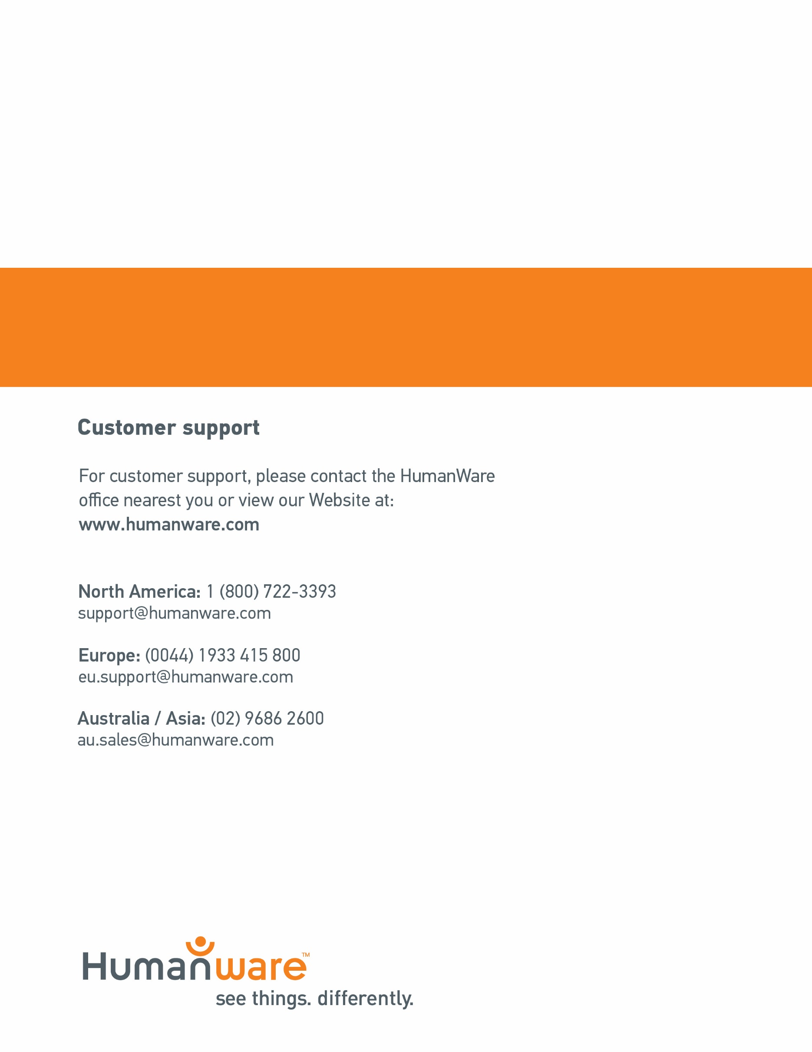
ACCD-0221
REV 05

