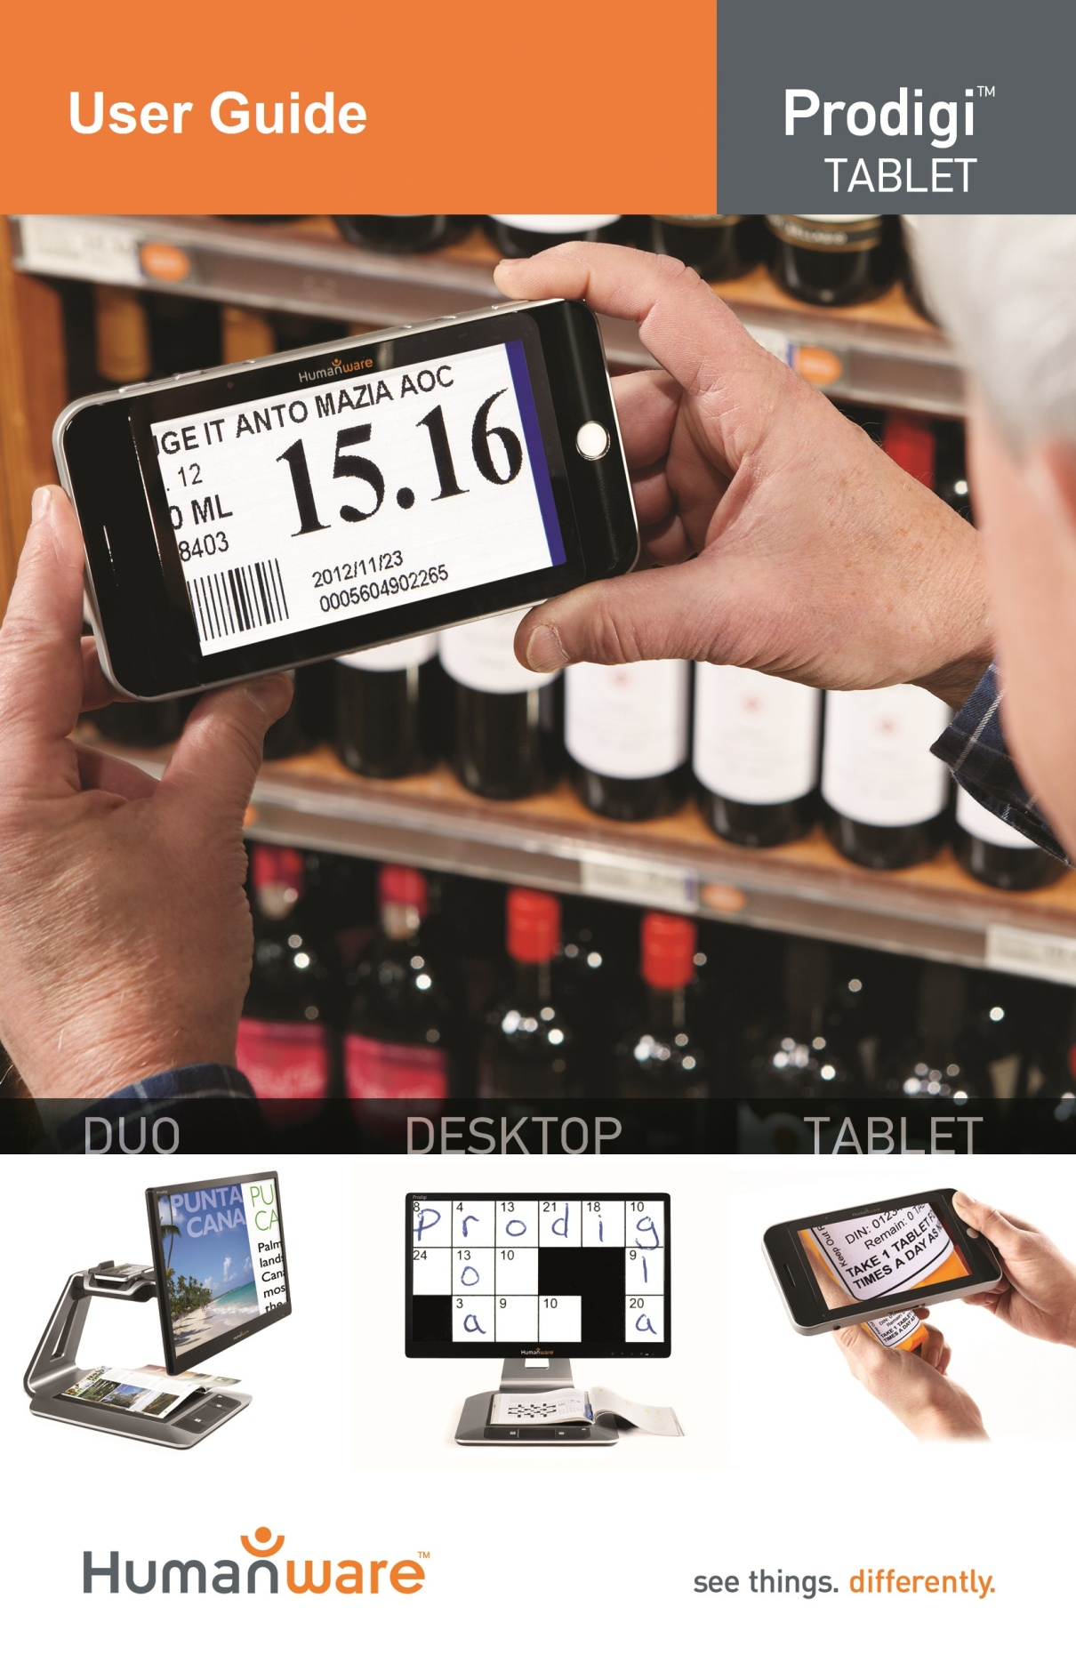

Contents
Chapter 1 – Introduction 1
Chapter 2 – Getting to know your Prodigi 2
Box Contents 2
Prodigi Tablet at a glance 2
Setting up 4
Chapter 3 – Using Prodigi 6
Using the Magnifier 6
Navigating on your Prodigi 9
Using the menu 10
Chapter 4 – Reading documents 11
Capturing documents 11
Spot Reading 12
Continuous Reading 14
Viewing saved documents 15
Choosing your contrast 18
Activating speech 20
Chapter 5 – Changing your Settings 22
Chapter 6 – Recharging your Tablet 28
Chapter 7 – Software update 31
Chapter 8 – Troubleshooting 33
Appendix A: Safety and Maintenance 35
Appendix B: Specifications 38
Appendix C: Warranty 39

Chapter 1 – Introduction
Thank you for purchasing Prodigi, the touch-controlled personal vision assistant system from HumanWare, global leader in assistive technologies for people who have low vision. Prodigi is a simple, intelligent, portable, and adaptable line of products aimed at restoring and maintaining independence for people living with vision loss.
Prodigi Tablet, small enough to fit in your pocket, is a complete magnification system that will allow you to magnify and read documents, capture images, and spot read on-the-go, anywhere you are.
Carefully read the operating and safety instructions described in this user guide prior to using your Prodigi. If you have any questions about your system, please contact HumanWare Customer Service by consulting the contact information in the back of this user guide.
Copyright 2013 by Technologies HumanWare Inc., all rights reserved. No part of this publication may be reproduced or distributed in any form or by any means, or stored in a database or retrieval system, without the prior written permission of Technologies HumanWare Inc.

Chapter 2 – Getting to know your Prodigi

Box Contents
- Tablet
- Power Supply
- USB Recharge Cable
- Reading Stand (under the plastic blister)
- Getting Started Guide
- User Guide
- Warranty Sheet
- Cleaning Tissue
- DVD

Prodigi Tablet at a glance
Top Edge and Front Face
3

2

1

6

4

5

Bottom Edge and Back Side
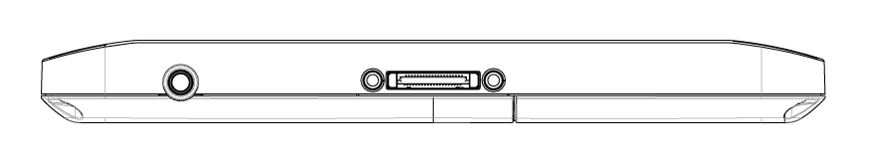
8

7

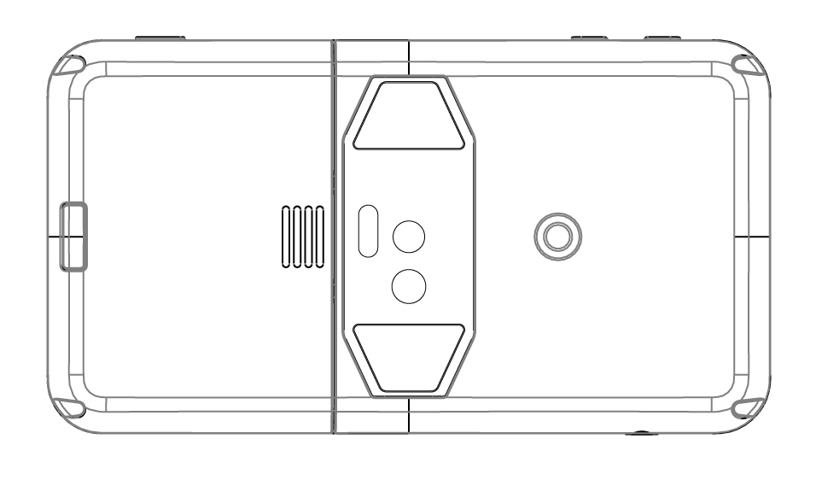
9

Prodigi

11

10

- Plus-Minus keys
- Power Button
- Read Button
- Speaker
- Touchscreen
- Back Button
- Audio Port
- Recharge Port
- Release Button (for battery)
- Battery Compartment
- LED Lights (2)

Setting up
- Connect the USB Recharge Cable to the Power Supply.
- Hold the Tablet so that the screen side is facing you and the recharge port is aiming downwards. Make sure the tactile HumanWare logo on the recharge cable is facing you (1). Carefully connect the cable to the recharge port and plug it to an outlet.
1

IMPORTANT: Use caution while inserting the cable into the Recharge Port.
- Let the Tablet recharge for 8 consecutive hours (initial charge).
- Press Power to power on the Tablet. Prodigi will take about 1 minute to initialize. HumanWare’s logo will appear on the screen, followed by Prodigi’s startup screen.

Chapter 3 – Using Prodigi

Using the Magnifier
Prodigi’s Magnifier allows you to enlarge objects and quickly find information on documents (Spot Reading) with ease and simplicity.
- Press Power. After initializing, Prodigi will automatically launch the Magnifier.
- Hold the Tablet about 1 to 2 inches (3 to 5 cm) above the document or object you wish to view.
- It is recommended to use the Reading Stand to stabilize the Tablet above the document you wish to view. Make sure the tactile HumanWare logo on the Reading Stand is facing up (1) and that you place the Tablet front face up on the Reading Stand:
1

- Use the Plus-Minus keys to adjust the zoom level. To decrease character size, press the Minus key (the left one). To increase character size, press the Plus key (the right one).
Note: You can also use the pinch and zoom gesture to adjust the zoom level. Decrease the distance between 2 fingers to zoom out, and increase the distance to zoom in:
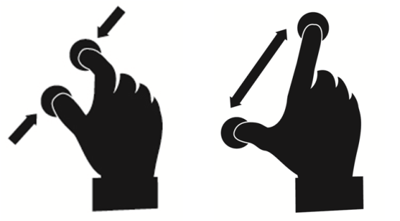
- Move the Tablet above the object/document (or slide the Reading Stand) to find the information you are looking for.
- To freeze and save an image of what you are viewing, press and hold the Read button for 2 seconds. It will be saved in Prodigi’s Gallery for future use. Press Back to unfreeze the image.
- To toggle between color, positive, and negative contrasts, swipe on the right edge of the touchscreen:
Note: To learn more about Prodigi’s contrasts, see section Choosing your Contrast in Chapter 4.
- You can adjust the brightness of what you are viewing by accessing the Quick Settings menu. Press and hold the Back button and tap or use the Plus-Minus keys to adjust the brightness in percentage. Once you reach your desired brightness level, press Back or simply wait a few seconds to continue using the Magnifier. Press and hold the Back button if you want to return to the Quick Settings menu.
Note: For more information about the Quick Settings menu, see Chapter 5 – Changing your Settings.

Navigating on your Prodigi
You can navigate on your Prodigi by performing 3 simple touch gestures on the touchscreen. Here’s a short description of these gestures.
TAP
Press your finger down shortly anywhere on the touchscreen.
SWIPE
Think of it as turning a book page. Swipe forward (to the left) or back (to the right) by sliding and releasing your finger.
PAN
Slowly move your finger in any direction without lifting it.

Using the menu
Prodigi has 3 main applications – Magnifier, Gallery, and Settings. They are presented one by one in the carousel menu:
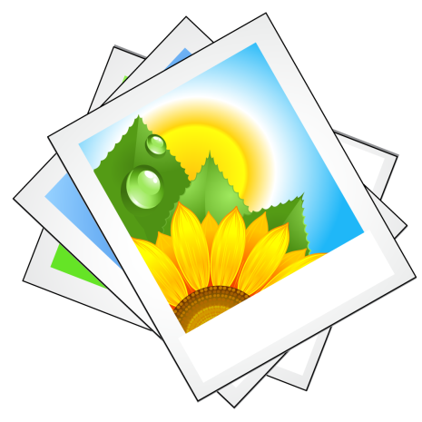
To access the carousel menu from the Magnifier:
- Press Back to close the Magnifier and access the carousel menu.
- The currently selected application is positioned in the center of the screen:
- Swipe forward or back in the carousel menu to select an application.
- To launch a selected application, simply tap.
- To cancel, press Back.

Chapter 4 – Reading documents
Capturing and reading documents is made easy with Prodigi, allowing you to quickly find information on a document (Spot Reading), or sit back and relax as text is scrolled in the most comfortable view and pace for your vision (Continuous Reading).

Capturing documents
- First, press and hold the Back button to access the Quick Settings menu and swipe down to select Working Range. Tap to select Far. Press Back to exit the Quick Settings menu (See Chapter 5 – Changing your Settings to learn more about the Quick Settings menu).
- Launch the Magnifier. Position your Tablet at 4 inches (10 cm) or more above the document you wish to capture and read.
Note: To see a complete letter-size page on the screen, position your Tablet at about 10 inches (25 cm) above your document.
- Press and hold the Read button for 2 seconds to capture your document. Make sure you do not move the Tablet until you hear a clicking noise indicating that the document has been captured. An image capture may take up to 2 seconds.
Note: If the captured image is too dark, blurry, or unfocused, you may want to turn on the camera’s flash and capture a new image. Press and hold the Back button to access the Quick Settings and swipe down to select Flash. Tap to select On. Press Back to exit the Quick Settings.
Note: Turning on or off the camera’s flash is only possible from the Magnifier when the camera’s Working Range is set to Far.

Spot Reading
- You can now begin spot reading. On the top left corner, you will notice an orange frame. This is Prodigi’s locator. Move the locator by panning to quickly reach a section of the document you want to read:
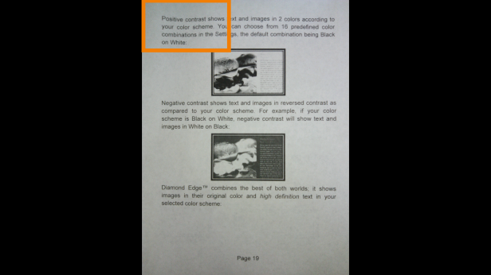
- Tap to enlarge the section delimited by the locator:
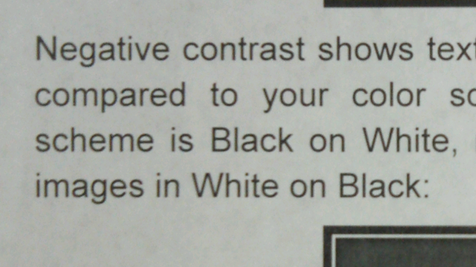
- When a section of a document is magnified, pan to reach other parts of the document.
- Use the Plus-Minus keys or the pinch and zoom gesture to adjust the zoom level.
- Press Back to see the locator again. This is a practical way to locate your position on the document.

Continuous Reading
Prodigi’s Continuous Reading feature scrolls text according to your preferences. Text can be presented in 3 different ways (Reading Modes): it can be transformed into a single line in the Line mode (default), a column in the Column mode, or you can read text without losing its configuration in the Page mode. Two “greater than” inequality signs will mark the end of a paragraph in the Line and Column modes (˃˃).
- To start reading, simply press Read after having captured a document that contains text. You can also move the locator over a specific place on your document and press Read to start reading from there.
- To increase the reading speed, swipe forward.
- To slow down the reading speed, swipe back.
- To pause, tap or press Read.
- To resume, tap or press Read again.
- When paused, pan left or right (Line mode), up or down (Column mode), or in any direction (Page mode) to go forward or back in the text.
- Use the Plus-Minus keys or the pinch and zoom gesture to adjust the zoom level.
- Press Back to stop reading and go back to your previous position.
- To set a different Reading Mode, first press Back to stop reading. Then, press and hold the Back button to access the Quick Settings menu, and Swipe down to select Reading Mode. Tap to change your Reading Mode. Press Back to exit the Quick Settings menu.

Viewing saved documents
The Gallery contains all the documents you saved.
- Select and tap on the Gallery in the carousel menu:
- Swipe forward or back in the Gallery to flip through the documents.
- The currently selected document is the one in the center of the screen. To open a selected document, simply tap.
- Move the locator to quickly reach a section of the document you want to magnify.
- Tap to see the section delimited by the locator at your preferred zoom level.
- You can toggle between color, positive, negative, and Diamond Edge™ (if the image contains text) contrasts, and adjust the brightness in the same way as with the Magnifier (see Chapter 3, section Using the Magnifier for more information).
- Press Back to see the locator again.
- Press Back again to close a document and return to the Gallery. Once you close a document, Prodigi will remember your position and apply it automatically the next time you open the document.
Notes: If a document contains text, the first word of the text will be shown to identify it in the Gallery. The word ‘EMPTY’ will appear if the Gallery contains no documents. The Gallery should contain no more than 100 documents. Once you pass this number, you will be prompted to delete some documents from the Gallery before saving new ones.
To delete a document:
- In the Gallery, press and hold your finger down on the image you want to delete. You will be prompted ‘DELETE?’ and a red X will appear. Tap to confirm, or press Back to cancel.
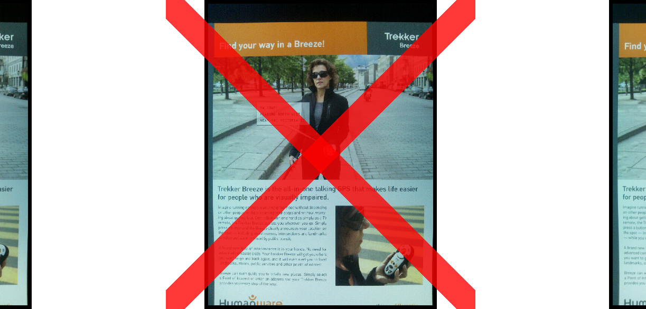

Choosing your contrast
Prodigi allows you to view documents, pictures and objects in 3 types of contrast: color, positive or negative. For documents that contain text, a 4th type of contrast can be used: Diamond Edge™. Positive, negative, and Diamond Edge™ contrasts are enhanced; they are meant to enhance the original color of a document or object to facilitate your visual experience.
Color contrast is useful if you want to view documents, objects, and photographs in their original color.
Positive contrast shows text and images in 2 colors according to your selected color combination, the default combination being Black on White. This is a practical way to view text in the best color combination for your vision.
Negative contrast shows text and images in reversed contrast as compared to your color combination. For example, if your color combination is Black on White, negative contrast will show text and images in White on Black. This is useful if you wish to reverse the contrast of a text that contains different contrasts.
Diamond Edge™ contrast combines the best of both worlds; it shows Diamond Edge Text™ in your selected color combination and images in their original color. This allows you to magnify text indefinitely without compromising its quality in the best color combination for your vision, while viewing images in their original color on the same page.
To toggle between the different contrasts, swipe on the right edge of the touchscreen:
You can also change your contrast from the Quick Settings menu. Press and hold the Back button, select Contrast, and tap to choose a contrast. Press Back to exit the Quick Settings menu.
Note: The contrast cannot be changed while in Line or Column mode, or while viewing an image at 1x in Read view or in the Gallery.

Activating speech
To prevent eye fatigue, you can have Prodigi read text aloud to you.
- Activate speech first in the Quick Settings. Press and hold the Back button, and select Speech. Tap to set it to On. Press Back to return to your document.
- Press Read. Prodigi will simultaneously highlight the word and read it aloud to you:
Note: You can also toggle between Speech On and Off by doing a double tap gesture (tapping twice rapidly with 1 finger) while in Continuous Reading mode. To learn how to activate the double tap gesture, see Chapter 5 – Changing your Settings, Gestures and Controls).
- To increase the reading speed, swipe forward.
- To slow down the reading speed, swipe back.
- To pause, tap or press Read.
- To resume, tap or press Read again.
- To adjust the volume, first tap or press Read to pause. Access the Quick Settings (press and hold the Back button), select Volume and tap or use the Plus-Minus keys to adjust the volume. Press Back to exit the Quick Settings. Tap or press Read to resume reading.
- To stop reading, press Back.
Note: Prodigi contains 2 different voices that can be used to read aloud text documents. To select a different voice, press and hold the Back button to access the Quick Settings, swipe down to select Voice, and tap to toggle between the 2 reading voices. Press Back to exit the Quick Settings. Make sure that the language of the selected voice is the same as in the document you want to read.

Chapter 5 – Changing your Settings
(Note: The values marked with a star (*) are default settings.)
To quickly configure your system while viewing a document, you can access the Quick Settings menu, an abbreviated version of the Settings, by pressing and holding the Back button. The currently selected item is highlighted by a rectangular frame. Swipe up or down to move the rectangle and select an item. Tap or use the Plus-Minus keys to toggle the value. Press Back again to return to your document.
The Quick Settings menu lists the battery status and the most used settings:
- Brightness (Change the brightness of a live or captured image, except for 1x image in Gallery): 0 to 100% (50%*)
- Contrast: Color*, Diamond Edge (only for documents that contain text), Positive, Negative
- Colors: 16 color pairs (see main Settings below)
- View: Live*
- Reading Mode: Page, Column, Line*
- Speech: On, Off*
- Voice: Voice 1*, Voice 2
- Volume: 0 to 15 (8*)
- Flash (Turn flash on or off in Magnifier when Working Range: Far is selected): On, Off*
- Working Range (Camera’s focus on work area): Near*, Far
You can further customize your system by selecting the Settings in the carousel menu:
The Settings are divided in 5 main categories: Visual, Audio, Gestures and Controls, General, and About. Swipe up or down in the Settings to select a category. An arrow on the right edge of the screen indicates that a category contains either sub-categories or a list of settings. To open a category or sub-category, simply select it and tap. Once you have reached the setting you want to modify, simply tap on it to change its value. To change numerical values, you can also use the Plus-Minus keys. Press Back to return to a previous screen.

Visual
The Visual category consists of 3 sub-categories:
- Display contains the following settings:
- Screen Brightness (Change the screen’s brightness level): 1 to 100% (60%*)
- View: Live*
- Contrast: Color*, Positive, Negative (see chapter 4, Choosing your contrast)
- Diamond Edge™: Always, On Request* (see chapter 4, Choosing your contrast)
- Colors (Select from 16 color pairs): Black on White*, White on Black, Yellow on Black, Orange on Black, Cyan on Black, Purple on Black, Green on Black, Black on Green, Black on Purple, Black on Cyan, Black on Orange, Black on Yellow, Blue on Yellow, Yellow on Blue, White on Blue, Blue on Black
- Locator color (change the locator’s color): Orange*, Yellow, Purple, Cyan, Green, Blue, Red
- Preferred Zoom (change the locator’s initial zoom level): 2 to 35x (6x*)
- Text contains the following settings:
- Reading Mode: Page, Column, Line*
- Font Size: Medium, Large*, Very large, Extra large
- Font Type: Regular*, Bold
- Camera contains the following setting:
- Working Range (Camera’s focus on work area): Near*, Far

Audio
The Audio category contains the following settings:
- Volume: 0 to 15 (8*)
- Sounds: On*, Off
- Vibrations: On*, Off
- Speech: On, Off*
- Voice: Voice 1*, Voice 2
- Speech Rate: Very Slow, Slow, Normal*, Fast, Very Fast

Gestures and Controls
The Gestures and Controls consists of 2 sub-categories:
- Gestures (enable and disable gestures):
  - Swipe on right edge*: Once selected, this gesture will enable you to toggle between Color, Positive, Negative, and Diamond Edge™ contrasts (Note: The last selection will be saved in Prodigi’s memory)
- Pinch and Zoom*: Once selected, this gesture will enable you to adjust the zoom level by increasing and decreasing the distance between 2 fingers
- Double Tap: Once selected, this gesture will enable you to toggle between Speech On and Off by tapping twice rapidly with 1 finger
- Controls (Configure the behavior of the Plus-Minus keys):
- Plus-Minus keys: Volume, Magnification*

General
The General category consists of 6 items:
- System Language: Language 1*, Language 2 (Choices depend on country or region)
- Wireless Setup (Help of a sighted person required): Wi-Fi Setup, Bluetooth Setup
- Auto Shutoff: 3 min*, 5 min, 10 min, Never
- Software Update (see chapter 7)
- Restore to Factory Defaults
- Mains Electricity: 50 Hz, 60Hz (Default value depends on country regulations)

About
The About category allows you to see the following:
- Software Version
- Tablet Model
- Tablet SN (Serial Number)

Chapter 6 – Recharging your Tablet
Maximizing operating efficiency:
- In a working situation where you need the Tablet intermittently, you can enter Sleep mode when you are not using the Tablet by pressing Power shortly. The screen will power off.
- Exit Sleep mode by pressing Power shortly again.
- If you will not be using the Tablet for the next few days, it is recommended that you power it off by pressing and holding the Power button.
Recharging the battery:
To verify the Tablet’s battery status, press and hold the Back button to access the Quick Settings. If the battery charge level is below 10%, it is recommended that you recharge the battery.
To recharge the battery using mains electricity:
- Connect the USB Recharge Cable to the Tablet Power Supply. Then, carefully connect the USB Recharge Cable to the Tablet and plug the Power Supply to an outlet (See section Setting up for more details on how to plug the Tablet).
- Let the Tablet recharge for 8 hours the first time and for 4 hours subsequently.
To recharge the battery with a computer:
- First, press Power shortly to enter Sleep Mode.
- Then, plug the USB recharge cable to a computer USB port.
Note: Please note that recharging the battery this way can take longer than by plugging it to an outlet.
- Press Power to exit Sleep Mode.
IMPORTANT: The battery becomes warm during recharging. Do not recharge the battery near a heat source.
Replacing the battery:
Contact HumanWare or your authorized distributor to obtain a replacement battery.
- Power off the Tablet by pressing and holding the Power button for 1 second, and unplug it from the outlet.
- Hold the Tablet up, its back side facing you.
- Press the release button near the left edge of the Tablet, and simultaneously slide the compartment door to the left to remove it.
- The battery’s upper left edge has a tab. Use this tab to lift the used battery up.
Note: The model and serial numbers can be found under the battery.
- To insert the new battery: There are connector pins on the lower right edge of the battery. Insert the right edge first, and press gently on the left edge to snap the new battery in place.
- Slide the compartment door back on until the release button snaps back in place.

Chapter 7 – Software update
Before initiating a software update, the WI-FI network has to be configured with the help of a sighted person.
- Select and open the Settings in the carousel menu. Swipe down to select General and tap. Swipe down to select Wireless Setup and tap. Tap again to open WI-FI Setup.
- Tap the OFF button on the top edge of the screen to switch it to ON.
- Tap on the network you wish to configure.
- To enter your password, tap on the blinking cursor. A keyboard will appear on the screen. Enter the password and tap on Done. Then, tap on Connect.
- Press Back twice to return to General in Prodigi’s Settings.
To initiate a software update, swipe down to select Software Update and tap.
IMPORTANT: Make sure your system is connected to power before updating the software.
- If your system is connected to power, the messages “Enabling WI-FI...” and “Checking for update” will appear.
- Once the WI-FI connection is established, Prodigi will tell you whether your software is up to date or whether a new version is available.
- Select and press on “Install” to download the new software version, or “Cancel” to abort.
- If you pressed “Install”, the message “Downloading update...” will appear.
- Once the download is complete, Prodigi will restart automatically with the new software version.

Chapter 8 – Troubleshooting
If the image on the screen is flickering while using the Magnifier:
- Make sure that the Working Range is set to Near in the Quick Settings.
If the screen is blank:
- Zoom out of the image for minimum magnification.
- The Tablet could be powered off or in Sleep Mode. Press Power to power it on or to exit Sleep Mode.
If colors are difficult to detect:
- Check if you have sufficient ambient light.
- Choose a different contrast or color combination in the Settings.
- Adjust the brightness level in the Quick Settings.
If there is a lot of glare:
- Tilt object in a different direction to reduce glare.
- Reduce the brightness level in the Quick Settings.
- Reduce external lighting effects.
- If the camera’s flash is turned on and your captured image is too bright or uneven, turn off the flash in the Quick Settings and capture a new image.
If the image/text is out of focus or blurry:
- Use the Plus-Minus keys to zoom in and then out of the image so as to trigger the camera’s focus. If needed, capture a new image of your document.
- Make sure you hold the camera still for 2 full seconds while capturing an image.
- Turn on the camera’s flash in the Quick Settings and capture a new image.
- Make sure your Tablet is powered off, and wipe the LED lights and camera surface on the back side with your included cleaning tissue.
If the audio reading does not make sense:
- Make sure the voice setting is the same as your document’s language. Change it in the Settings if necessary.
If the Tablet is not responding:
- Make sure the battery is not empty. Recharge it if necessary.
Other problems:
- Restore factory defaults in the Settings.
- Press and hold the Power button for 10 seconds and release. Wait 30 seconds, and press Power again.
- Power off the Tablet, remove the battery, and install it back again.
- Contact your dealer or technical support.

Appendix A: Safety and Maintenance
Safety Instructions:
The user must not stare at the 2 LED light sources that are located on the back side of the Tablet.
Keep away from water or high humidity. Do not submerge.
Power off your Prodigi before cleaning it.
Use only cables provided with your Prodigi.
This product should be operated from the type of power indicated on the marking label. If you are unsure of the type of power available, consult your dealer or local power company.
Only use your Prodigi indoors. Do not expose it to sudden or extreme changes in temperature or humidity conditions. This product should not be placed near a heat source or exposed to direct sun light for a prolonged period of time.
Refer all servicing of this product to qualified service personnel. Do not attempt to service it yourself, as opening or removing covers may expose you to dangerous voltage points or other risks.
Susceptibility to Interference:
There may be temporary degradation of the image when Prodigi is subjected to a strong radio-frequency field, electro-static discharge or transient electrical noise. An electro-static discharge (caused by static electricity) may cause the screen to go blank. If this happens, power the system off and on again.

FCC Warning:
This equipment has been tested and found to comply with the limits for a Class B digital device, pursuant to part 15 of the Federal Communications Commission (FCC) Rules. These limits are designed to provide reasonable protection against harmful interference in a residential installation. This equipment generates and can radiate radio frequency energy and, if not installed and used in accordance with the instructions, may cause harmful interference to radio communications. However, there is no guarantee that interference will not occur in a particular installation. If this equipment causes harmful interference to radio or television reception, which can be determined by turning the equipment off and on, you are encouraged to try to correct the interference by one or more of the following measures:
Reorient or relocate the receiving antenna.
Increase the space between the equipment and receiver.
Connect the equipment to an outlet on a circuit different from that to which the receiver is connected.
Consult your dealer or an experienced radio/TV technician for help.
Maintenance and Disposal Instructions:
Wipe your Prodigi’s surfaces with a soft and dry cloth.
At the end of Prodigi’s operational lifetime, its internal components must be disposed in compliance with local authorities.
Prodigi contains no hazardous materials. For disposal, return to HumanWare or follow local governing ordinances or hospital procedure.

Appendix B: Specifications
Operating Conditions:
- Temperature: 0 to 35 °C / 32 to 95 °F
- Humidity: 5 to 95%
Transport and Storage Conditions:
- Temperature: -20 to 60 °C / -4 to 140 °F
- Humidity: 5 to 95%
Power Supply:
- Tablet Input Voltage: 5 V

Appendix C: Warranty
HumanWare warrants Prodigi, effective from the date of delivery, to be free of any defects in material and workmanship for a period of 1 year unless otherwise required by law in the country or region of purchase.
This warranty is non-transferable and applies to all cases where the damage is not a result of improper use, mistreatment, or negligence. Improper use is use of this device other than described in this manual. In no event shall HumanWare or its distributors be liable for indirect or consequential damages.
No replacement or repair covered by the warranty will be carried out unless the system is accompanied by a copy of the original bill of purchase. Please keep your original receipt. If the system has to be returned, please use the original packaging.

[End of document VER-05-20131129]

REV 05

REV01

