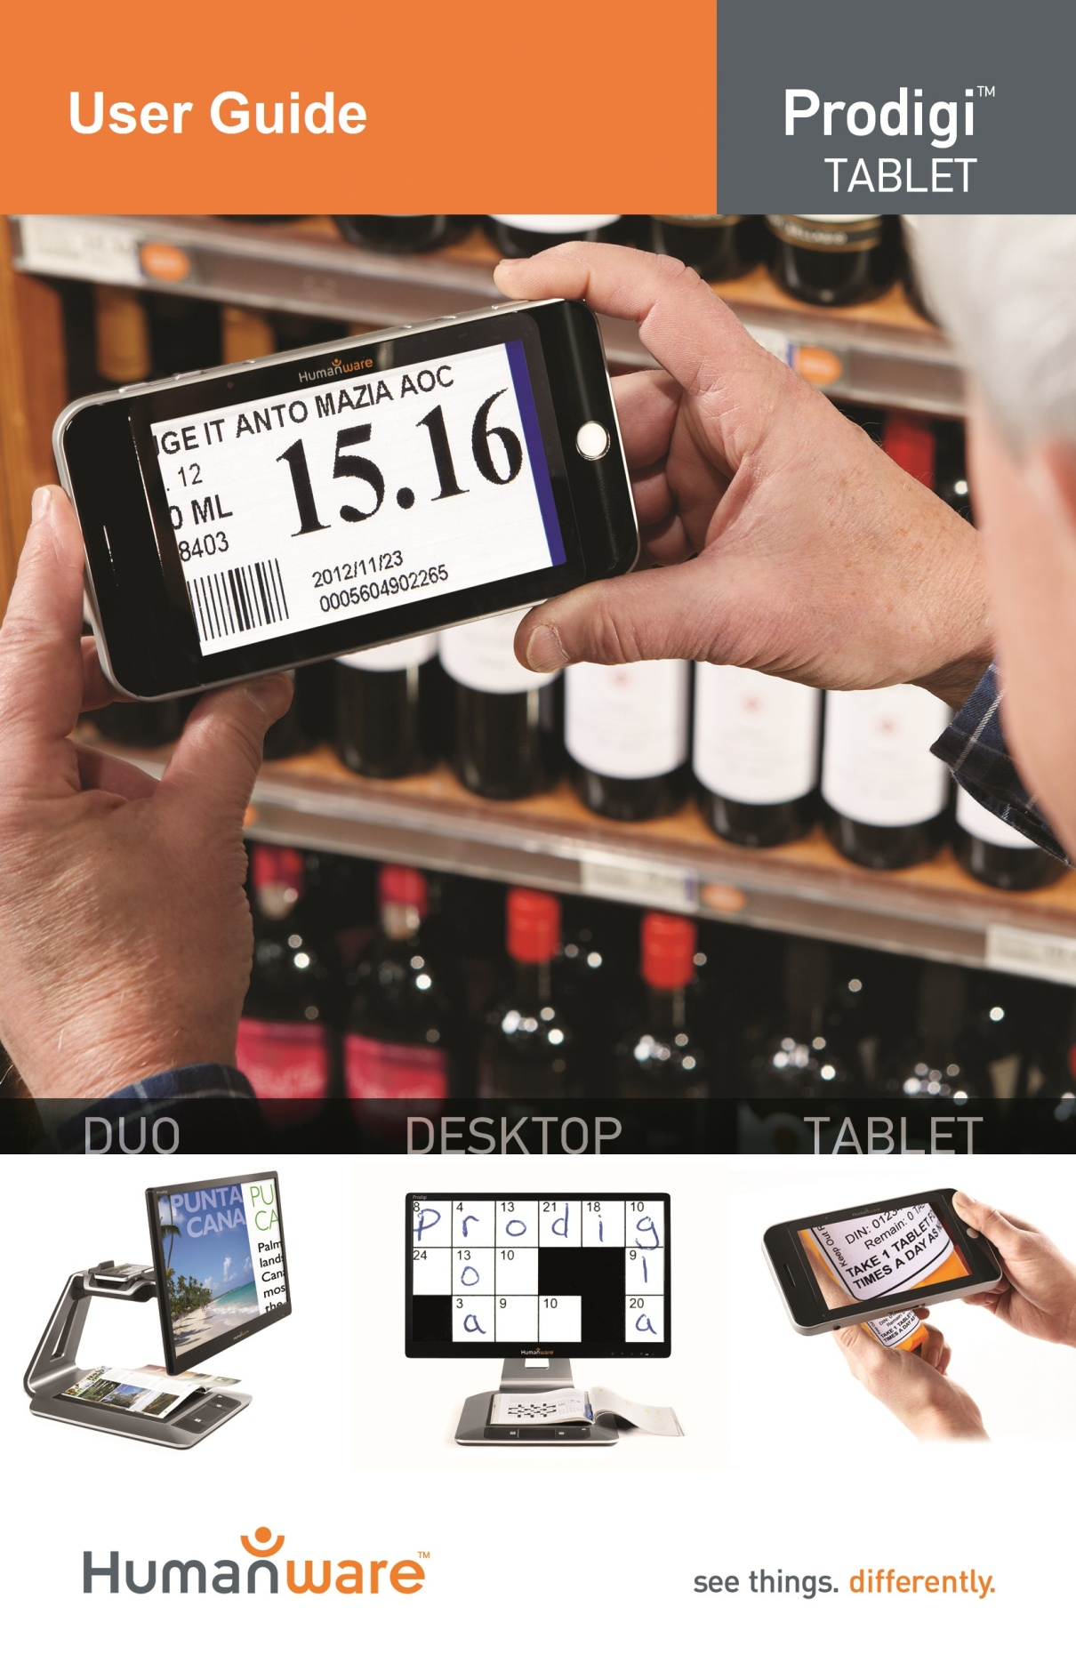

Contents
Contents 1
Chapter 1: Introduction 2
Chapter 2: Getting to know your Prodigi 3
Box Contents 3
Prodigi Tablet at a glance 4
Setting up 6
Chapter 3: Using Prodigi 7
Magnifying 7
Capturing and Reading 11
Chapter 4: Switching to Standard Interface 14
Magnifying (Standard Interface) 15
Capturing and Reading (Standard Interface) 16
Multi-Capture (Standard Interface) 18
Spot Reading 20
Using the Carousel menu 21
Viewing saved documents 23
Action Menu 25
Chapter 5: Choosing your contrast 29
Chapter 6: Changing your Settings 32
Chapter 7: Recharging your Tablet 39
Chapter 8: Software update 43
Chapter 9: Troubleshooting 44
Appendix A: Safety and Maintenance 47
Appendix B: Specifications 51
Appendix C: Warranty 52

Chapter 1: Introduction
Thank you for purchasing Prodigi, the touch-controlled personal vision assistant system from HumanWare, global leader in assistive technologies for people who have low vision. Prodigi is a simple, intelligent, portable, and adaptable line of products aimed at restoring and maintaining independence for people living with vision loss.
Prodigi Tablet, small enough to fit in your pocket, is a complete magnification system that will allow you to magnify and read documents, capture images, and spot read on-the-go, anywhere you are.
Carefully read the operating and safety instructions described in this user guide prior to using your Prodigi. If you have any questions about your system, please contact HumanWare Customer Service by consulting the contact information in the back of this user guide.
Copyright 2016 by Technologies HumanWare Inc., all rights reserved. No part of this publication may be reproduced or distributed in any form or by any means, or stored in a database or retrieval system, without the prior written permission of Technologies HumanWare Inc.

Chapter 2: Getting to know your Prodigi

Box Contents
Tablet Box
- Prodigi 5-inch Tablet
- Protective Carrying Case
- Power Supply
- USB Recharge Cable
- HDMI Output Cable (not available with Duo model)
- Reading Stand
- Unboxing Guide
- Getting Started Guide
- User Guide
- Warranty Sheet
- Cleaning Tissue
- DVD
Capture Stand Box
- Capture Stand
- Carrying Pouch
- One-Page Instruction Document

Prodigi Tablet at a glance
Top Edge and Front Face
3

2

1

6

4

5

Bottom Edge and Back Side
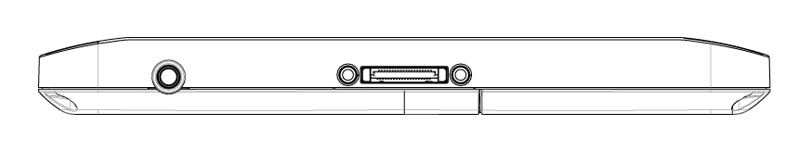
8

7

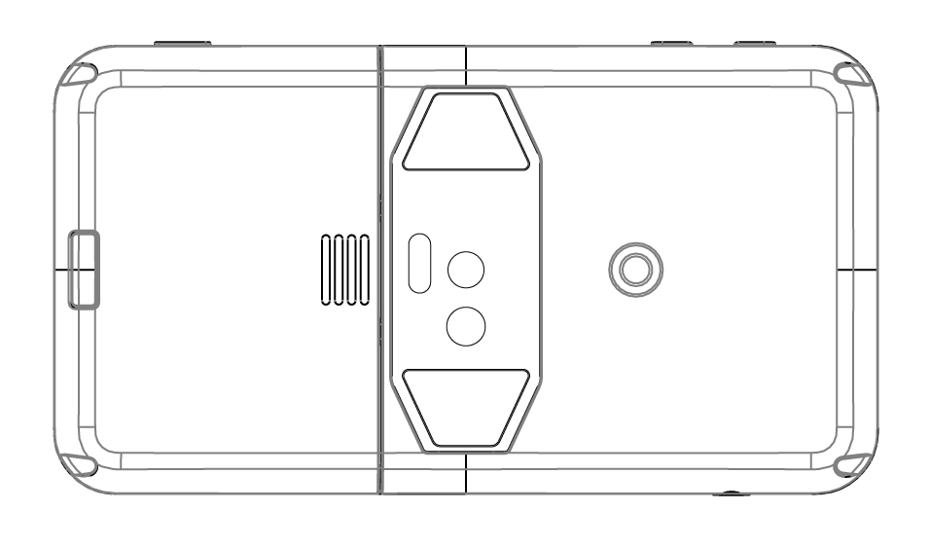
Prodigi

11

9

10

- Plus-Minus keys
- Power Button
- Read Button
- Speaker
- Touchscreen
- Back Button
- Audio Port
- Recharge/HDMI Output Port
- Release Button (for battery)
- Battery Compartment
- LED Lights (2)

Setting up
- Connect the USB Recharge Cable to the Power Supply.
- Hold the Tablet so that the screen side is facing you and the recharge port is aiming downwards. Make sure the tactile HumanWare logo on the recharge cable is facing you (1). Carefully connect the cable to the recharge port and plug it to an outlet.
1

IMPORTANT: Use caution while inserting the cable into the Recharge Port.
- Let the Tablet recharge for 8 consecutive hours (initial charge).
- Press Power to power on the Tablet. Prodigi will take about 1 minute to initialize. HumanWare’s logo will appear on the screen, followed by Prodigi’s startup screen.

Chapter 3: Using Prodigi

Magnifying
- Power on the Tablet.
- Hold the Tablet about 1 to 2 inches (3 to 5 cm) above the document or object you wish to view.
- It is recommended to use the Reading Stand to stabilize the Tablet above the document you wish to view.

Make sure the tactile HumanWare logo on the Reading Stand is facing up (1) and that you place the Tablet front face up on the Reading Stand:
1

- Use the Plus-Minus keys to adjust the zoom level. To increase character size, press the Plus key (the right one). To decrease character size, press the Minus key (the left one). You can also press and hold the Plus-Minus keys to progressively adjust the zoom level, and release once you reach your desired zoom level.
- Move the Tablet (or slide the Reading Stand) above the object/document to find the information you are looking for.
- To toggle between color, positive, and negative contrasts, press and hold the Back button to access the Settings. Then, scroll down to select Contrast, and tap (press your finger down quickly on the touchscreen) to toggle between the different contrasts. Press Back to exit the Settings.
Note: You can either tap or use the Plus-Minus keys to toggle between different values in the Settings.
- By default, Prodigi will read aloud the Settings’ menus, items, and values. To deactivate Speech, press and hold the Back button, select Speech, and tap. Press Back to return to your document.
- Diamond Edge contrast will become available once you freeze an image of what you are viewing. To freeze an image, press and hold the Read button. You will hear a clicking noise indicating that the document has been captured.
- Press Back to unfreeze the image.
- You can adjust the brightness of what you are viewing by accessing the Settings menu. Press and hold the Back button and select Brightness. Tap to adjust the brightness in percentage. Once you reach your desired brightness level, press Back or simply wait a few seconds to continue magnifying. Press and hold the Back button if you want to return to the Settings menu.
Note: You can also view your document or object on an external monitor (such as a TV). Carefully connect the HDMI cable to the Tablet’s recharge port and to the external monitor. The Tablet screen will be turned off and replicated on external monitor.

Capturing and Reading
- First, press and hold the Back button to access the Settings menu and tap to select Working Range: Full Page. Press Back to exit the Settings menu.
- Position the Tablet at 4 inches (10 cm) or more above the document you wish to capture and read.
Note: To see a complete letter-size page on the screen, position the Tablet at about 10 inches (25 cm) above your document.
- Press and hold the Read button to capture your document. You will hear a clicking noise indicating that the document has been captured.
- Press Read again to scroll and read aloud the text according to your reading preferences.
- To adjust the volume, use the Plus-Minus keys while reading.
- To pause, press Read.
- To resume, press Read again.
Note: Text can be presented in 3 different ways (Reading Modes): it can be transformed into a single line in the Line mode, a column in the Column mode (default), or you can read text without losing its configuration in the Page mode. Two “greater than” inequality signs will mark the end of a paragraph in the Line and Column modes (˃˃). Prodigi will beep and announce “End of document” when you reach the end of your document; press Read to start reading from the beginning again.
- To set a different Reading Mode, press and hold the Back button to access the Settings menu and select Reading Mode. Tap to change your Reading Mode. Press Back to exit the Settings menu.
- You can increase the speech rate by swiping to the left (sliding and releasing your finger to the left) on the touchscreen, and decrease the speech rate by swiping to the right.
Note that changing the speech rate will change the reading speed (text scrolling speed) accordingly.
Note: You can also increase or decrease the speech rate from the Settings. Press and hold the Back button, select Speech Rate, and tap to change the value. Press Back multiple times to exit the Settings.
- To deactivate Speech, press and hold the Back button, select Speech and tap. When Speech is deactivated, you will be able to change the reading speed (text scrolling speed) by swiping left or right, or from the Settings (in the Visual menu and Text submenu). You can toggle back to Speech On by pressing and holding the Read button anywhere in the Settings menu.
- Prodigi contains 2 different voices that can be used to read aloud text documents. To select a different voice, press and hold the Back button, select Voice, and tap to toggle between the 2 reading voices.

- Press Back to return to your document. Make sure that the language of the selected voice is the same as in the document you want to read.
- Press Back to stop reading and return to camera view.

Chapter 4: Switching to Standard Interface
Prodigi contains two different interfaces, Simple and Standard, which can be changed according to your specific needs. By default, Prodigi’s interface is set to Simple (see previous chapter for more information). Prodigi’s Standard interface allows you to perform more touch gestures, keep your documents in memory, and further customize your system.
To switch your interface to Standard:
- Press and hold the Back button to access the Settings, select All Settings and tap.
- Select General and tap.
- Tap again to change the User Interface. Select Yes, and tap to confirm.

Magnifying (Standard Interface)
- After switching your interface to Standard, Prodigi will automatically launch the Magnifier.
- You can manipulate the Tablet, navigate in the text and adjust the brightness in the same way as on the Simple interface. See chapter 3 (section Magnifying) for more information.
- In addition to the Plus-Minus keys, you can use the pinch and zoom gesture to adjust the zoom level. Decrease the distance between 2 fingers to zoom out, and increase the distance to zoom in:
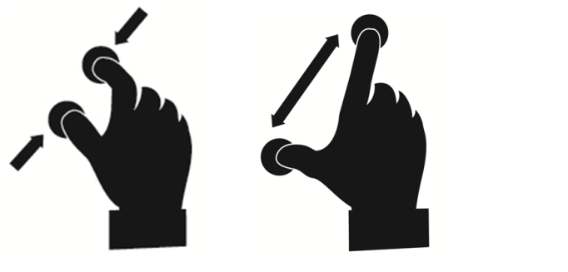
- In addition to changing the contrast from the Settings, you can toggle between color, positive, and negative contrasts by swiping on the right edge of the touchscreen:
- To freeze and save an image of what you are viewing, press and hold the Read button. It will be saved in the Gallery for future use. Press Back to unfreeze the image.

Capturing and Reading (Standard Interface)
- First, press and hold the Back button to access the Settings menu and tap to select Working Range: Full Page. Press Back to exit the Settings menu.

Note: Manipulate the Tablet, navigate in the enlarged text, and adjust the brightness in the same way as on the Simple interface (see chapter 3, section Magnifying for more information). To toggle between the different contrasts, swipe on the right edge of the touchscreen or access the Settings (see previous section for more information).
- Press and hold the Read button to capture and save your document. You will hear a clicking sound indicating that the document has been captured, and it will be saved in the Gallery for future use.
- Press Read again to scroll and read aloud the text according to your reading preferences.
- To pause, press Read or Back.
- To resume, press Read again.
- On the Standard interface, in addition to deactivating speech from the Settings, you can toggle between Speech On and Off when reading a document by doing a double tap gesture on the touchscreen (tapping twice quickly with 1 finger).
- You can change the speech rate or reading speed, adjust the volume, and select a different reading voice in the same way as on the Simple interface (see chapter 3, section Capturing and Reading).
- While paused, press Back to stop reading, and Back again to return to camera view.

Multi-Capture (Standard Interface)
If you wish to capture and save a multipage document:
- First, make sure you are in Full Page mode. Press and hold the Back button to access the Settings menu and tap to select Working Range: Full Page. Press Back to exit the Settings menu.
- Toggle to Multi-Capture mode by swiping on the left edge of the touchscreen:
Note: You can also toggle to Multi-Capture mode in the Settings. Access the Settings, select Mode and set it to Multi-Capture. Exit the Settings.
- Press Read to capture the first page of your document. Proceed in the same way for each page you wish to capture. Your multipage document will be saved in the Gallery.
- Press Back to end Multi-Capture and access your document. Swipe left or right to select a page, and tap to open the page and spot read with Prodigi’s locator.
- To read your document, select a page you wish to start reading from and press Read. Prodigi will read your entire document and announce when it reaches the end of your document. A sound will indicate when a new page is being read.
- Press Back to return to the page placement frame, and Back again to return to the carousel menu.

Spot Reading
- Once you have captured a document (either at Working Range: Close-up or Full Page), you will notice a rectangle frame on the top left corner. This is Prodigi’s locator. Move the locator by slowly moving your finger on the touchpad without lifting it (pan gesture) to quickly reach a section of the document you want to read:
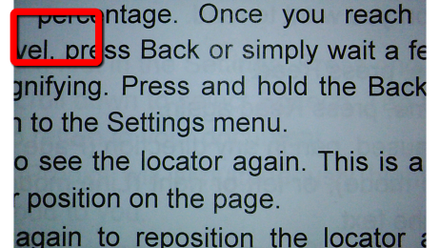

- Tap to enlarge the section delimited by the locator:
- When a section of a document is magnified, pan to reach other parts of the document.
- Tap or press Back to see the locator again. This is a practical way to locate your position on the document.

Using the Carousel menu
Prodigi has 3 main applications – Magnifier, Gallery, and Settings. They are presented one by one in the carousel menu:
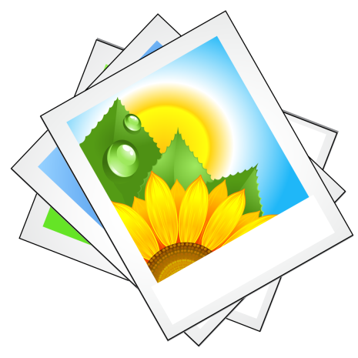

To access the carousel menu from the Magnifier:
- Press Back to close the Magnifier and access the carousel menu.
- From anywhere on the system, you can access the carousel menu by tapping twice quickly with two fingers (double-finger, double tap gesture).
- Prodigi will announce “Main Carousel” followed by the currently selected application.
The currently selected application is positioned in the center of the screen:
- Swipe left or right in the carousel menu to select an application.
- To launch a selected application, simply tap.
- To cancel, press Back.

Viewing saved documents
The Gallery contains all the documents you saved.
- Select and tap on the Gallery in the carousel menu:
- Swipe left or right in the Gallery to flip through your saved documents.
- The currently selected document is in the center of the screen. Prodigi will announce and indicate the first word contained in the currently selected document. If the document contains no words, Prodigi will tag it as an image. A notebook icon will indicate a multipage document.
- To open a selected document, simply tap.
- Move the locator to quickly reach a section of the document you want to magnify.
- Tap to see the section delimited by the locator at your preferred zoom level.
- You can toggle between color, positive, negative, and Diamond Edge™ (if the image contains text) contrasts, and adjust the brightness in the same way as with the Magnifier (see section Magnifying (Standard interface) for more information).
- Tap or press Back to see the locator again.
- Press Back to close a document and return to the Gallery. Once you close a document, Prodigi will remember your position and apply it automatically the next time you open the document.
Notes: Prodigi will announce “Gallery empty” if the Gallery contains no document. The Gallery cannot contain more than 100 documents. Once you pass this number, you will be prompted to delete some documents from the Gallery before saving new ones.

Action Menu
The Gallery features an “Action Menu” that includes many useful functions for your saved documents.
In the Action menu, you can:
- Create a new category
- Rename a document or category
- Delete a document, category, or the content of a category
- Move a document to a category
- Export the text from document to a text file in Android file system
- Delete, replace, insert or append pages in a multipage document.
To access the Action menu, simply long press on a document or category icon in the Gallery. You will be directed to a menu listing available actions for your selected file.

To delete a document, a category, or the content of a category
- Long press on the document or category you want to delete.
- Tap Delete, Delete category or Delete category content.
- Tap Yes to confirm deletion.
To rename a document or category
- Long press on the document or category you wish to rename.
- Tap Rename or Rename category.
- Type in the new name of your document or category.
- Tap DONE (Enter key on keyboard).
To create a new Category
- Long press on any document.
- Tap Create new category.
- Type in the name of your new category.
- Tap DONE. Categories will be sorted alphabetically in the Gallery.

To move a document to a category
- Long press on the document you want to move.
- Tap Move.
- Tap the category where you wish to move your document.
Export the text from a single-page or multipage document to a text file in Android file system to be retrieved via the USB cable from PC
- Carefully connect the USB recharge cable to the recharge port and plug it to a computer.
- Long press on the document whose text you wish to export.
- Tap Export OCR text.
- The OCR (optical character recognition) text will be saved as a text file in the root of your Tablet named Prodigi_ followed by the same filename as in the Gallery.

To delete, replace, insert, or append a page in a multipage document.
- Open the multipage document you wish to modify.
- To delete a page, long press on the page you wish to delete and tap Yes to confirm deletion.
- To replace a page, long press on the page you wish to replace. Tap replace, tap Yes and capture a new page.
- To insert a page, long press on the page where you want to insert a new page. Tap insert and capture a new page.
- To append a page, long press on any page in a multipage document and tap append. Capture your document. It will be added at the end of your document.

Chapter 5: Choosing your contrast
Prodigi allows you to view documents, pictures and objects in 3 types of contrast: color, positive or negative. For documents that contain text, a 4th type of contrast can be used: Diamond Edge™. Positive, negative, and Diamond Edge™ contrasts are enhanced; they are meant to enhance the original color of a document or object to facilitate your visual experience.
Color contrast is useful if you want to view documents, objects, and photographs in their original color.
Positive contrast shows text and images in 2 colors according to your selected color combination, the default combination being Black on White. This is a practical way to view text in the best color combination for your vision.

Negative contrast shows text and images in reversed contrast as compared to your selected color combination. For example, if your combination is Black on White, negative contrast will show text and images in White on Black. This is useful if you wish to reverse the contrast of a text that contains different contrasts.
Diamond Edge™ contrast combines the best of both worlds; it shows Diamond Edge Text™ in your selected color combination and images in their original color. This allows you to magnify text indefinitely without compromising its quality in the best color combination for your vision, while viewing images in their original color on the same page.
To toggle between the different contrasts, press and hold the Back button to access the Settings, select Contrast, and tap to choose a contrast. Press Back to return to your document or object.

Prodigi’s Standard interface also allows you to toggle between the different contrasts by swiping on the right edge of the touchscreen:
Note: The contrast cannot be changed while in Line or Column mode, or while viewing an image at 1x (Gallery).

Chapter 6: Changing your Settings
(Note: The values marked with a star (*) are default settings.)
To quickly configure your system while viewing a document, you can press and hold the Back button to access the Settings menu. The currently selected item is announced and highlighted by a rectangular frame. Scroll up or down to move the rectangle and select an item. The items will be read one at a time (by default). Tap or use the Plus-Minus keys to toggle the value. Press Back to return to your document.
The Settings menu lists the battery charge level and the most frequently used settings:
- Working Range (Camera’s focus on work area): Close-up*, Full Page
- Brightness (Change the brightness of a live or captured image, except for 1x image in Gallery): 0 to 100% (50%*)
- Contrast: Diamond Edge (if captured image contains text), Color*, Positive, Negative
- Colors: Black on White* (see list of 16 color pairs in main Settings below)
- Mode (Standard Interface): Live*, Multi-Capture
- Reading Mode: Column*, Line, Page
- Speech: On*, Documents only, Off
- Speech Rate: Very slow, Slow, Normal*, Fast, Very fast
- Voice: Voice 1*, Voice 2
- Tablet Volume: 0 to 15 (9*)
- Headphone Volume (when headphones are plugged in): 0 to 15 (3*)
- Flash (Turn flash on or off when Working Range: Full Page is selected): On*, Off
You can further customize your system by selecting All Settings at the end of the Settings menu. With Prodigi’s Standard interface, you can also access these Settings by selecting and opening the Settings application in the carousel menu:
The Settings contain 5 main menus: Visual, Audio, Gestures and Controls, General, and About. Scroll up or down in the Settings to select a menu. Prodigi will announce “submenu” if a selected menu contains submenus and display an arrow on the right edge of the screen. To open a menu or submenu, simply select it and tap or press the Plus key. Once you have reached the setting you want to modify, tap or use the Plus-Minus keys to change its value. Press Back to return to a previous screen. Press and hold the Back button to exit the Settings from anywhere in the Settings menu.

Visual
The Visual menu contains 3 submenus:
- Display contains the following settings:
- Screen Brightness (Change the screen’s brightness level): 1 to 100% (60%*)
- Mode: (Standard Interface): Live*, Multi-Capture
- Contrast: Diamond Edge (if captured image contains text), Color*, Positive, Negative (see chapter 5)
- Diamond Edge: Always*, On Request (See chapter 5)
- Colors (Select from 20 color pairs): Black on white*, White on black, Black on gray, Gray on black, Black on yellow, Yellow on black, Black on orange, Orange on black, Black on cyan, Cyan on black, Black on purple, Purple on black, Black on green, Green on black, Blue on yellow, Yellow on blue, White on blue, Blue on white, Beige on black, Black on beige
- Locator Color (change the locator’s color): Red*, Orange, Yellow, Purple, Cyan, Green, Blue
- Preferred Zoom (change the locator’s initial zoom level): 2 to 35x (4x*)
- Text contains the following settings:
- Reading Mode: Column*, Line, Page
- Reading Speed: Very slow, Slow, Normal*, Fast, Very fast
- Font Size: Minimum, Small, Medium, Standard*, Large, Very large, Extra large, Maximum
- Font Type: Regular, Bold*
- Highlight (Column and Line modes only. Highlight on spoken words): Display*, Hide
- Camera contains the following setting:
- Working Range (Camera’s focus on work area): Close-up*, Full Page

Audio
The Audio menu contains the following settings:
- Tablet Volume: 0 to 15 (9*)
- Headphone Volume (when headphones are plugged in): 0 to 15 (3*)
- Sounds: On*, Off
- Tablet Vibrations: On*, Off
- Speech: On*, Documents only, Off
- Speech Rate: Very slow, Slow, Normal*, Fast, Very fast
- Voice: Voice 1*, Voice 2
- OCR Sound: On, Off*

Gestures and Controls
The Gestures and Controls menu contains 1 item:
- Gestures (Enable and disable gestures. By default, all gestures are deactivated on Simple interface and activated on Standard interface):
- Swipe on left edge / Mode (Standard interface only): Toggle between Live and Multi-Capture modes.
- Swipe on right edge / Contrast: Toggle between Color, Positive, Negative, and Diamond Edge™ contrasts (Note: The last selection will be saved in Prodigi’s memory).
- Pinch and Zoom: Adjust the zoom level by decreasing or increasing the distance between 2 fingers.
- Double tap / Speech: Toggle between Speech On and Off by tapping twice quickly with 1 finger.
- Tap / Zoom: Press your finger down quickly (tap) to zoom at your preferred zoom level from the locator.

General
The General menu contains the following items:
- User Interface: Simple*, Standard
- System Language: Language 1*, Language 2 (Choices depend on country or region)
- WI-FI Setup (Help of a sighted person is required to configure wireless network)
- Tablet Auto Shutoff: 3 min*, 5 min, 10 min
- Software Update (see chapter 8)
- Delete Gallery content (Standard interface only): Permanently delete all files in Gallery.
- Restore to Factory Defaults

About
The About menu contains the following items:
- Software (Version)
- Tablet SN (Serial Number)
- Tablet Model
- Android (Version)

Chapter 7: Recharging your Tablet
Maximizing operating efficiency:
- In a working situation where you need the Tablet intermittently, you can enter Standby mode when you are not using the Tablet by pressing Power. The screen will power off and a double-beep will be sounded.
- Exit Standby mode by pressing and holding the Power button.
- If you will not be using the Tablet for the next few days, it is recommended that you power it off by pressing and holding the Power button, and tapping anywhere on the touchscreen to select OK.
Recharging the battery:
Press and hold the Back button to enter the Settings menu and to display the Tablet’s battery charge level. Swiping upwards in the Settings menu from the first item will announce the charge level (if Speech is set to On in the Settings). If the battery charge level is below 10%, it is recommended that you recharge the battery.
IMPORTANT: The battery becomes warm during recharging. Do not recharge the battery near a heat source.
To recharge the battery using mains electricity:
- Connect the USB Recharge Cable to the Tablet Power Supply. Then, carefully connect the USB Recharge Cable to the Tablet and plug the Power Supply to an outlet.
- Let the Tablet recharge for 8 hours the first time and for 4 hours subsequently.
To recharge the battery with a computer:
- First, press Power to enter Standby Mode.
- Then, plug the USB recharge cable to a computer USB port.
Note: Please note that recharging the battery this way can take longer than by plugging it to an outlet.
- Press and hold the Power button to exit Standby Mode.
Battery safety precautions:
- Do not disassemble or modify the battery.
- Use only the specified HumanWare charger.
- There is a risk of overheating, fire or explosion if the battery is put in a fire, heated, subjected to impact, put in contact with water, or if its terminals are shorted.
Replacing the battery:
Contact HumanWare or your authorized distributor to obtain a replacement battery.
- Power off the Tablet and unplug it from the outlet.
- Hold the Tablet up, its back side facing you.

- Press the release button near the left edge of the Tablet, and simultaneously slide the compartment door to the left to remove it.
- The battery’s upper left edge has a tab. Use this tab to lift the used battery up.
Note: The model and serial numbers can be found under the battery.
- To insert the new battery: there are connector pins on the lower right edge of the battery. Insert the right edge first, and press gently on the left edge to snap the new battery in place.
- Slide the compartment door back on until the release button snaps back in place.

Chapter 8: Software update
Before initiating a software update, the WI-FI network has to be configured with the help of a sighted person.
- Press and hold the Back button to access the Settings, and select All Settings. Tap to open. Select General and tap. Select WI-FI Setup and tap.
- Tap the OFF button on the top edge of the screen to switch it to ON.
- Tap on the network you wish to configure.
- To enter your password, tap on the blinking cursor. A keyboard will appear on the screen. Enter the password and tap on Done. Then, tap on Connect.
- Press Back twice to return to General in Prodigi’s Settings.
- To initiate a software update, select Software Update and tap.
IMPORTANT: Make sure your system is connected to power before updating the software.
- Once the WI-FI connection is established, Prodigi will tell you whether your software is up to date or whether an update is available.
- If an update is available and you wish to install it, select Install and tap. If you wish to cancel, select Cancel and tap.
- If you chose to install the update, Prodigi will download the update and show the download progress in percentage.
- Once the download is complete, Prodigi will reboot and install the update automatically. Android’s green logo will be shown on screen during the update.

Chapter 9: Troubleshooting
If the image on the screen is flickering while magnifying:
- Make sure that the Working Range is set to Close-up in the Settings.
If the screen is blank:
- Zoom out of the image for minimum magnification.
- The Tablet could be powered off or in Standby Mode. Press Power to power it on, or press and hold the Power button to exit Standby Mode.

If colors are difficult to detect:
- Check if you have sufficient ambient light.
- Choose a different contrast or color combination in the Settings.
- Adjust the brightness level in the Settings.
If there is a lot of glare:
- Tilt object in a different direction to reduce glare.
- Reduce the brightness level in the Settings.
- Reduce external lighting effects.
- If your captured image is too bright or uneven, turn off the flash in the Settings and capture a new image.
If the image/text is out of focus or blurry:
- Use the Plus-Minus keys to zoom in and then out of the image so as to trigger the camera’s focus. If needed, capture a new image of your document.
- Make sure you hold the camera still while capturing an image.

- Make sure your Tablet is powered off, and wipe the LED lights and camera surface on the back side with your included cleaning tissue.
If the audio reading does not make sense:
- Make sure the voice setting is the same as your document’s language. Change it in the Settings if necessary.
If the Tablet is not responding:
- Make sure the battery is not empty. Recharge it if necessary.
Other problems:
- Restore factory defaults in the Settings.
- Press and hold the Power button for 10 seconds and release. Wait 30 seconds, and press Power again.
- Power off the Tablet, remove the battery, and install it back again.
- Contact your dealer or technical support.

Appendix A: Safety and Maintenance
Safety Instructions:
The user must not stare at the 2 LED light sources that are located on the back side of the Tablet.
Keep away from water or high humidity. Do not submerge.
Power off your Prodigi before cleaning it.
Use only cables provided with your Prodigi.
This product should be operated from the type of power indicated on the marking label. If you are unsure of the type of power available, consult your dealer or local power company.
Only use your Prodigi indoors. Do not expose it to sudden or extreme changes in temperature or humidity conditions. This product should not be placed near a heat source or exposed to direct sun light for a prolonged period of time.
Refer all servicing of this product to qualified service personnel. Do not attempt to service it yourself, as opening or removing covers may expose you to dangerous voltage points or other risks.
Susceptibility to Interference:
There may be temporary degradation of the image when Prodigi is subjected to a strong radio-frequency field, electro-static discharge or transient electrical noise. An electro-static discharge (caused by static electricity) may cause the screen to go blank. If this happens, power the system off and on again.
Warning RF Exposure Compliance:
The antenna(s) used for this transmitter must be installed to provide a separation distance of at least 20 cm from all persons and must not be co-located or operating in conjunction with any other antenna or transmitter. Users and installers must be provided with antenna installation instructions and transmitter operating conditions for satisfying RF exposure compliance.
FCC / Industry Canada Two Part Statement:
This device complies with FCC Part 15 and Industry Canada license exempt RSS standard(s). Operation is subject to the following two conditions: (1) this device may not cause interference, and (2) this device must accept any interference, including interference that may cause undesired operation of the device.
Per Industry Canada RSS rules:
This device complies with Health Canada’s Safety Code. The installer of this device should ensure that RF radiation is not emitted in excess of the Health Canada’s requirement. Changes or modifications not expressly approved by the party responsible for compliance could void the user’s authority to operate the equipment.
FCC and Industry Canada identification numbers:
FCC ID: XT5PGITAB
IC: 8760A-PGITAB
These identification numbers are printed on the permanent label located in the battery compartment. Remove the battery to see the label.
FCC Warning:
This equipment has been tested and found to comply with the limits for a Class B digital device, pursuant to part 15 of the Federal Communications Commission (FCC) Rules. These limits are designed to provide reasonable protection against harmful interference in a residential installation. This equipment generates and can radiate radio frequency energy and, if not installed and used in accordance with the instructions, may cause harmful interference to radio communications. However, there is no guarantee that interference will not occur in a particular installation. If this equipment causes harmful interference to radio or television reception, which can be determined by turning the equipment off and on, you are encouraged to try to correct the interference by one or more of the following measures:
Reorient or relocate the receiving antenna.
Increase the space between the equipment and receiver.
Connect the equipment to an outlet on a circuit different from that to which the receiver is connected.
Consult your dealer or an experienced radio/TV technician for help.
Maintenance and Disposal Instructions:
Wipe your Prodigi’s surfaces with a soft and dry cloth.
At the end of Prodigi’s operational lifetime, its internal components must be disposed in compliance with local authorities.
Prodigi contains no hazardous materials. For disposal, return to HumanWare or follow local governing ordinances or hospital procedure.

Appendix B: Specifications
Operating Conditions:
- Temperature: 0 to 35 °C / 32 to 95 °F
- Humidity: 5 to 95%
Transport and Storage Conditions:
- Temperature: -20 to 60 °C / -4 to 140 °F
- Humidity: 5 to 95%
Power Supply:
- Tablet Input Voltage: 5 V

Appendix C: Warranty
HumanWare warrants Prodigi, effective from the date of delivery, to be free of any defects in material and workmanship for a period of 1 year unless otherwise required by law in the country or region of purchase.
This warranty is non-transferable and applies to all cases where the damage is not a result of improper use, mistreatment, or negligence. Improper use is use of this device other than described in this manual. In no event shall HumanWare or its distributors be liable for indirect or consequential damages.
No replacement or repair covered by the warranty will be carried out unless the system is accompanied by a copy of the original bill of purchase. Please keep your original receipt. If the system has to be returned, please use the original packaging.

[End of document VER-13-2016-05-31]

ACCD-0053
REV 09

REV01

