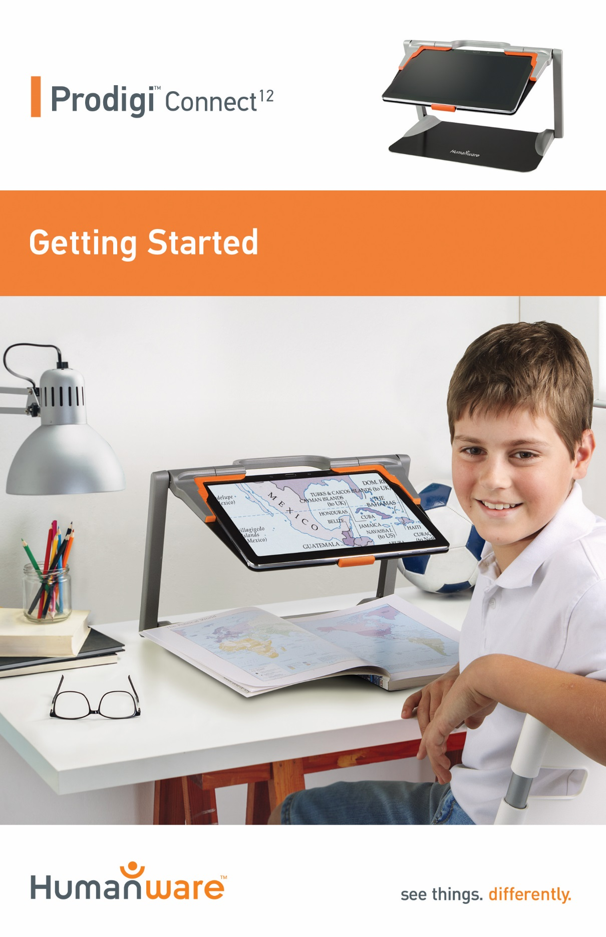

Getting Started
- On a flat and stable surface, hold your Prodigi stand in an upright position making sure the panel with the word “PULL” is facing you. While holding the handle with one hand, unfold the “PULL” panel with your other hand until it is flat on the table.
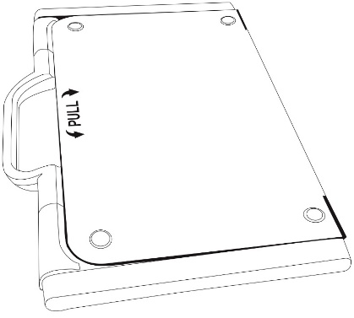

- Next, unfold the top panel until it is roughly parallel with the lower panel.
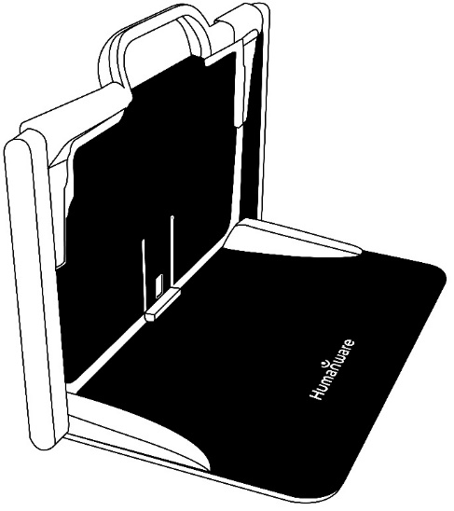

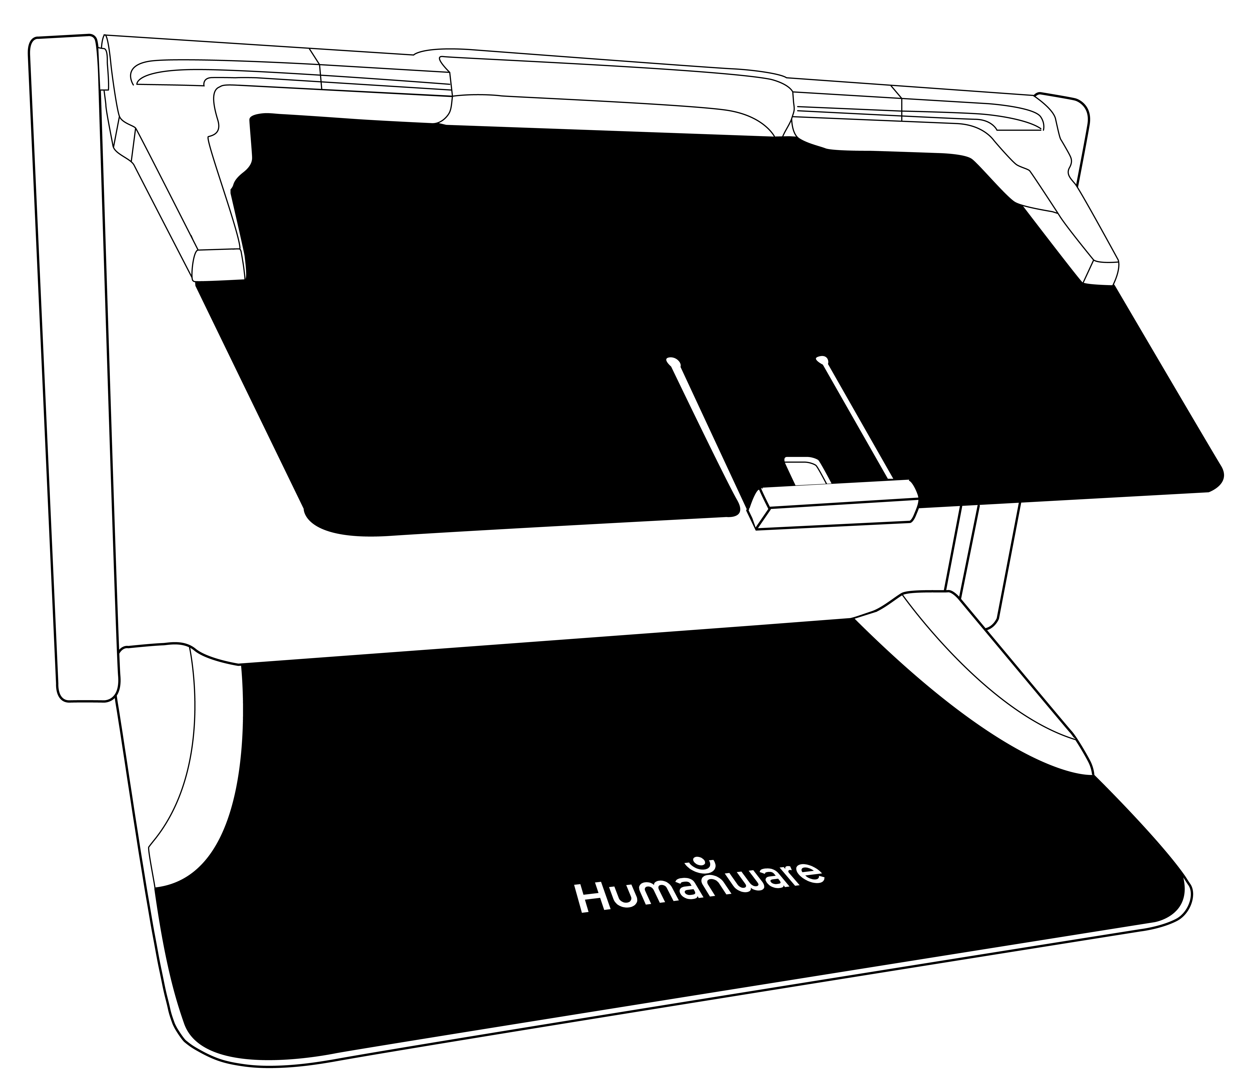
- Hold your tablet with the screen side facing you, making sure the Samsung logo is upside down. Carefully insert your tablet into the slot and slide it forward until you reach the back end of the slot. Lock the front bracket to fasten your tablet onto the folding stand.

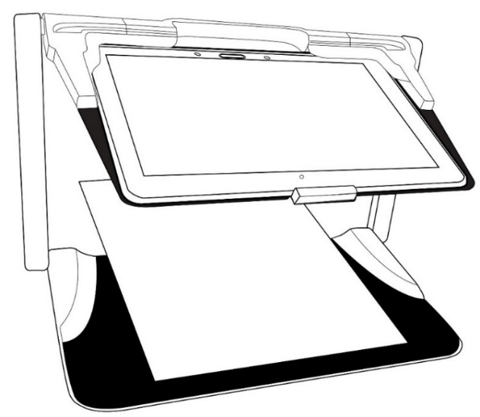

- Connect the USB Recharge Cable to the Power Supply.
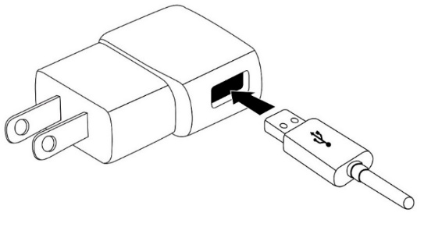

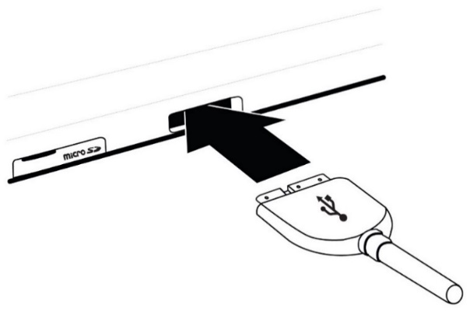
- Carefully connect the cable to the recharge port and plug it to an outlet. The recharge port is located on the left side of the tablet.
IMPORTANT: Use caution while inserting the cable into the Recharge Port.
IMPORTANT: Do not close your folding stand with your tablet in it when the recharge cable is plugged in. You could damage the recharge cable or tablet.
- Allow the tablet to charge until the battery is full (initial charge is 8 hours).

- Press and hold the Power button to power on your tablet. Your tablet will take about 30 seconds to initialize. The Samsung logo will appear on the screen (possibly upside down for booting, as the tablet is inserted upside down).

- Tap the Zoom In-Out buttons to adjust the zoom level. To increase character size, tap the Zoom In button (the right one). To decrease character size, tap the Zoom Out button (the left one). You can also tap and hold the Zoom In-Out buttons to progressively adjust the zoom level, and release once you reach your desired zoom level.
For more information on how to use Prodigi, please refer to the user guide.
[End of document: VER 02-2015-12-14]

ACCD-0132
REV 02

REV01

