Getting Started
- Pull the Base out of its box by holding the temporary cardboard handle, and place it on a flat and level surface.
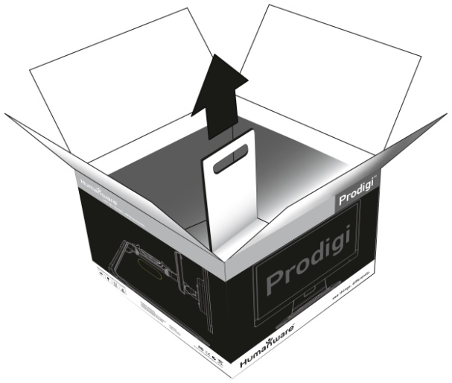

- Make sure the capture and front panel surface is clean before placing the overlay stickers on your front panel, then carefully place the stickers at their appropriate location based on the images below:
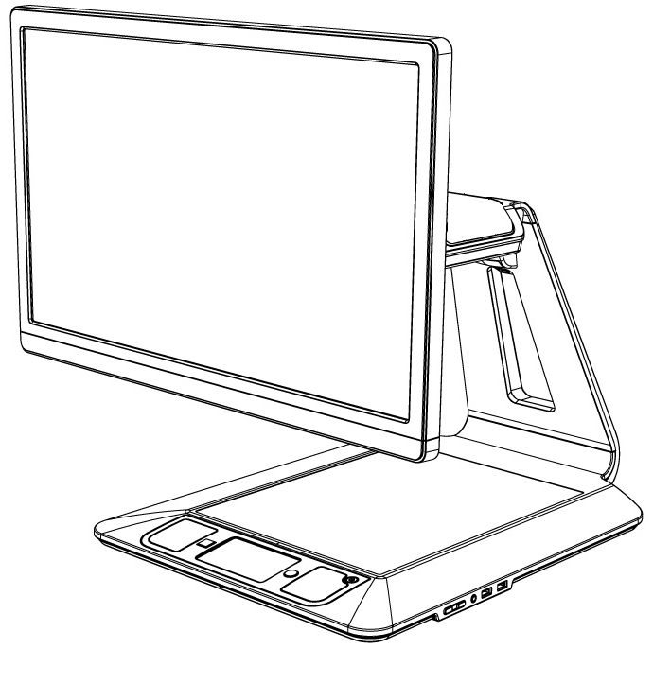
Once you have placed the stickers, wait 10 minutes to make sure they are well in place.

- Connect the Power Supply to the Power Cable. Then, connect the cable to the Power Connector and plug it to an outlet.
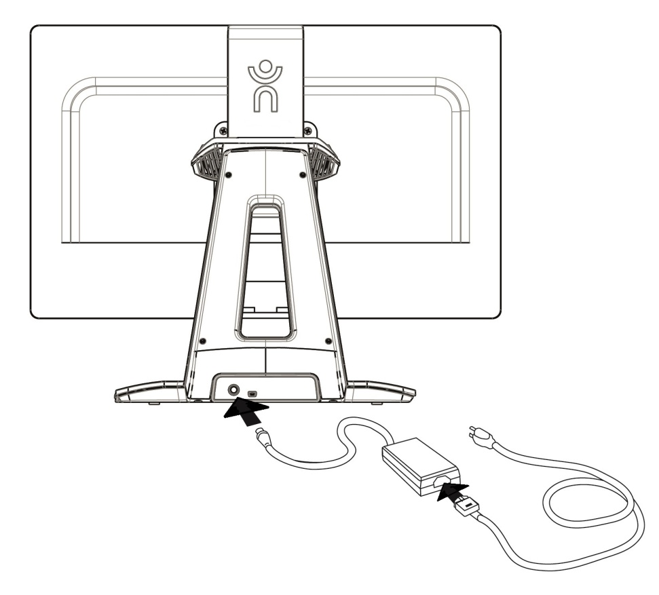

- Position the screen: The center of the screen should be at the same height as your eyes, ideally 16 inches (40 cm) away. To adjust the screen’s position, lift it up or down, tilt it forward or back, and swivel it left or right.
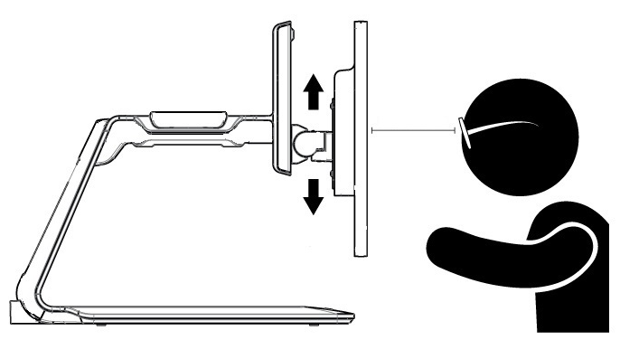
40 cm/16”

- Press the Power button. Prodigi will take about 1 minute to initialize. HumanWare’s logo will appear on the screen, followed by Prodigi’s startup screen.

[End of document VER 04-2016-05-31]

ACCD-0062
REV 04

REV01

